Exploratory and Predicative Analysis on Automobile Industry using SAS Viya

# Objective:

The objective of this report is as follows:

1. Derive insights and relationships among different factors of automotive industry.

2. Find out the most influencing features affecting profit margin across different car types, makers, and origins.

3. Using the underlying factors, estimate future predictions on Profit Margin and Type of vehicle with the help of different machine learning algorithms.

# SAS Viya:

To successfully make conclusions and derive relationships and trends for future predictions, we require a robust software that can help us perform all the required analytical and statistical tasks. The challenge for many organizations is processing large amounts of data as quickly and as efficiently as possible to create reliable analytical models and generate reports in a fast-moving economy.

SAS Viya is the ideal platform which contains all the necessary toolsets required for the entire data science life cycle. SAS Viya is basically a cloud enabled, in memory analytics engine that provides quick, accurate, and reliable analytical insights. Deployment in cloud comes with its own benefits like elasticity, scalability, data security, geo-distribution, fault-tolerant etc. SAS Viya also provides a collaborative environment where multiple users can explore, profile, and analyze the same data concurrently.

A key component of the SAS Viya architecture is SAS Cloud Analytic Services (CAS). CAS provides the run-time environment for analytics, data management and massively parallel processing architecture (MPP).

For the ease of explanation, the analytics life cycle for this report is going to be divided into 3 major parts:

1. Data preparation
2. Visual analytics
3. Statistical analysis

Data preparation is the process of cleansing, transforming, and governing our data. SAS data preparation tools enable users to perform advanced data preparation tasks to support predictive analytics, modeling, text analytics, and more.

Process of data preparation:

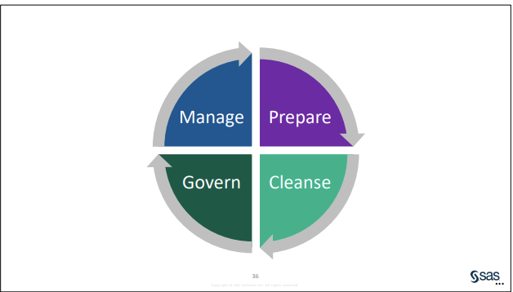

For the data preparation of our dataset, we will be using 3 major features:

## 1. SAS Data explorer

SAS Data Explorer enables us to load data into memory in the SAS Viya environment to work with it in other SAS Viya applications from different sources, using the import functionality. We are going to be using a dataset on the topic provided by SAS itself. So, a csv file will be imported for this report.

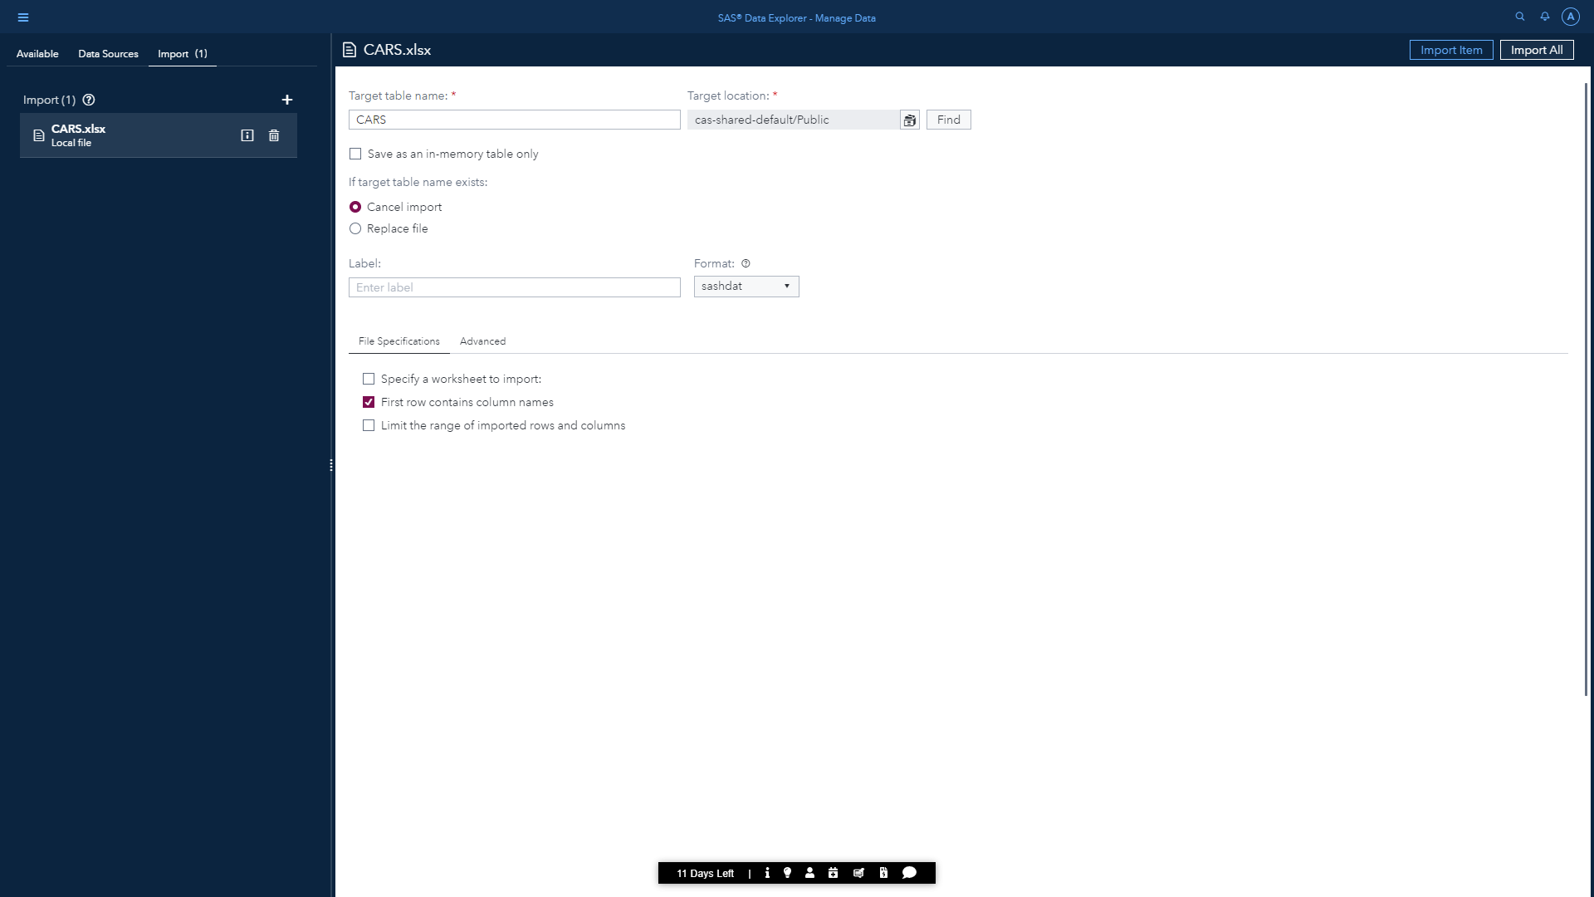

### Synopsis of our dataset:

Under the details tab of SAS Data Explorer, we can see basic details of our dataset. In this case:

No. of Columns:**28**

No. of Rows:**6.6 K**

Size:**2.2 MB**

Following are the column names for our dataset

|  |  |  |  |  |
| --- | --- | --- | --- | --- |
| 1 | | Velocity_Classification | 11 | DriveTrain |
| 2 | | Make | 12 | EngineSize |
| 3 | | Model | 13 | Cylinders |
| 4 | | Gears | 14 | Horsepower |
| 5 | | Displacement | 15 | Velocity |
| 6 | | Type | 16 | MPG_City |
| 7 | | MSRP | 17 | Co2 emission rate |
| 8 | | Invoice | 18 | Standard Index |
| 8 | | Invoice | 19 | Gear |
| 9 | | Profit_Margin | 20 | Transmission type |
| 10 | | Origin | 21 | MPG_Highway |
| 22 | Fuel Type | |
| 23 | Weight | |
| 24 | Wheelbase | |
| 25 | Length | |
| 26 | Invoice_1 | |
| 27 | distance_driven | |
| 28 | Combined MPG | |

We would be gathering few additional information on our dataset by running a profile under the ‘profile’ tab. This gives us details on distributions, measure of central tendency and univariate statistics. It comes in handy whenever we want to find missing values, skewed distributions, measure of dispersions, outliers etc.

* Our table has the utf-8 Encoding.
* Make, Model, Type, Origin, DriveTrain and Fuel Type are of varchar datatype and the remaining features are of double datatype.
* MSRP, Invoice and Profit Margin has an additional format as DOLLAR.
* ID and Distance driven have 100% unique values and ID column is treated as the primary key.
* Cylinder and origin have 0.33% and 33.58% of null values respectively.
* Model has the highest pattern count of 274.
* Following image shows statistical values like Mean, Median, Mode, Standard Deviation, Standard Error, min, and max for some features of our dataset.

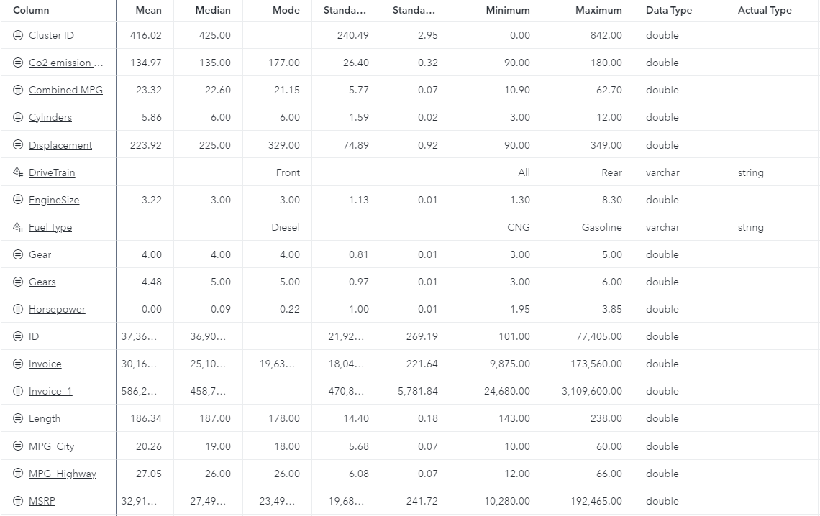

Let us derive additional info on ‘Type’ and ‘Profit margin’ features as we are going to perform predictions on them later.

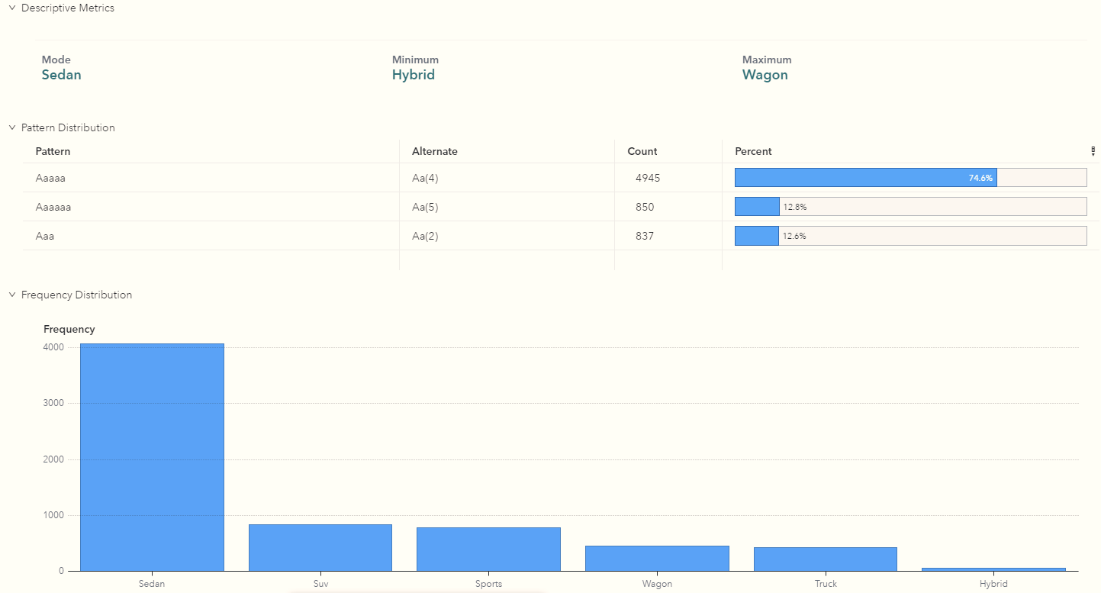

For Type feature:

* Sedan and Hybrid are the most and least recurring values respectively.
* 74.6% of values has the pattern ‘Aaaaa’ with a total count of 4945.

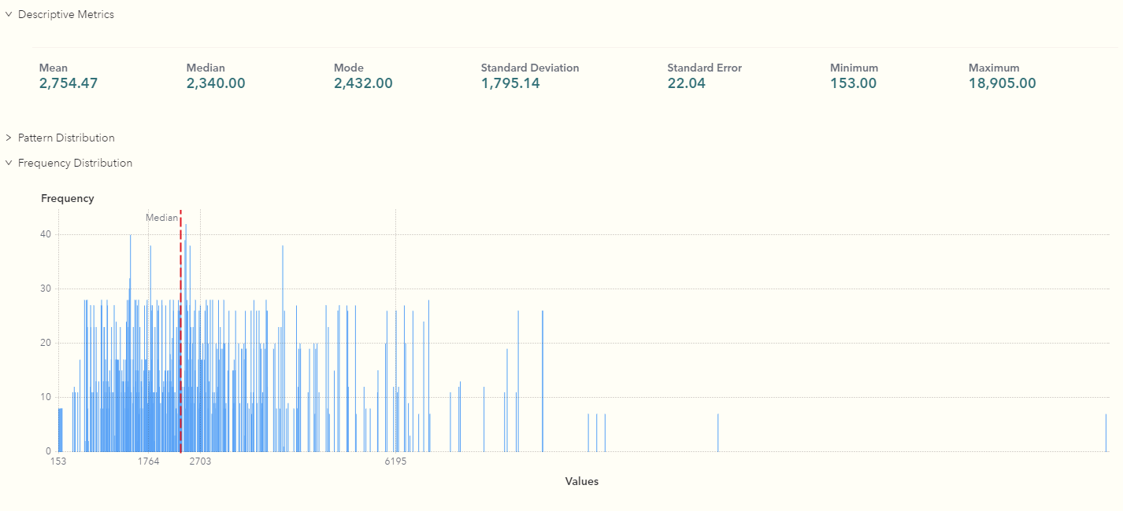

For Profit Margin feature:

* Has a standard deviation of 1795.14
* 153 and 18,905 are the following min and max value.
* Outliers can be detected as there are values beyond 6194 which are greater 3rd standard deviation.

## 2. SAS Data Studio:

Using SAS data studio, we can make all the necessary transformations to prepare our data for further analysis by creating data preparation plans which can be used later. We would also like to cleanse the data by improving the data quality. We will use the following functionalities:

1. Standardization of ‘Make’, ’Type’ and ‘Origin’ features which will help us improve the consistency of data by applying standardization definitions to the data values.
2. Centre and Scale transformation on ‘horsepower’ and ‘distance driven’ features to ensure It centers and scales a variable to mean 0 and standard deviation 1, which it will be implemented using CASL Code.

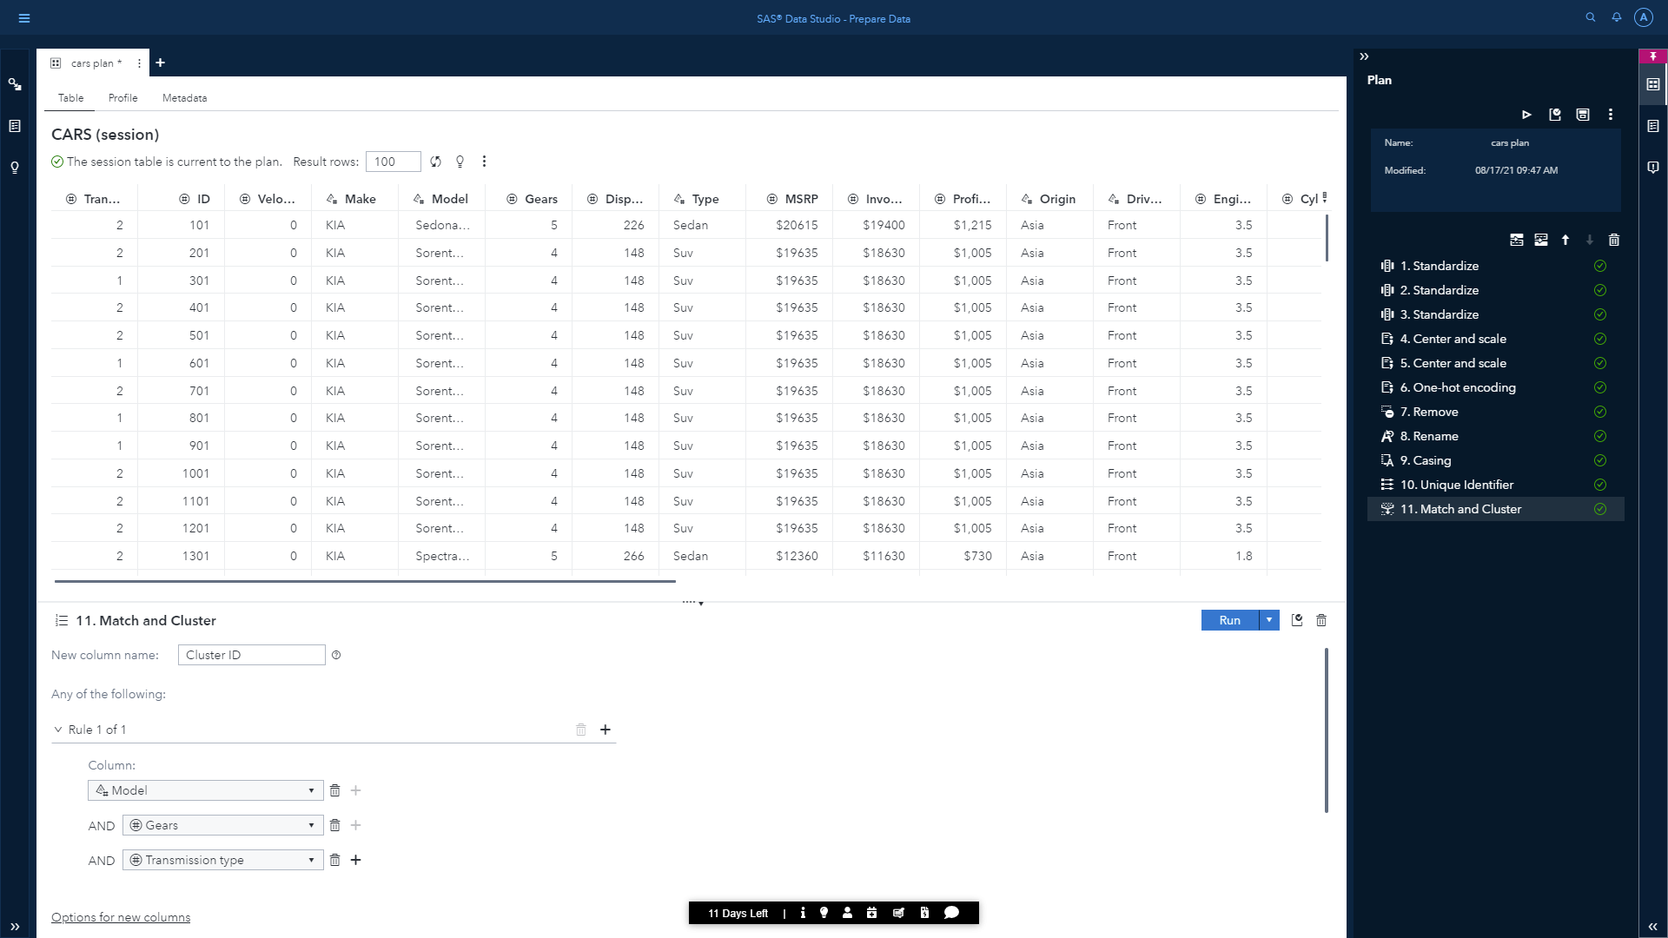

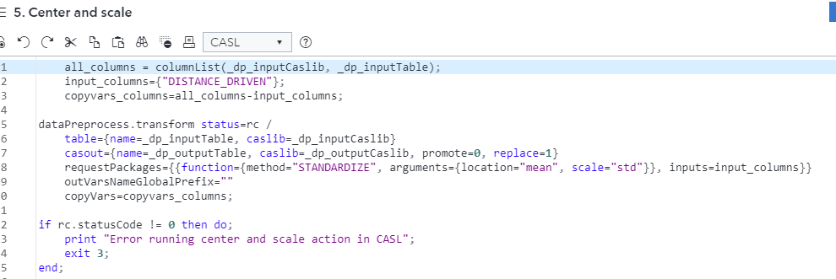

1. One-Hot Encoding on ‘Transmission Type’ which will allow us to represent the categorical variable into numeric, because many machine learning algorithms cannot work with categorical data. Also going to be implemented using CASL Code.
2. Removing the ‘Transmission Type’ to avoid dummy variable trap.
3. Converting ‘origin‘ column into proper case.
4. Addition of a column having unique values using Unique Identifier
5. Matching and grouping of data based on similarities between ‘Model’, ‘Gears’ and ‘Transmission Type’ using the Match and Cluster feature.

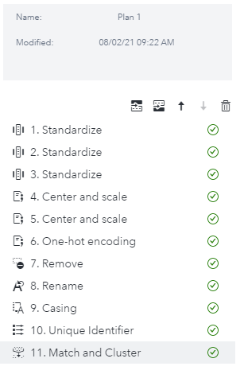

There are many other transformations that can be implemented like matchcodes, append and joins, parsing, splits, Gender Analysis etc.

## 3. SAS lineage viewer:

SAS Lineage Viewer will help us view object relationships and help govern data and data jobs. Here is the lineage view of our dataset:

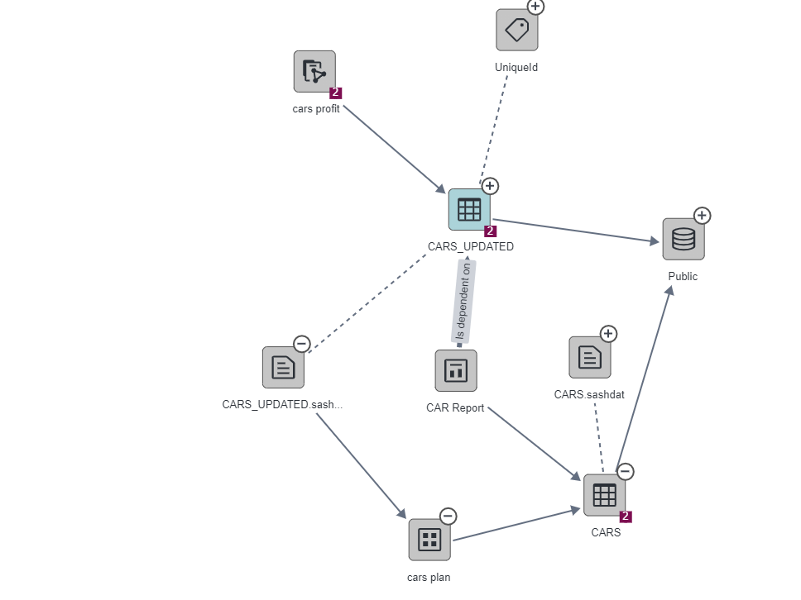

This diagram has objects like the original dataset, data plans, reports, model pipelines and data sources along with each line representing the relationship among them.

# SAS Visual Analytics

We would be using SAS Visual Analytics to enhance the analytic power of our data, explore new data sources, investigate them, uncover relevant patterns, and create reports. In traditional reporting, the resulting output is well defined up front.

Before creating a visual interactive report, we must keep in mind to follow the SAS Visual Analytics methodology.

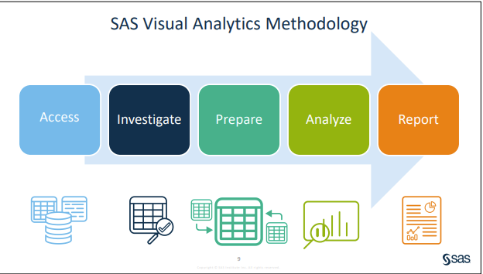

### Features of SAS Visual Analytics:

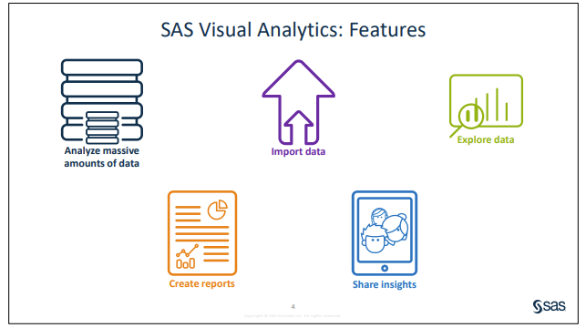

### Importing D3.JS charts:

D3.JS: D3.js is a JavaScript library for producing dynamic, interactive data visualizations in web browsers. It makes use of Scalable Vector Graphics, HTML5, and Cascading Style Sheets standards. It is the successor to the earlier Protovis framework.

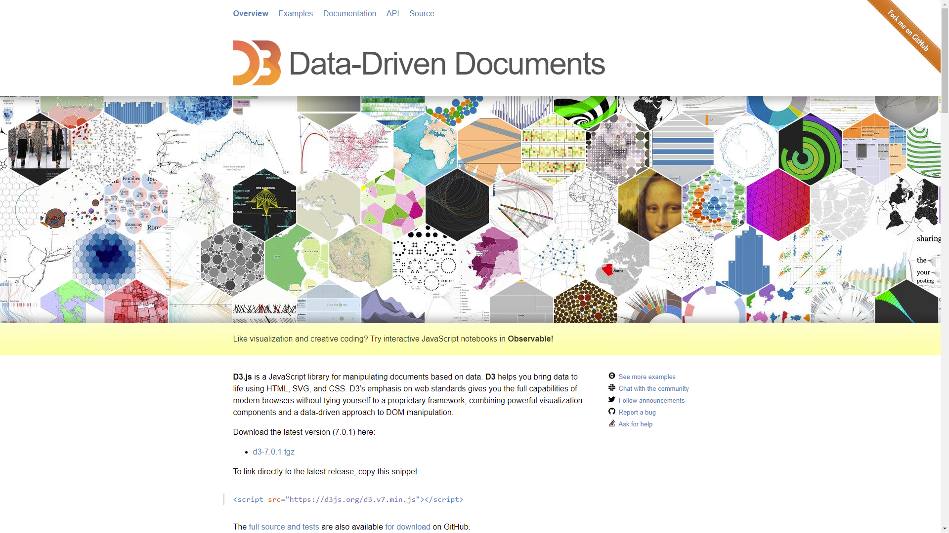

Data Driven object under SAS Visual Analytics gives us the functionality of importing any external visualizations in a webpage.

* The required data for the visualization will be imported into the CAS server first
* The D3.JS chart that we would be using a from a webpage, must be hosted in a web server before.
* The URL of the webpage will then be added in the web content section under the options tab.

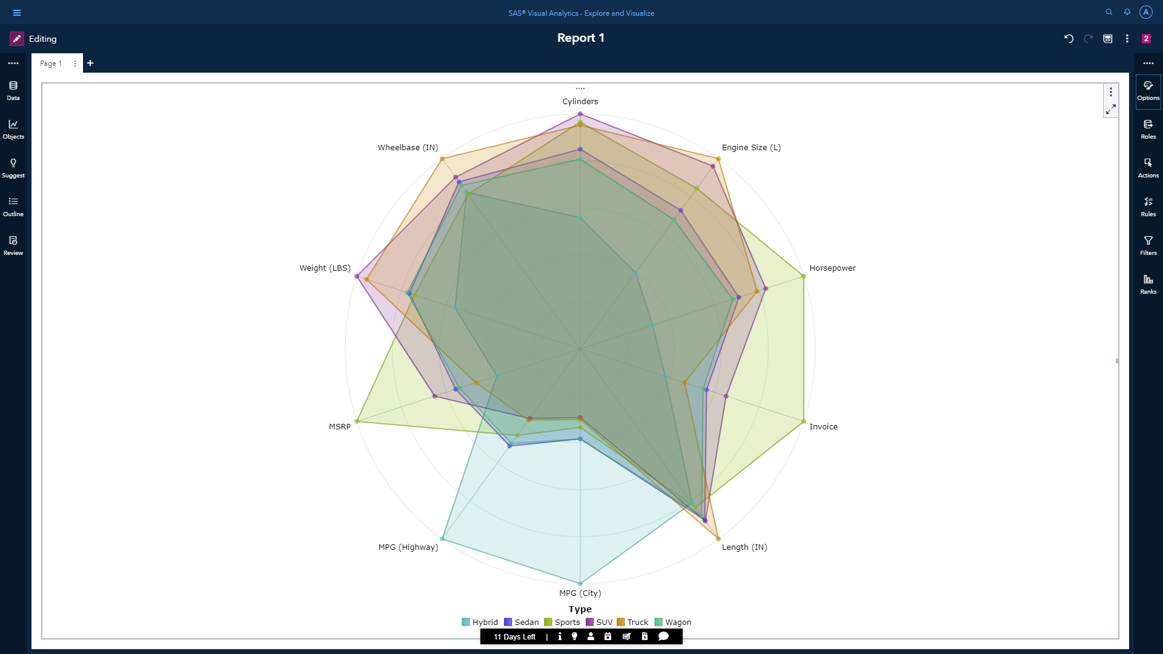

The above picture shows an example of an imported D3.JS Radar Chart that was already hosted in a web server. This radar chart depicts the measure of different properties for each vehicle type.

## Automobile industry overview and analysis

At first the updated dataset must be imported into SAS Visual Analytics which contains all the data transformations. To make the front page, we would be using an object called precision container that enables us to place, align, and size the objects within the container. The first page should generally give a rough idea on the motive of our visual report. Therefore, we would be using images for each car type including details or average profit margin and carbon emission of this industry.



To give some additional details on each vehicle type, we are going to create a hidden page (which won’t be visible directly) and link it to each of the images in the first page of the report. It means the page can only be viewed when we select an image. This can be implemented using the page links feature which has element of both action and filter.

On the hidden page itself we are going to include a list table showing Origin, MSRP, CO2 emission rate of each car type and maker. We will also include a bar chart displaying the MSRP of each car maker. A page prompt will be added having buttons to filter or narrow the scope of the data in the current page based on vehicle types. Inclusion of these elements should give us a generalized view of the industry as a starter.

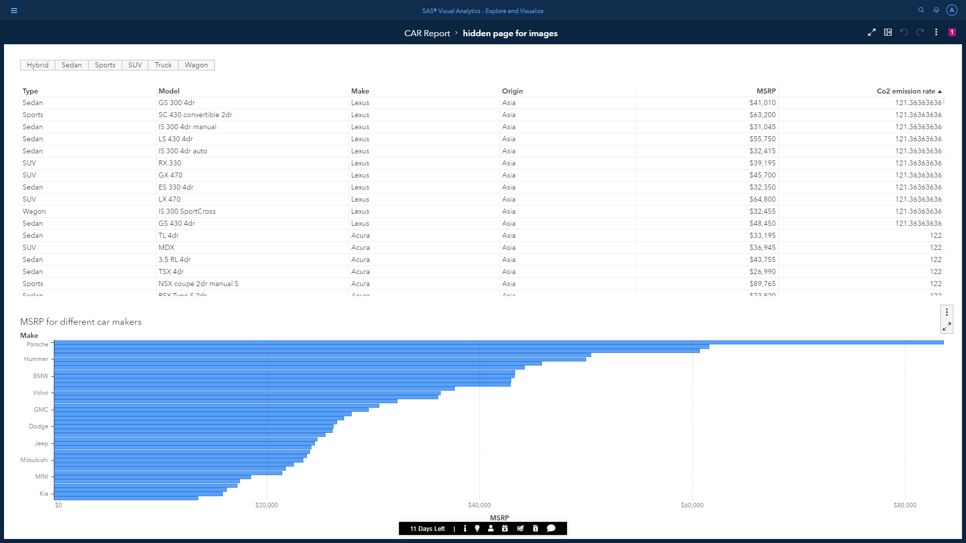

Data Storytelling:

Storytelling of our data is one of the most important aspect of the data analysis process. Most experts describe data storytelling as the ability to convey data not just in numbers or charts, but as a narrative that humans can comprehend. Keeping that in mind, the narrative of our report will mainly focus on MSRP and profit margin across different car types, makers, and origins.

Before doing any further analysis, we are going to change the aggregation for few measure items like invoice, CO2 emission, MSRP and Profit Margin from sum to average, because the number of vehicles in each vehicle type is not uniform.

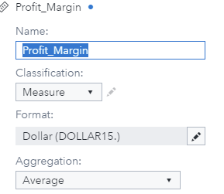

For the next page titled ‘MSRP Analysis’, our sole focus would be on MSRP. A pie chart will be included in this page. This chart would be the ideal choice for visualizing the proportions of MSRP across each vehicle type because it divides the entire circle based on ratio of a measure across a category. Next to pie chart, a treemap will be added which can show the relative MSRP based on area and profit based on the color. One thing to note that treemap can be useful for displaying hierarchical data. So, we are going to include a hierarchical data item to the tiles where maker will be the parent and model as child.

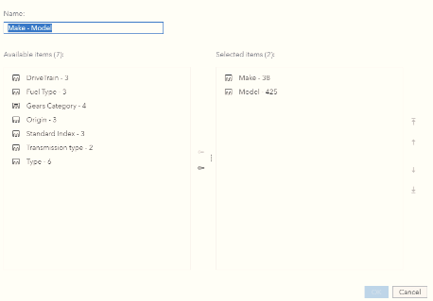

Whenever we click a tile displaying car makers, it will show the distribution of models under the selected maker. Lastly, we will also include a car type drop down list prompt to filter the page according to our needs.

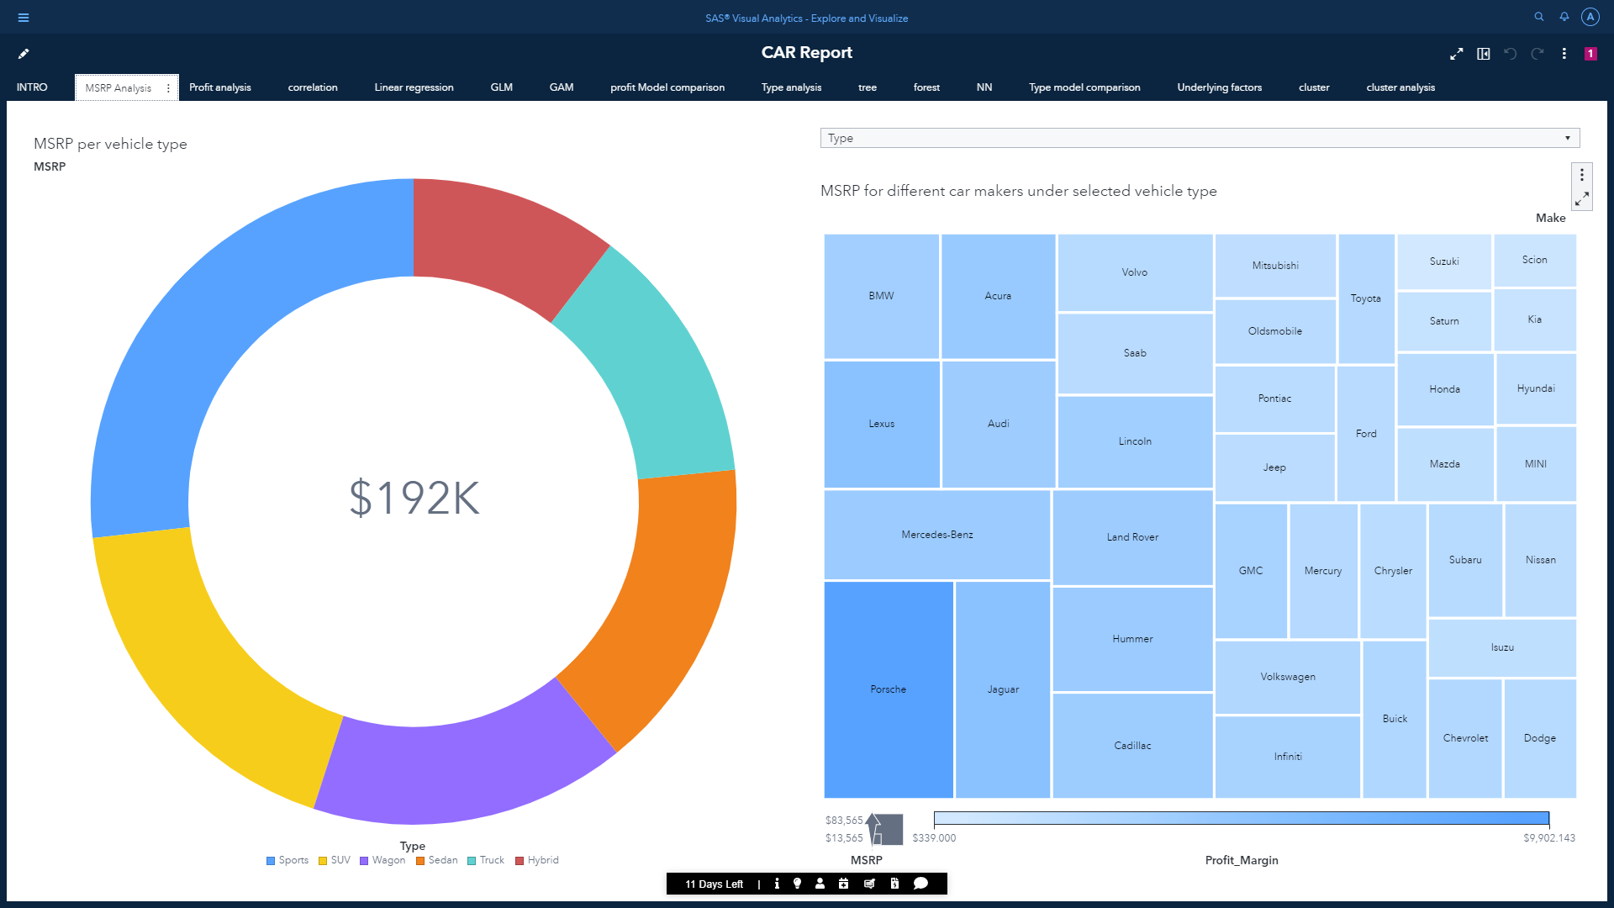

To get a filtered data on the treemap based on the selection on individual slice of the pie, we are going to add a linked selection to the pie chart.

To show the interactivity of this page, here are some images of filtered data using the Vehicle Type page prompt and linked selection between pie chart and treemap:

When ‘Sports’ is selected in page prompt.

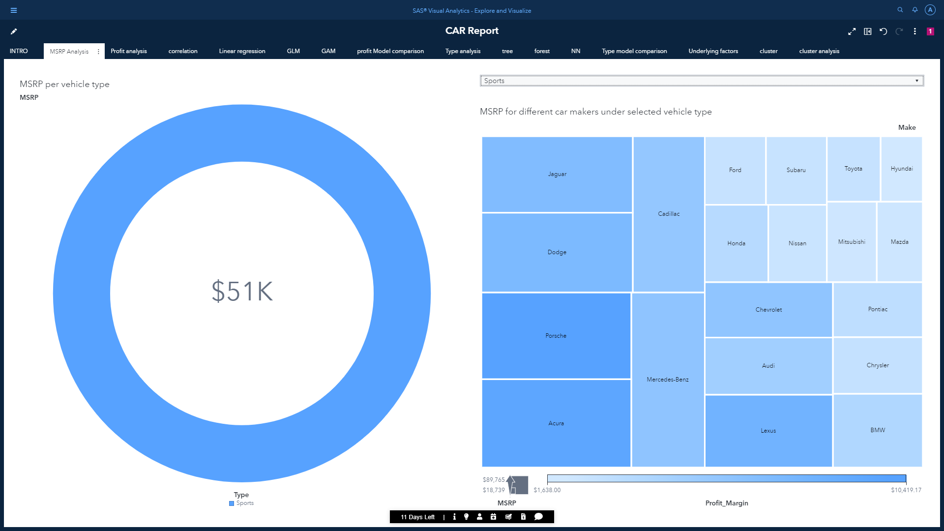

When ‘Sedan’ is selected in page prompt.

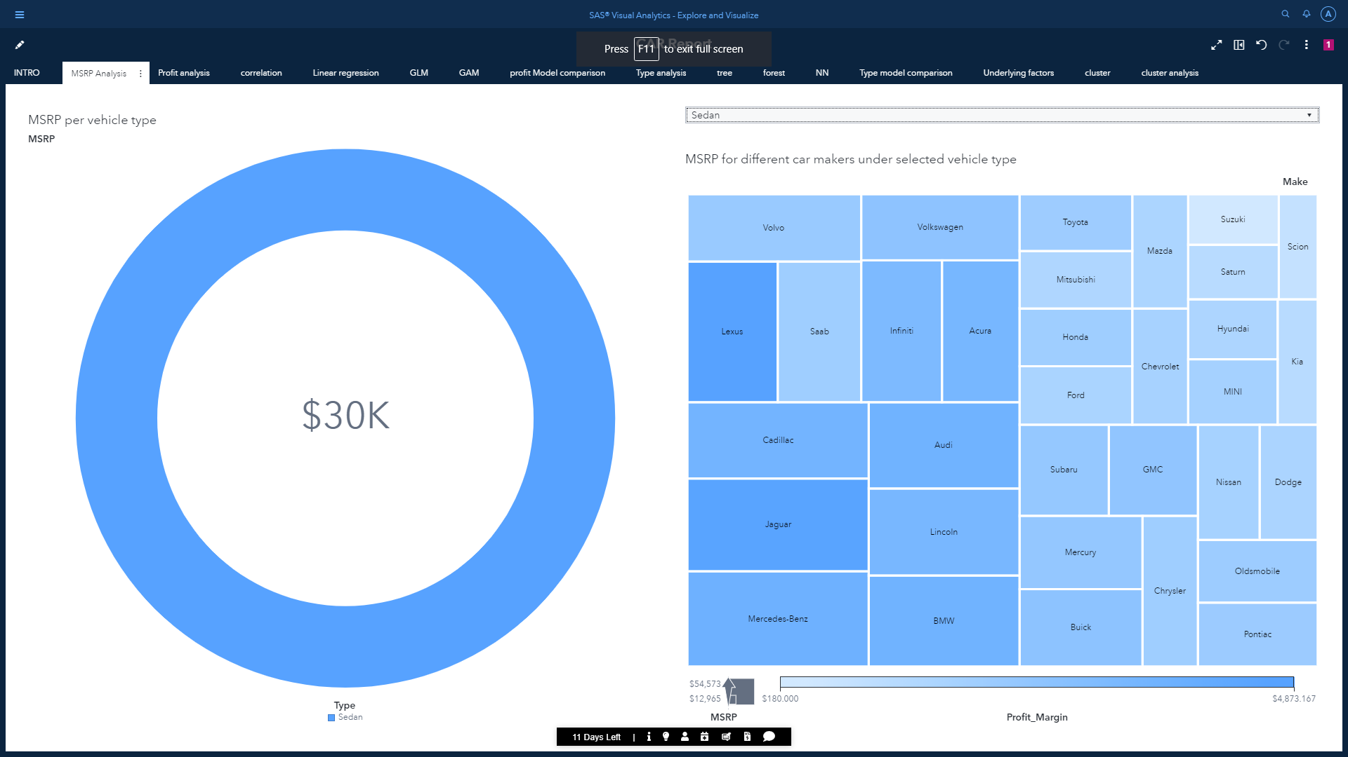

When SUV section of the pie chart is selected

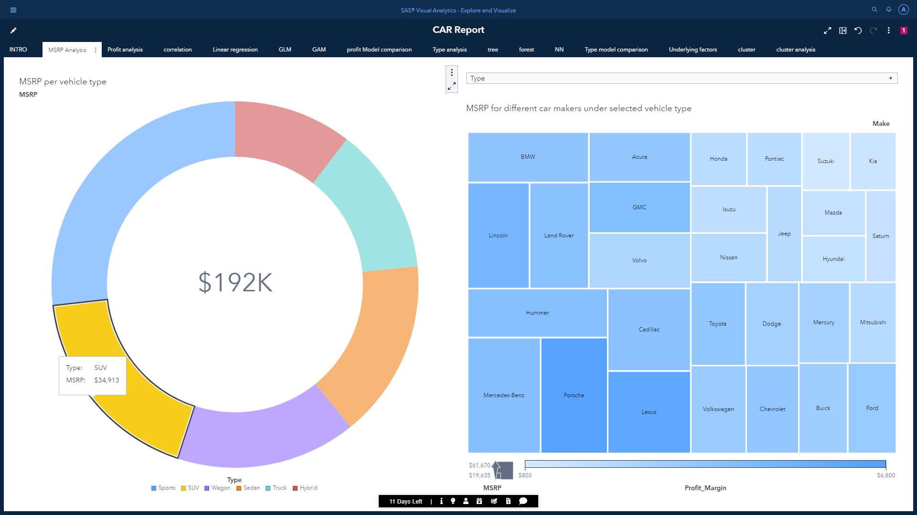

When the Mercedes tile is selected under ‘Sedan’ page prompt to show the treemap diagram of all Mercedes sedan models.

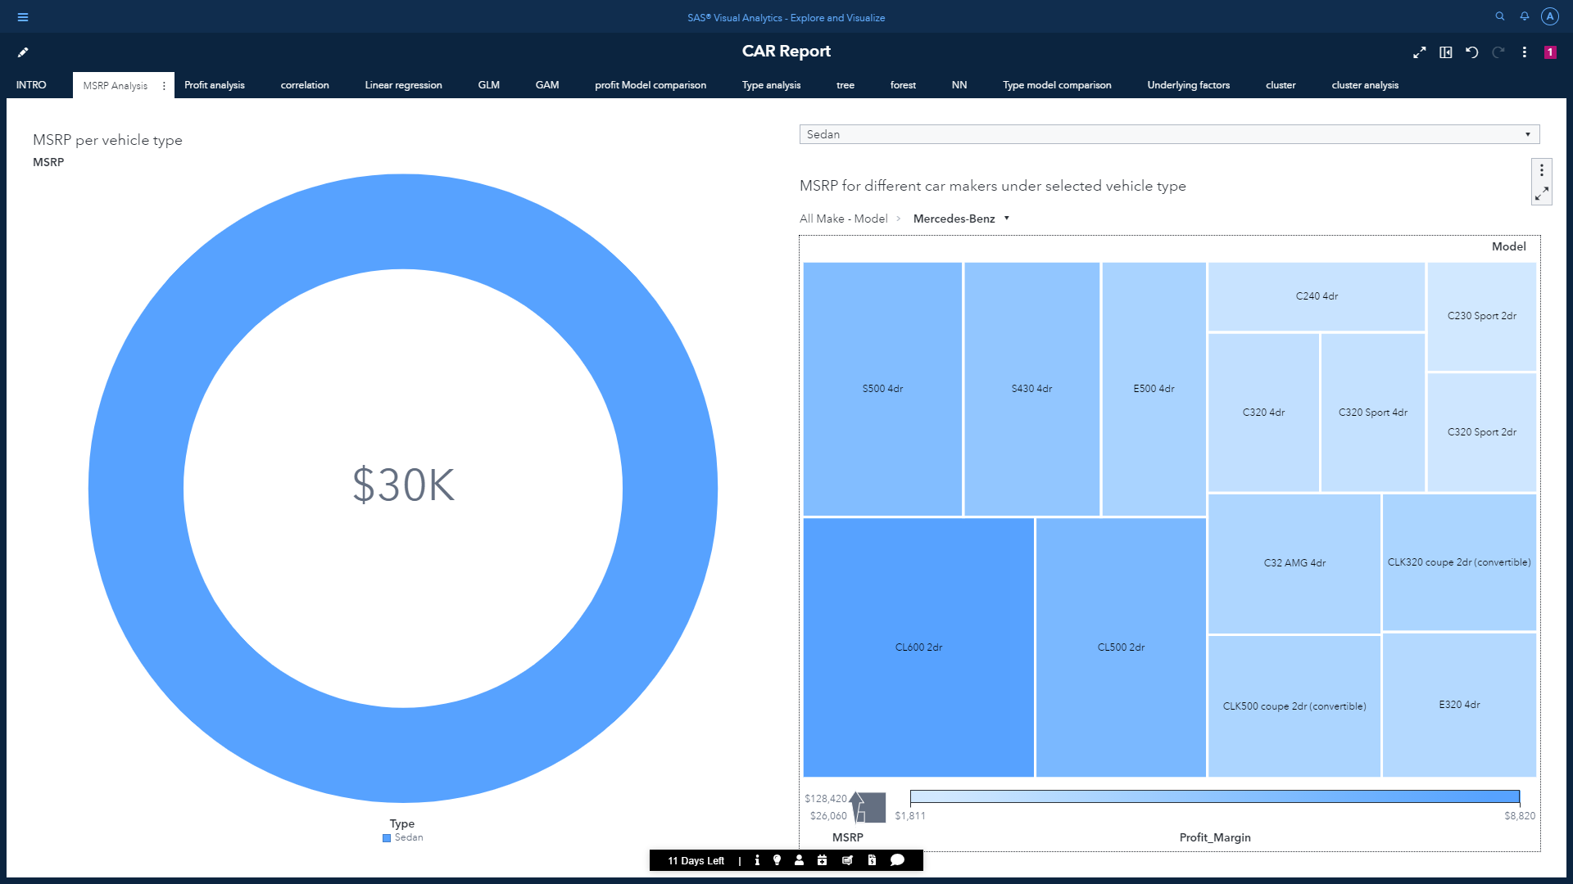

The pie chart will also be linked to another hidden page to show profit margin for the selected slice using a bar chart. This chart is going to have another hierarchical data item(type->make) grouped under origin and a list table being linked to it. This is not part of the MSRP narrative but to give addition info if needed in certain scenario.

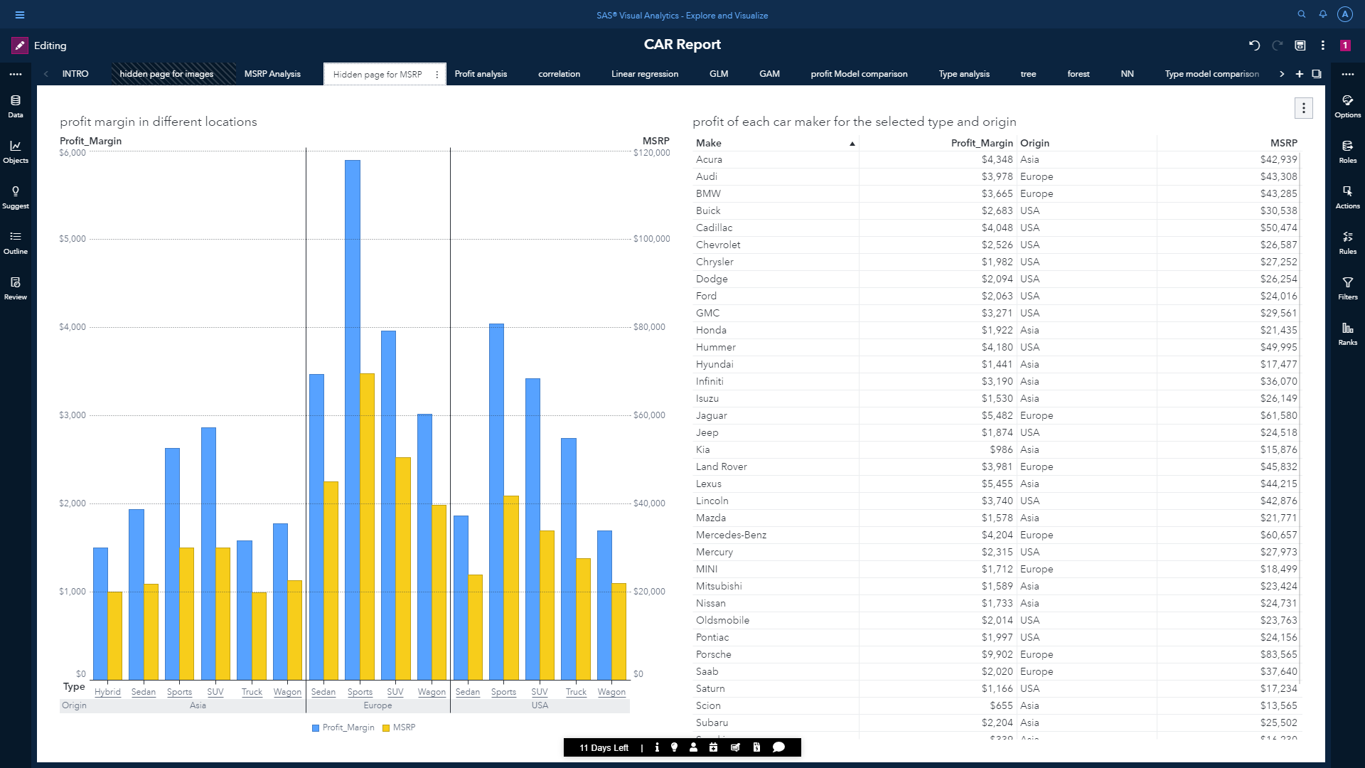

As it is linked to previous page, it is going to get filtered according to the selected section of the pie chart.

When Sedan section of the pie chart is selected

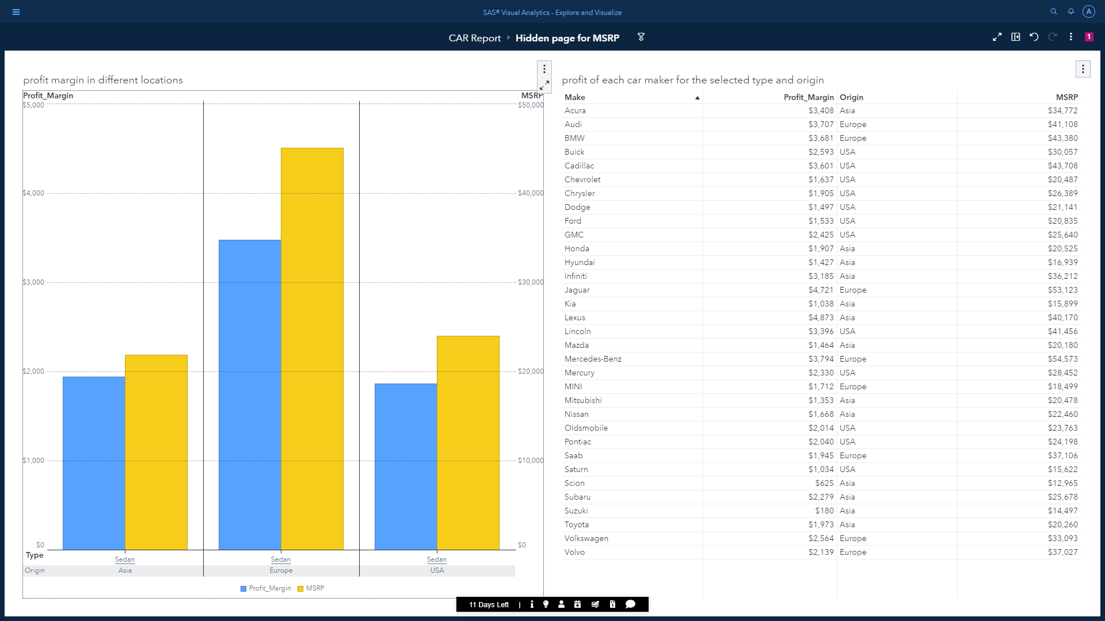

When Sports section of the pie is selected

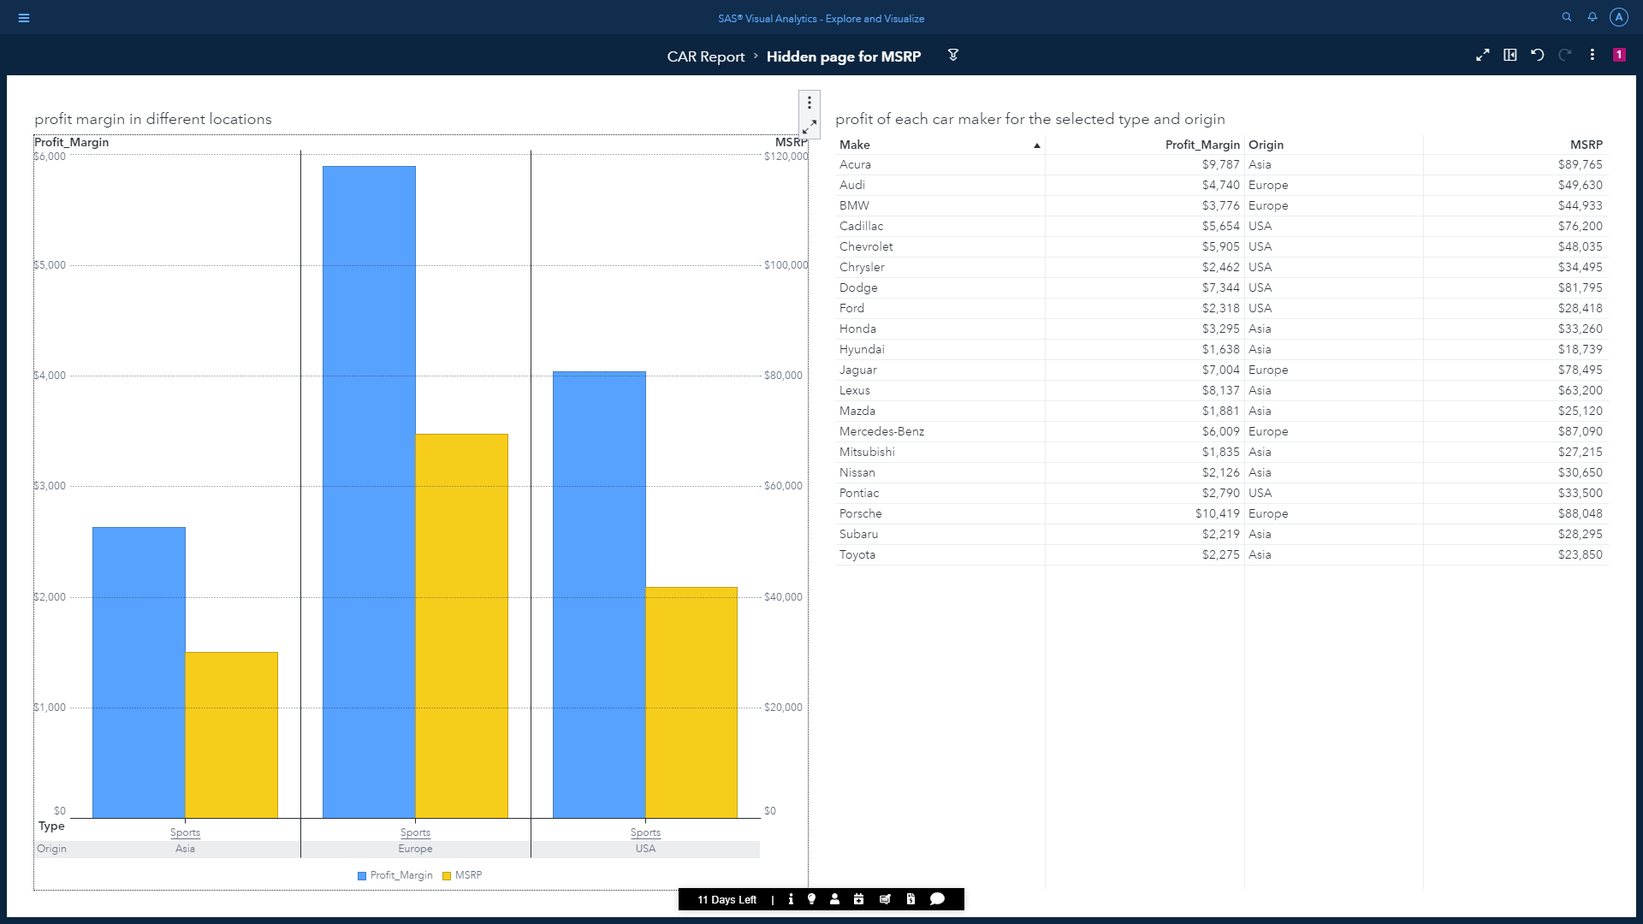

When SUV section of the pie chart is selected

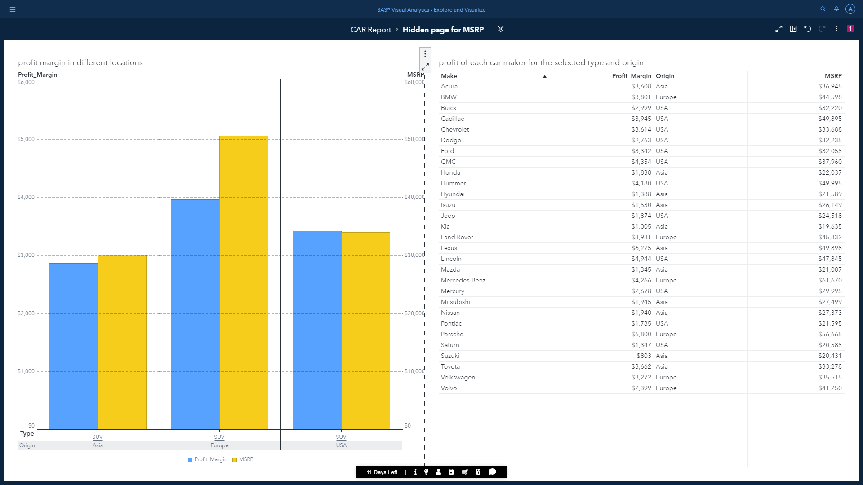

The following elements should give us a proper analysis on MSRP across different categories and conditions.

Page 3 will solely focus on profit margin as we would like to make predictions on this variable in next pages. We are going to include an object called ‘Automated Explanation’. In SAS Visual Analytics, the automated explanation object gives us a nice summary by determining the most important underlying factors for a specific response variable, using most of the data items in the table.

Performing automated explanation on profit margin will give the following results:

1. A relative importance score for each underlying factors in bar chart (The most important underlying factor is assigned a score of 1).
2. The relationship between the response factor and the selected underlying factor (profit margin).
3. Additional info and details on which factors were included and excluded under expand option.

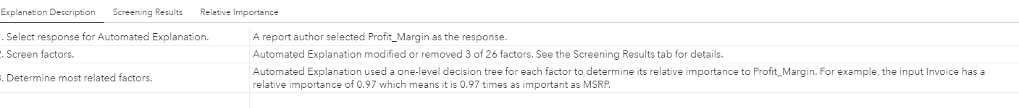

* From the page we could see the major influencing variables were Invoice, horsepower, Engine Size, cylinders, velocity etc.

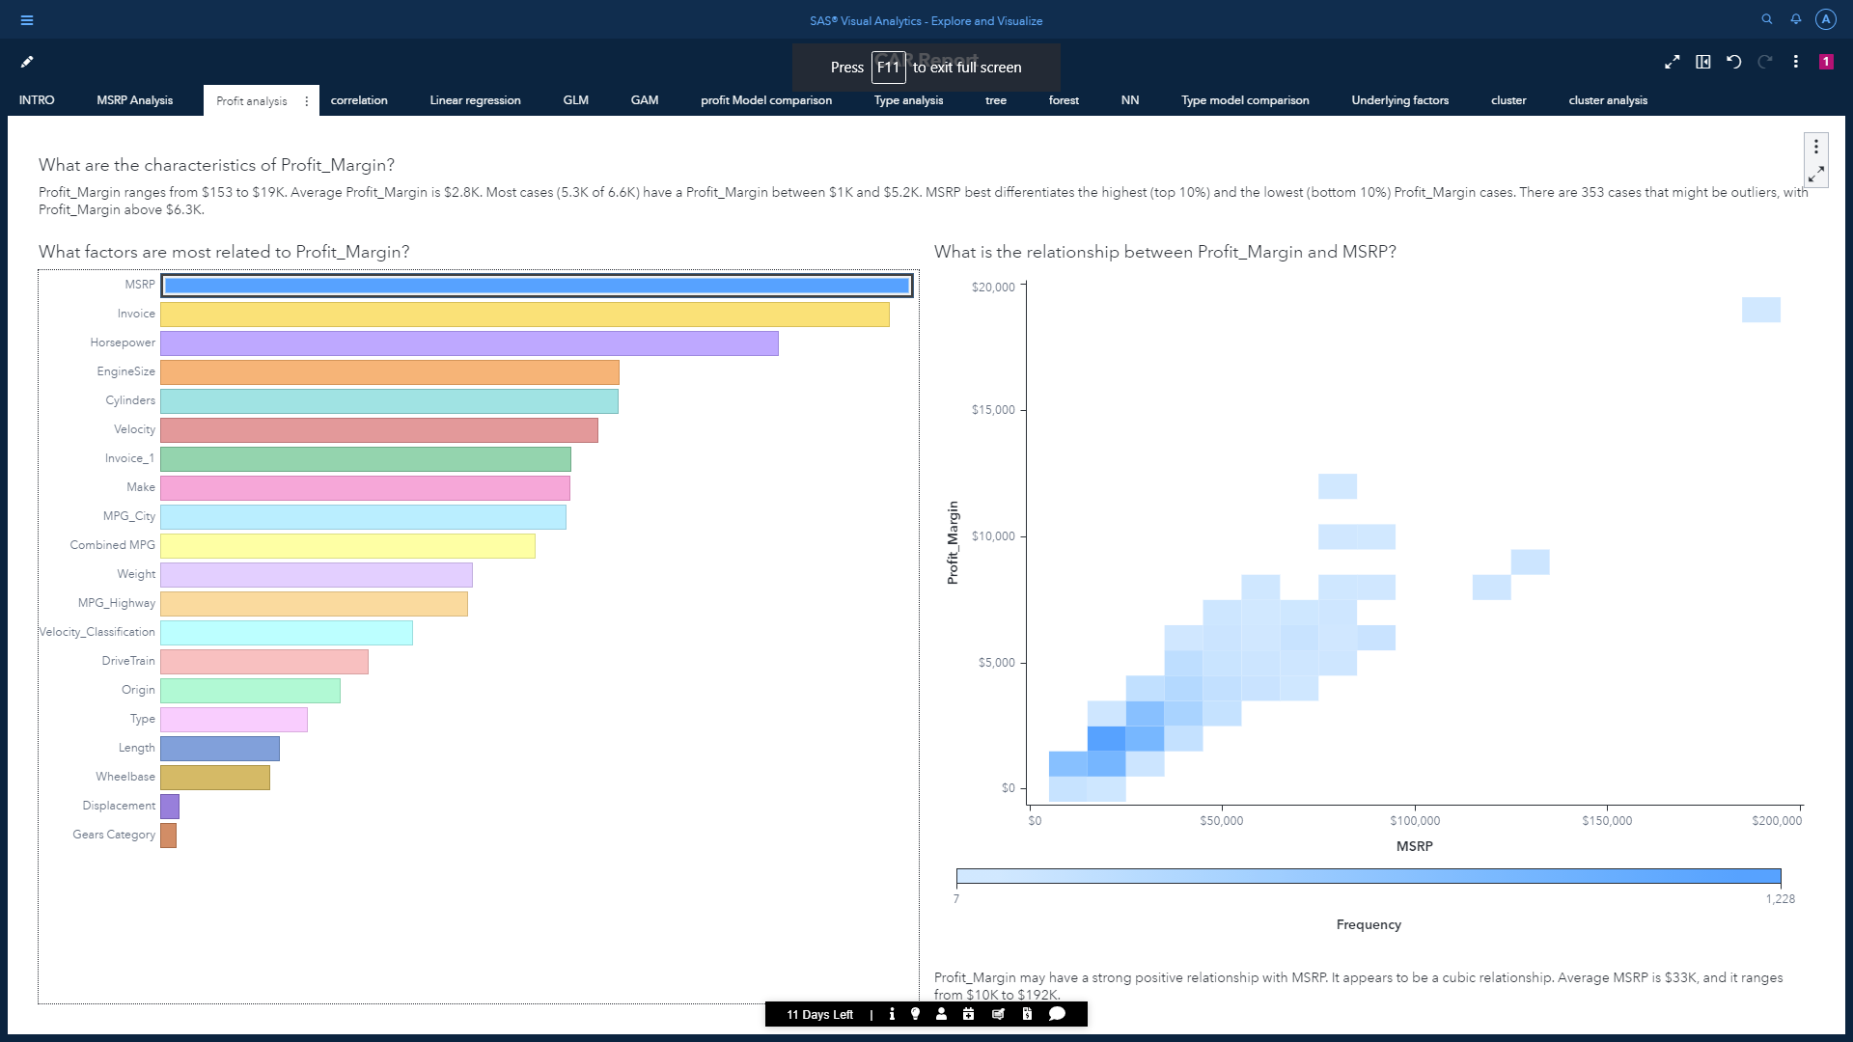

* From the relation plot it can be seen Profit Margin may have a strong relationship with MSRP. It can be seen when MSRP increases, Profit Margin also increases in general which indicates they are positively correlated.

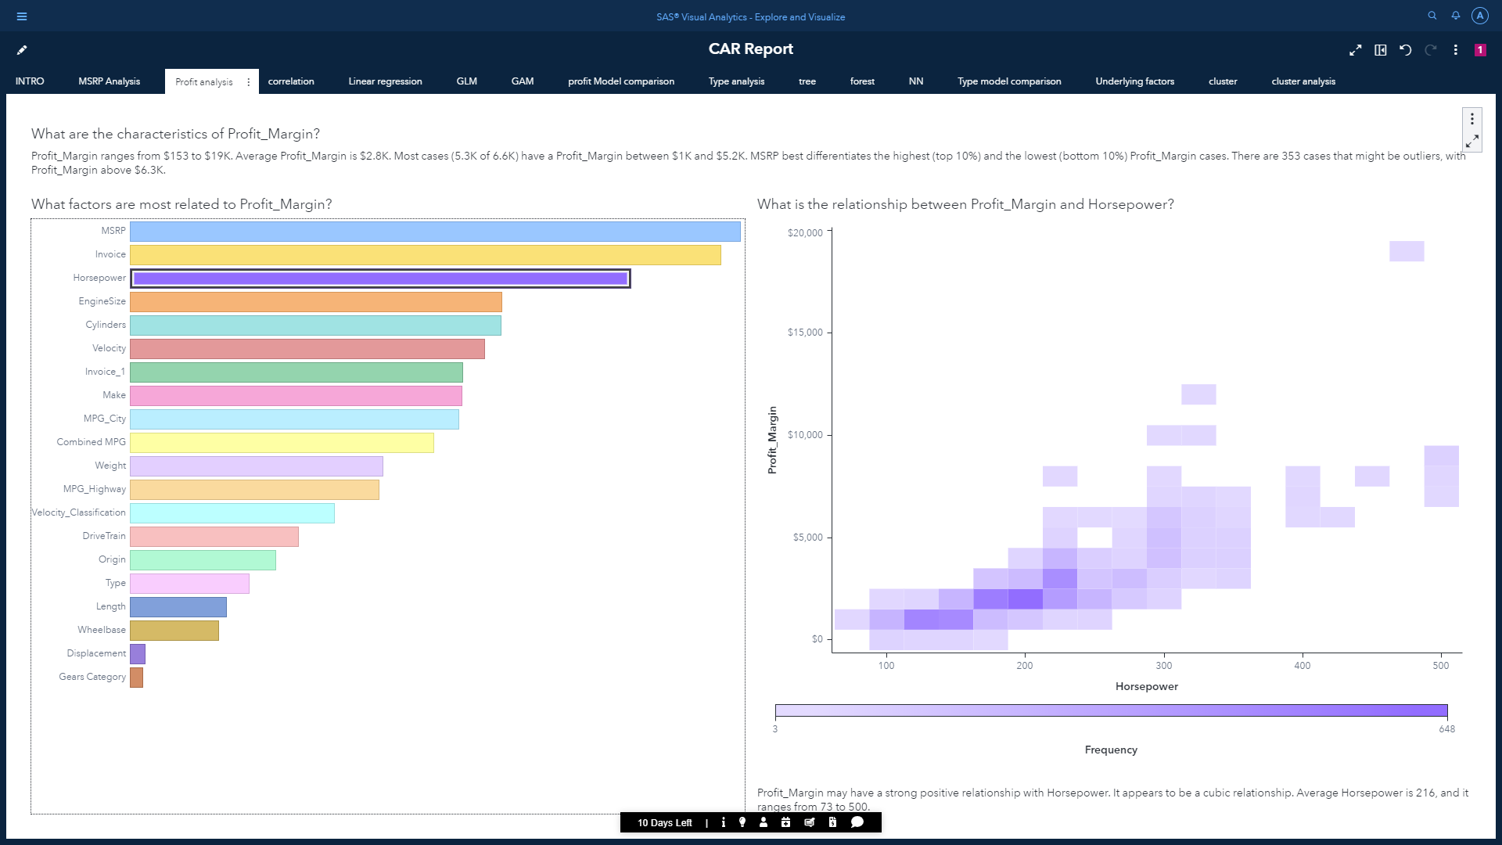

* From the relation plot it can be seen Profit_Margin also may have a strong relationship with Horsepower. It can be seen when Horsepower increases, Profit Margin also increases in general which indicates they are positively correlated.
* However, the slope seems less compared to relationship between MSRP AND Profit_Margin. This means MSRP is a more influencing factor.
* We can also observe there are few outliers for horsepower.

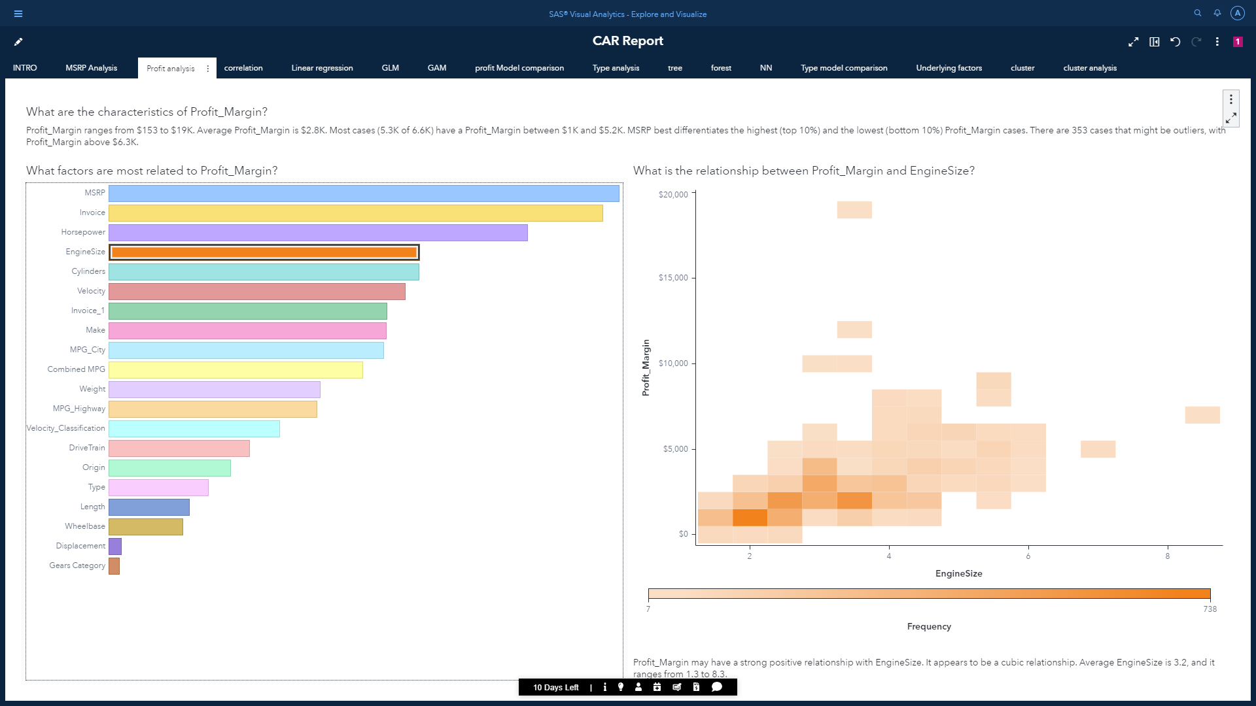

* From the relation plot it can be seen Profit Margin also may have a strong relationship with EngineSize. It can be seen when Engine Size increases, Profit Margin also increases in general which indicates they are positively correlated.
* We can again observe there are few outliers for EngineSize.

Now that we have an idea which are the best data items influencing profit margin, we would like to view correlation between the underlying factors before performing regression. In predictive models, fields having high correlation (dependent features) are generally removed to increase performance. To visualize dependency, we are going to use the correlation matrix object which shows the statistical relationship for bivariate (two variables) data. Some other filter options are added for further interactivity and freedom.

From the matrix we can conclude that CO2 emission, diastance_driven and displacement are one of the least correlated features. And combined MPG, cylinders, Engine Size, and horsepower has the maximum correlation.

Under SAS Visual Statistics, we don’t have to perform feature selection on our own as it is automatically handled. But these things must be kept in mind for creating the most effective predictive model.

There are many other features that can be implemented like vectors plots, time series plots, forecasting, parameters, text analytics, network analytics, calculated data etc.

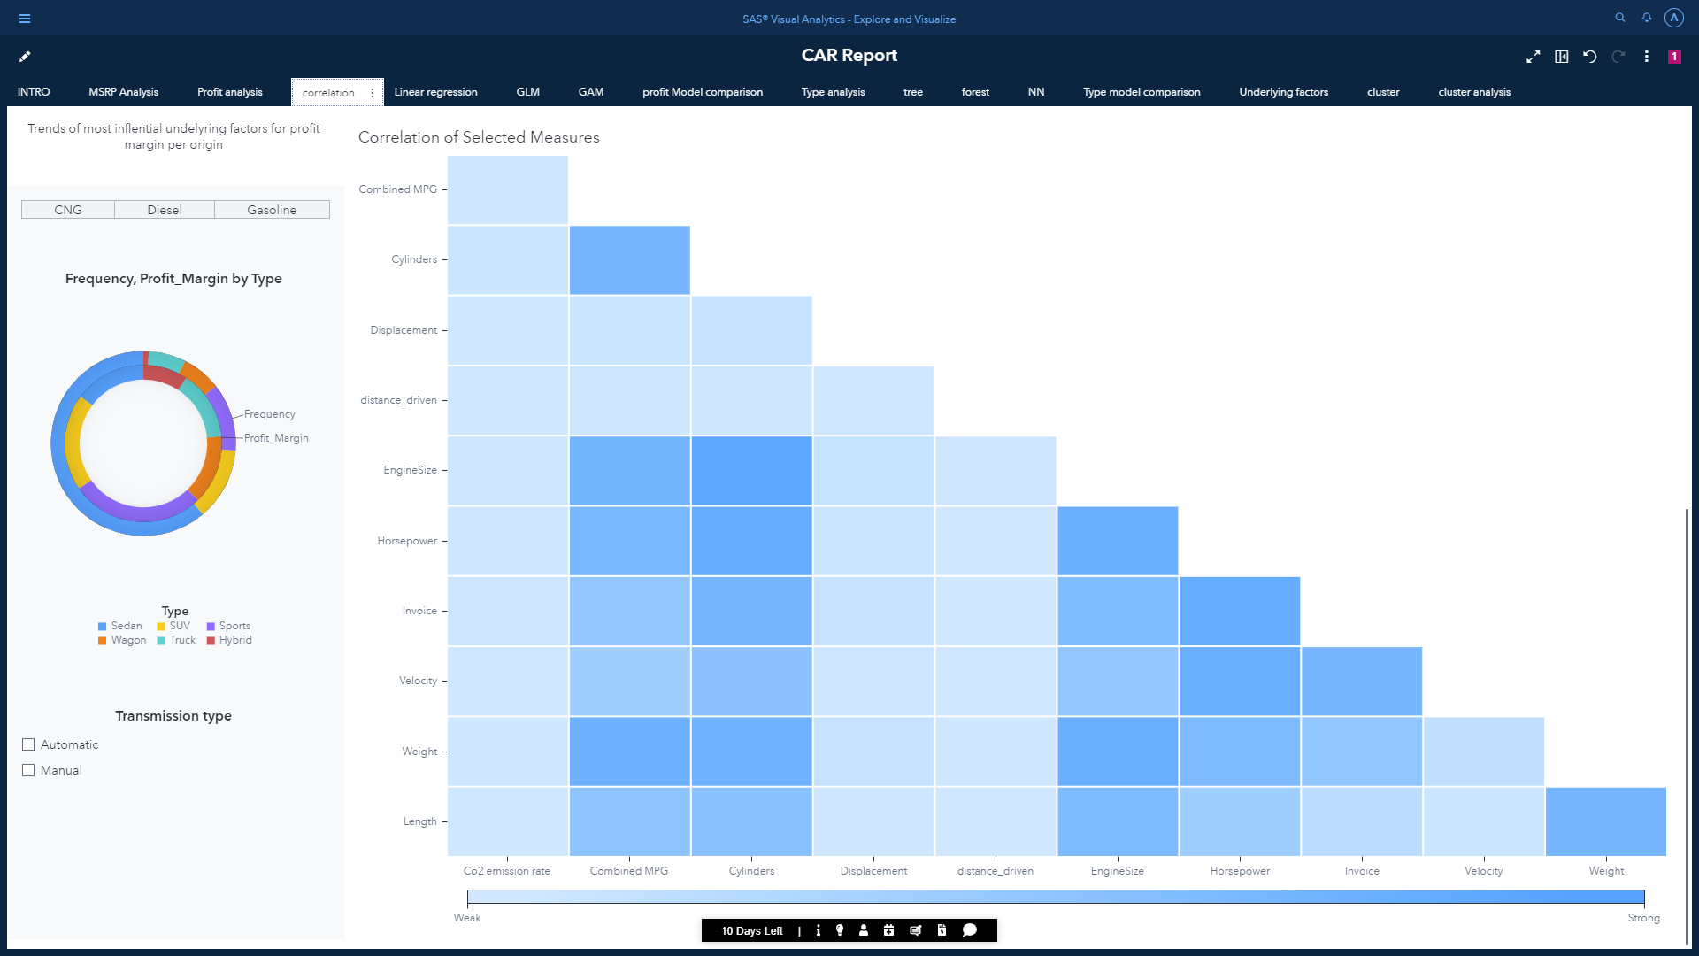

# SAS Visual Statistics:

To perform future predictions, we are going to implement machine learning with the help of SAS Visual Statistics.

SAS Visual Statistics models enable us to do the following actions:

• take advantage of the in-memory engine, the CAS server, to analyze in-memory data quickly and efficiently.

• enable concurrent access to data for multiple users to formulate and refine models.

Machine learning is a subset of AI, which uses analytical and statistical models to predict future outcomes based on historic data.

Before making predictions, we are going to apply log transformations on few independent variables, which will convert a skewed dataset into a normalized form using the calculated data item. Also, it is important to partition the data into test and training dataset.

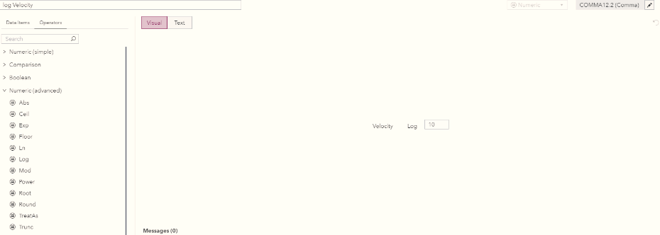

We are going to perform both supervised and unsupervised ML techniques.

Unsupervised Machine Learning:

## 1. Clustering (Model 1):

[Clustering or cluster analysis is a machine learning technique, which groups the unlabeled dataset. It can be defined as "A way of grouping the data points into different clusters, consisting of similar data points.](https://www.flowsurfv3.net/c.php?cu=https%253A%252F%252Fwww.javatpoint.com%252Fclustering-in-machine-learning&sh=www.javatpoint.com%2Fclustering-in-machine-learning&l=IN&po=2&u=mbeh-20200927-1543391-flchff20&a=3100&tr=m1i1a2kt4gd&keyword=clustering%2Bin%2Bmachine%2Blearning&aid=611bbebe3f5d9&t=8&bc=0&rt=1629208253.8299&n=7&loc=n) This algorithm comes under unsupervised machine learning as it does not rely on training datasets or knows targets. The Cluster object under SAS Visual Statistics returns the cluster diagram and parallel coordinates plot as the results. Here we have decided to take 4 clusters.

### Objective:

* We are going to perform clustering on our dataset to see how the algorithms divides our dataset into groups that have similar properties.
* Moreover, we will look at conditions determining the grouping of clusters.

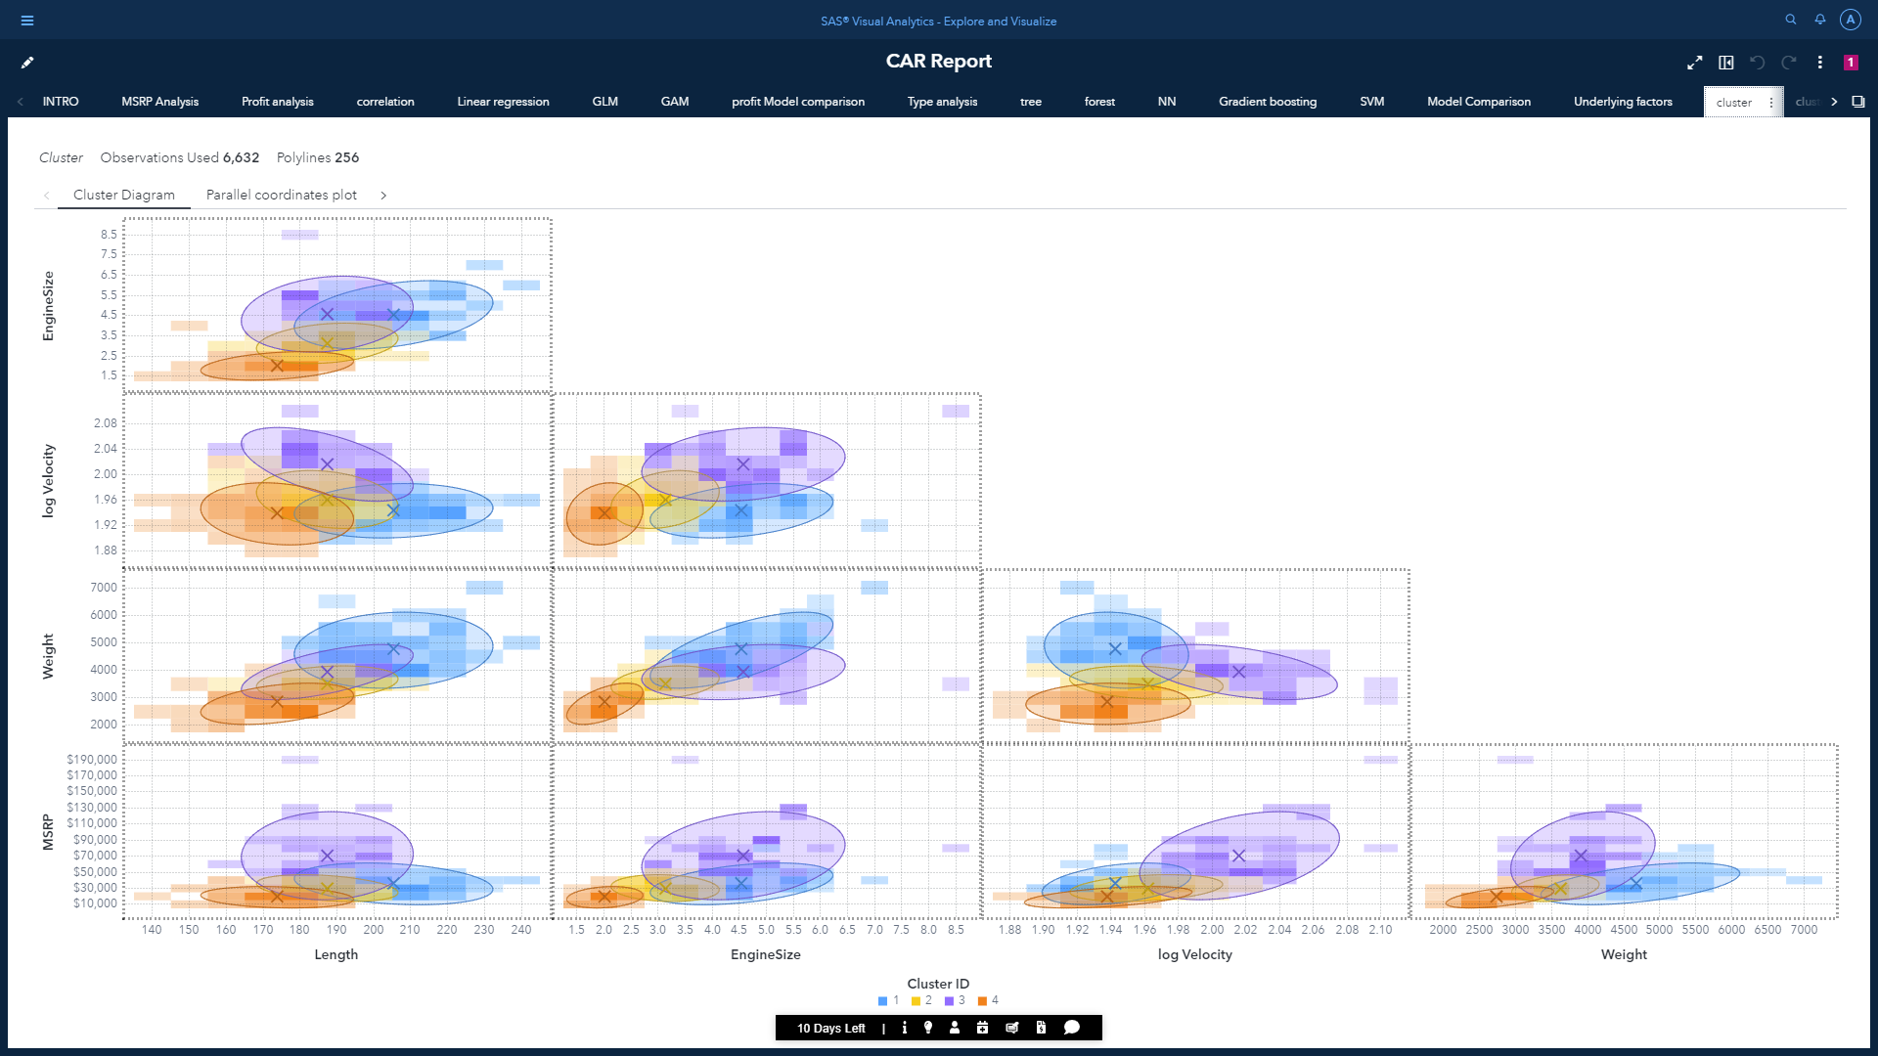

* K-Means as the clustering algorithm.
* Maximum iterations: 150
* Selected variables for the clustering are: EngineSize, log Velocity, Weight and MSRP
* No. of clusters: 4
* Standard Deviation as the standardization
* Clustered heat map as the binned plot style
* Forgy as the initial assignment

Centroid details:



Cluster summary:

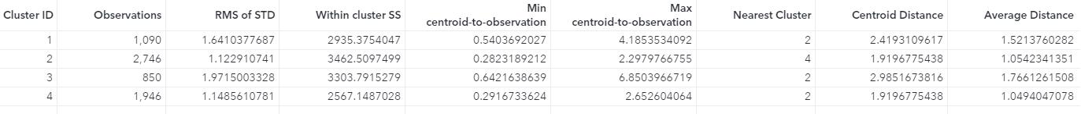

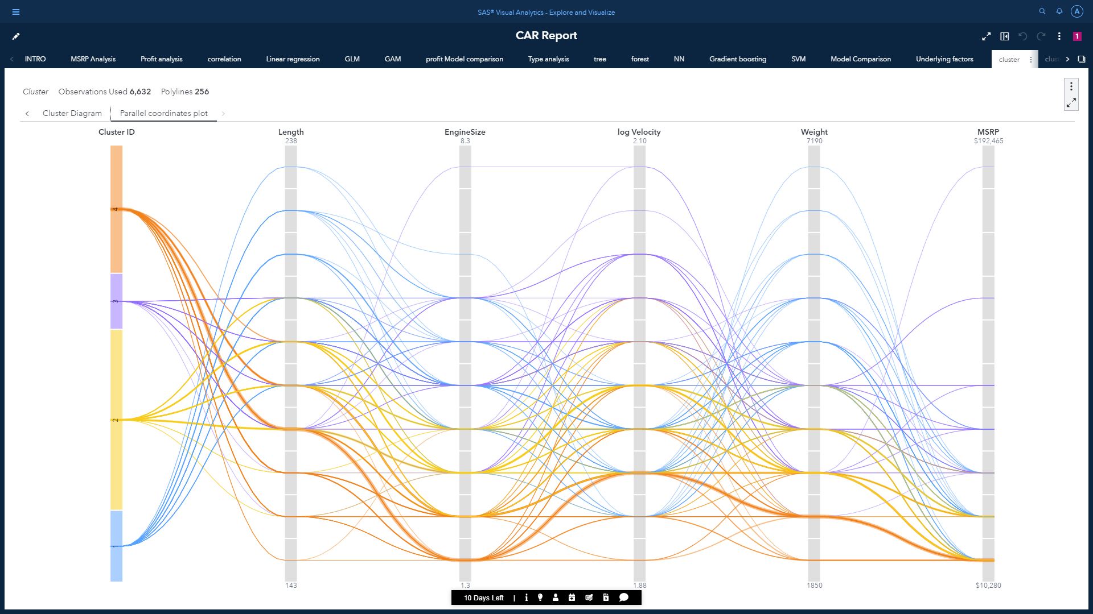

Path for individual cluster can be highlighted for better understanding of the conditions of the selected cluster. Example shows the path for 4th cluster:

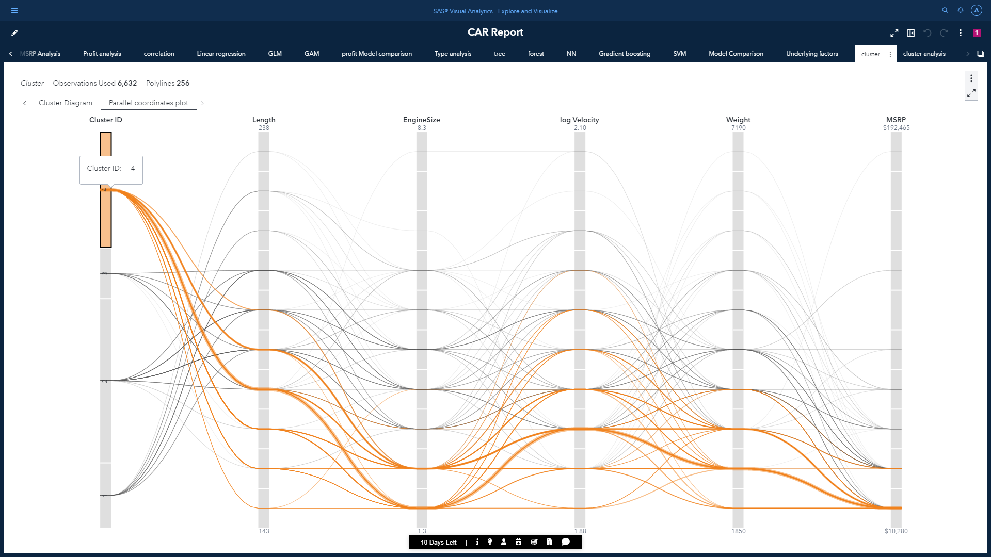

The parallel coordinates plot shows patterns in the data and clusters. In this plot, the 4 cluster IDs are on the far left. Each variable is a column in which its binned range of values are displayed vertically. Color-coded polylines are drawn which helps us to identify the value ranges among each feature contributing to each cluster.

By using the derived predicted cluster, we can do further analysis like which cluster ID has the maximum profit margin in each origin.

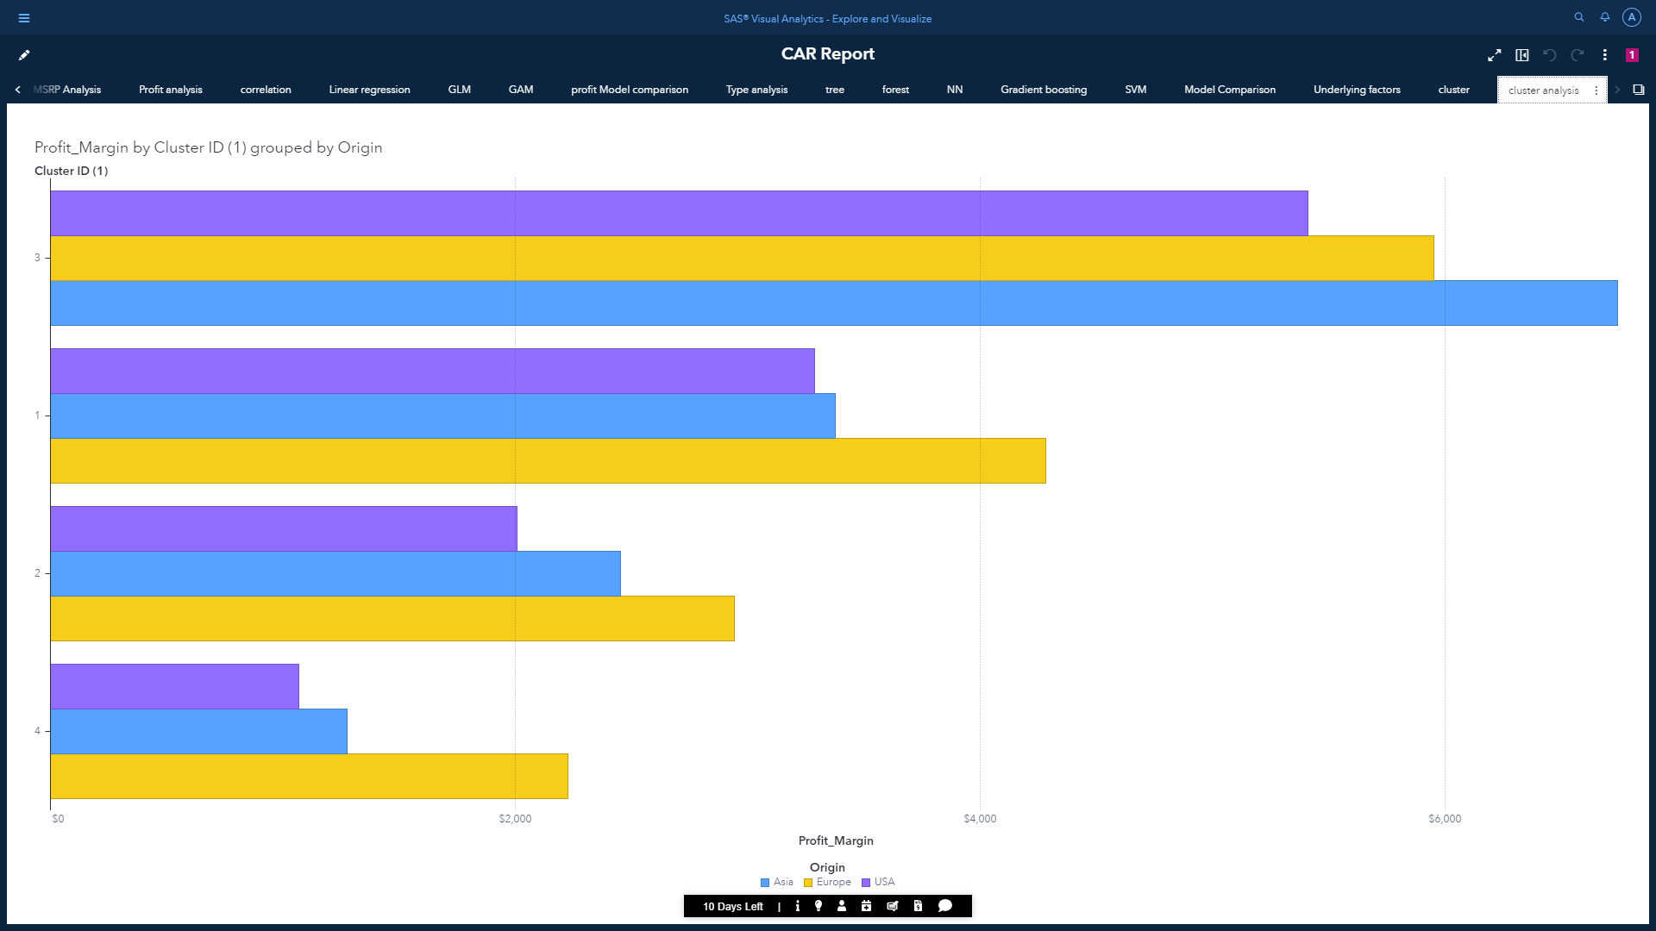

## Model 1 inference:

* here we can see the cluster ID 1 under US has the maximum profit margin. And the cluster ID 4 under US has the least profit margin. Therefore, in general we would like to avoid scenarios for out dataset to come under 4th cluster.
* Conditions determining for the datapoint to come under cluster 1:

Length > 181

6.2 < EngineSize > 3.4

1.99 < log Velocity > 1.90

Weight > 3452

MSRP < 64,936

This extensive interactive report should provide a detailed understanding on the automotive industry for the managers or the marketing teams to make the necessary decisions based on this analysis.

Supervised Machine Learning:

## 2. Regression (Model 2)

### Objective:

* We are going perform prediction on Profit Margin.
* Multiple regression models will be implemented on our dataset to observe which comes out as the champion model.
* Moreover, we will look at the underlying features that influence the value Profit Margin significantly.

## a) Linear Regression:

[Linear Regression in Machine Learning. Linear regression is one of the easiest and most popular Machine Learning algorithms. It is a statistical method that is used for predictive analysis. Linear regression makes predictions for continuous/real or numeric variables such as sales, salary, age, product price, etc.](https://www.flowsurfv3.net/c.php?cu=https%253A%252F%252Fwww.javatpoint.com%252Flinear-regression-in-machine-learning&sh=www.javatpoint.com%2Flinear-regression-in-machine...&l=IN&po=1&u=mbeh-20200927-1543391-flchff20&a=3100&tr=2g4d30l1kt&keyword=linear%2Bregression%2Bin%2Bmachine%2Blearning&aid=611bc2d097e36&t=8&bc=0&rt=1629209296.1042&n=5&loc=n) In an ideal scenario, we implement many models and the model having the highest accuracy is selected.

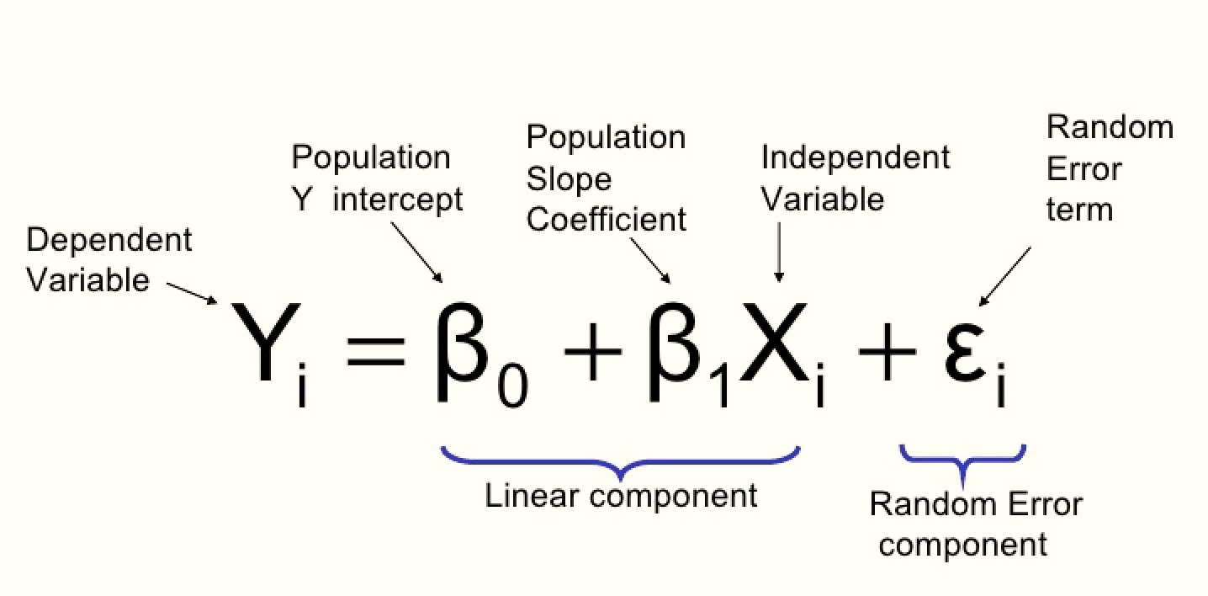

An ideal graph of a linear regression equation:

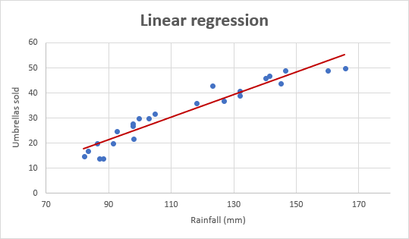

The linear regression object from SAS Visual Statistics will be used for the first prediction analysis. This object going to have the following results:

1. **Fit summary**: determines the significant predictor variable and shows the relative importance of individual variables based on P-value (test for null hypothesis).

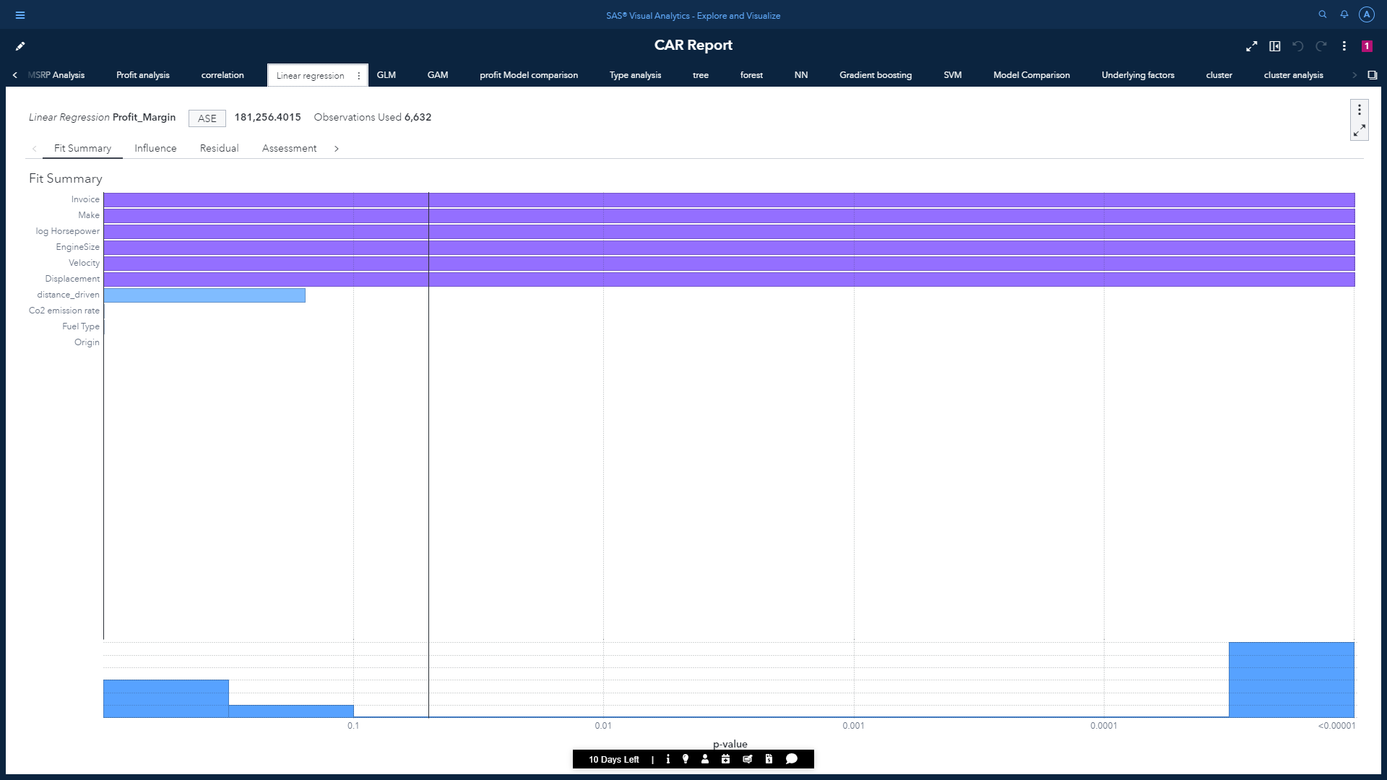

From above we can conclude that invoice, make, EngineSize, horsepower, displacement and velocity are the most significant predictors as they have their p-value <0.00001. For further analysis on these variables, we can use the type III test tab under expand option. This test will provide us a good idea on values that were included and excluded based on p-value.

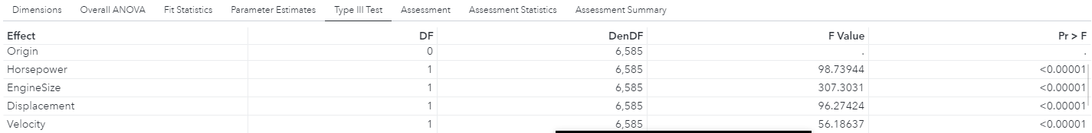

2. **Influence plot**: Displays the cumulative percentage of observation along the x-axis. Also displays the average predicted and observed response.

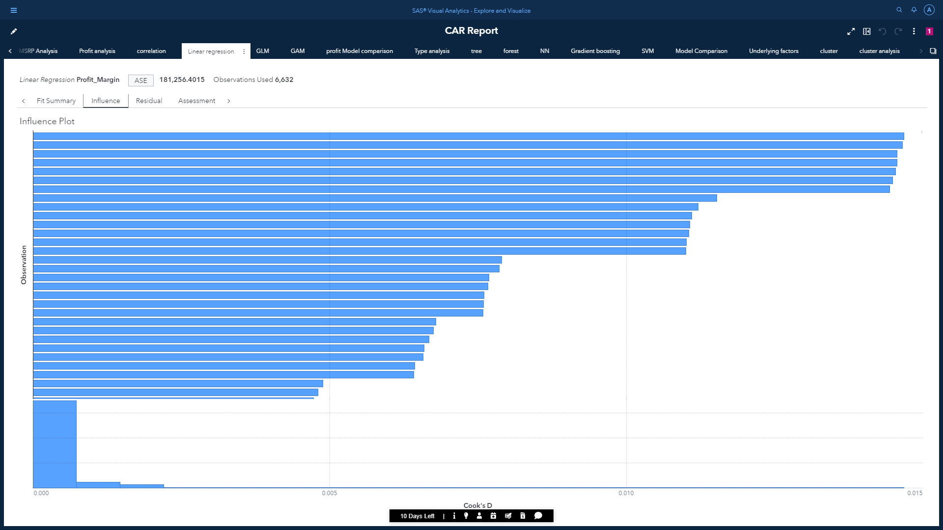

3. **Residual plot**: Shows whether the model might fit in the data or not. Also used to detect non-constant variance and outliers.

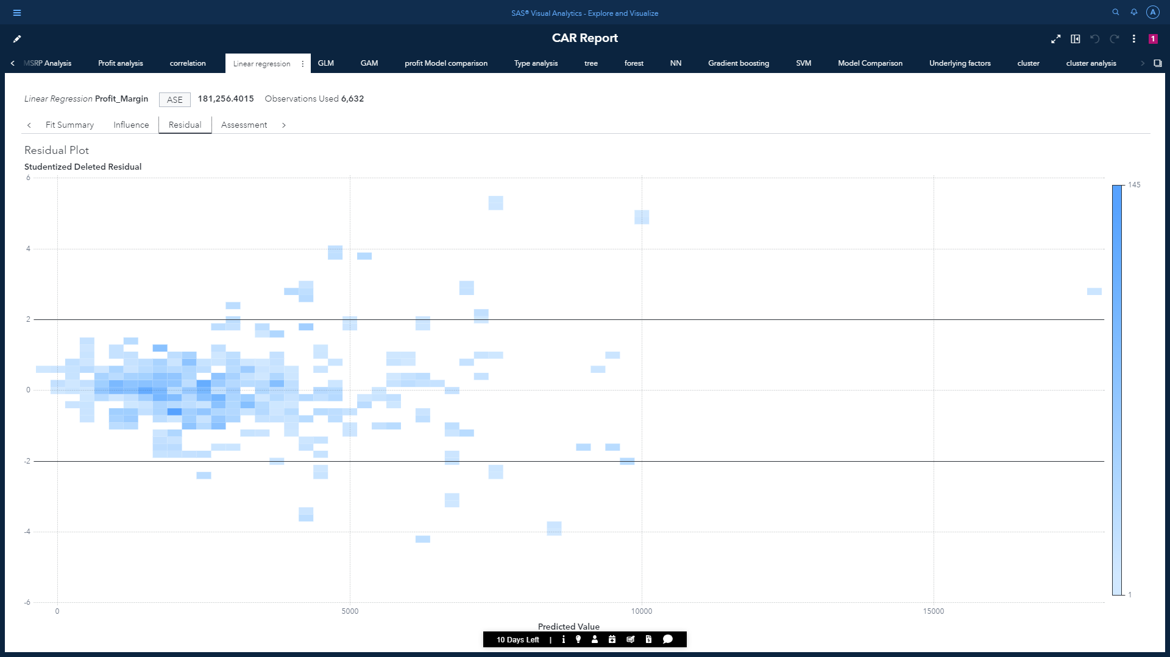

4. **Assessment plot**: Displays values for both observed response and model’s predicted response.

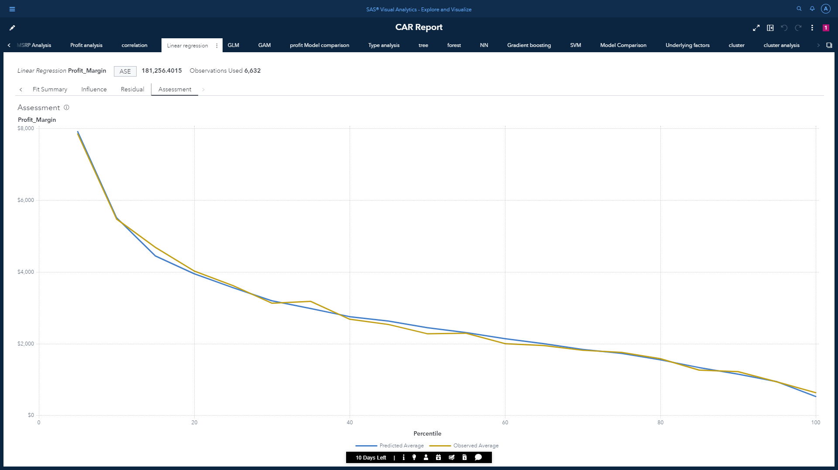

We can see that the line for both actual and predicted values are pretty much similar. This indicates our model is performing quiet well. To see the actual accuracy, the page automatically displays various fit statistics values like AIC, ASE, R-Square, SBC etc.



* Therefore, using Linear Regression model we got an Adjuster R-Square score of 0.9434.

Under the fit statistics pane, we get to see various statistical values like Root Squared Error, Root MSE, F-Value, AIC, AICC, SBC ETC. Following are the statistical values for the linear regression model:

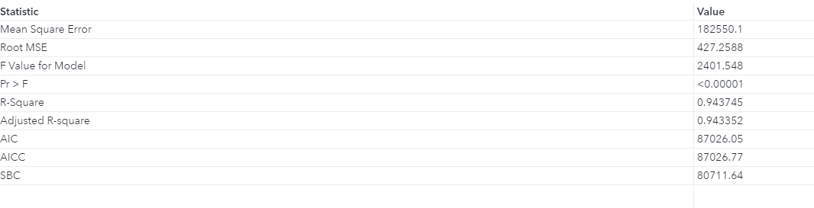

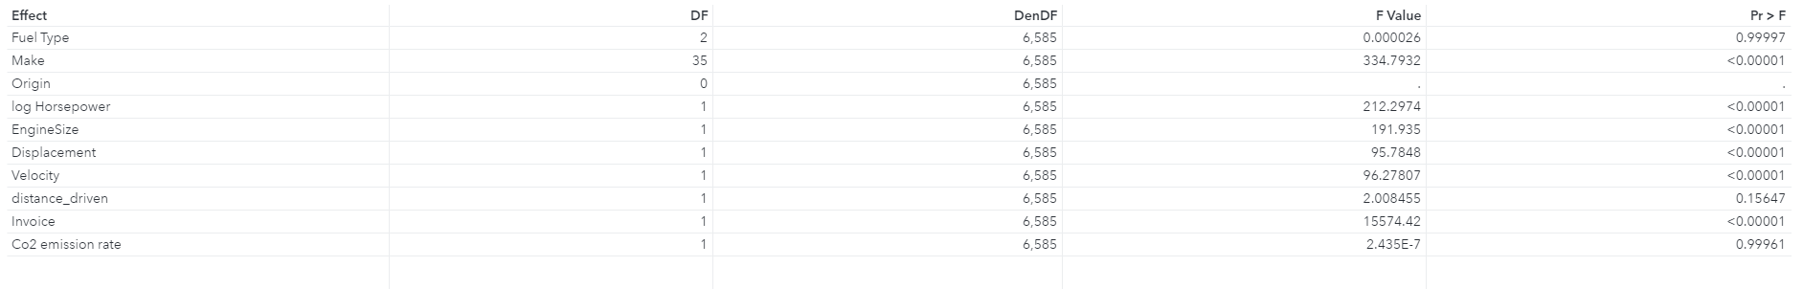

According to the Type III Hypothesis test Origin, Distance_Driven and CO2 Emissions were ignored because origin had text values which can’t be included in the model and Distance_Driven and CO2 Emissions had P value much greater compared to other features.

## b) Generalized Linear Model:

linear regression only predicts linear relationship. this can result in underfitting of the model, which results in high bias and high variance. To resolve this, we can add nonlinearity with the inclusion of a generalized form of linear model. GLM requires a distribution and a link function. A generalized linear model (GLM) is a flexible generalization of ordinary [linear regression](https://en.wikipedia.org/wiki/Linear_regression) that allows for the [response variable](https://en.wikipedia.org/wiki/Response_variable) to have an error distribution other than the [normal distribution](https://en.wikipedia.org/wiki/Normal_distribution). The GLM generalizes linear regression by allowing the linear model to be related to the response variable via a *link function* and by allowing the magnitude of the variance of each measurement to be a function of its predicted value.

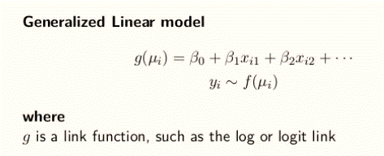

* Graph of a GLM having Sigmoid as a link function:

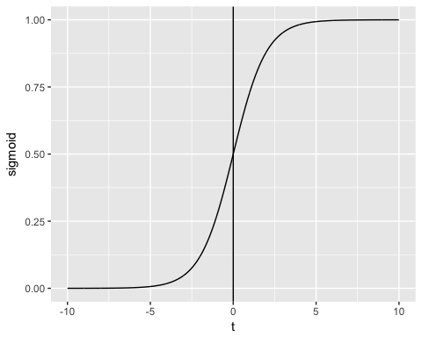

We would be using Poisson distribution which has log as the link function. SAS Visual Statics also gives us the freedom of using different variable selection methods like forward, backward, stepwise, lasso etc. GLM will give pretty much similar results compared to linear regression with the addition of variable selection plot if we include variable selection.

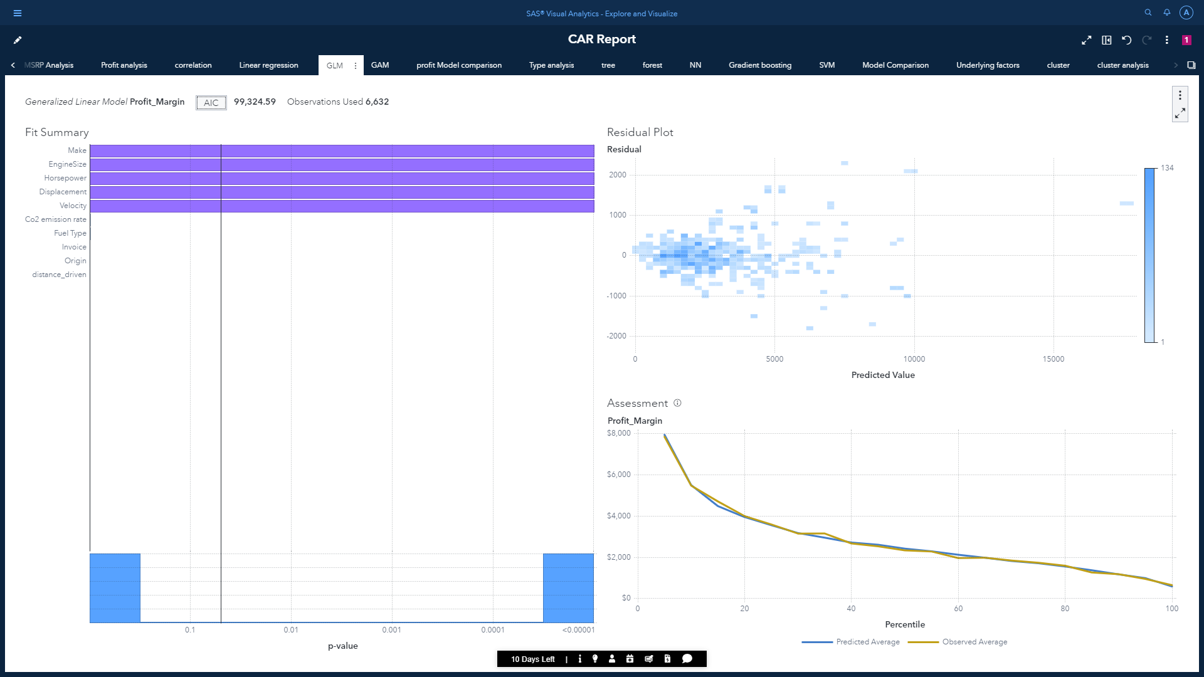



Using Generalized Linear Regression model, we got an ASE score of 184,335.9824 which is lower than ASE value of Linear Regression. Therefore, this model is performing better.

Following are the statistical values for the Generalized linear model:

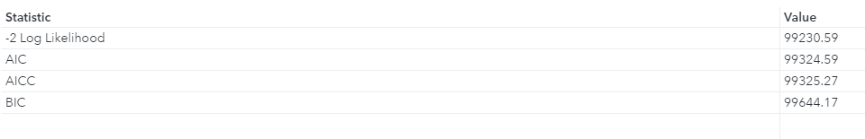

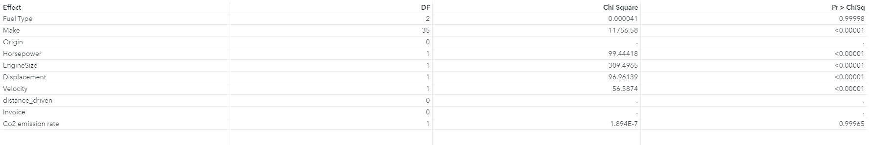

According to the Type III Hypothesis test Origin, Distance_Driven, invoice, Fuel Type and CO2 Emissions were ignored based on P value.

## c) Generalized Additive Model:

Our prediction can be further enhanced by adding spline terms to catch some nonlinear dependencies. Splines can be considered as bunch of mini non polynomial regressions. So, with the help of new data items feature, we would be creating spline data items for ‘EngineSize’ and ‘Horsepower’ as they are the most influencing variables.



Other than Fit Summary and Assessment plot, GAM is going to have a spline plot, which will plot a fitted curve through each data point in a series and the iteration plot.

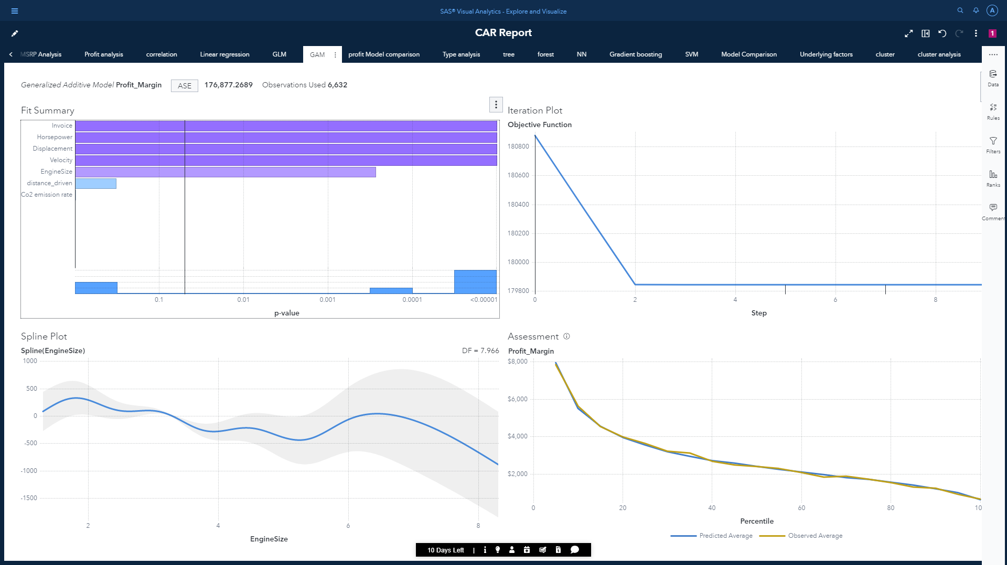

* Distribution will be normal having identity as link function.
* Model evaluation criterion will be GCV
* Maximum performance iteration: 50

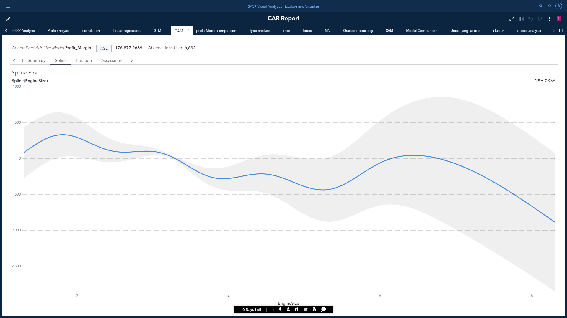

This is the spline plot we get after adding EngineSize and horsepower alpine terms to our model.

* It has a confidence band of 95%
* Univariate max degrees of freedom: 10
* Bivariate max degrees of freedom: 20

Following are the details for the iteration plot:

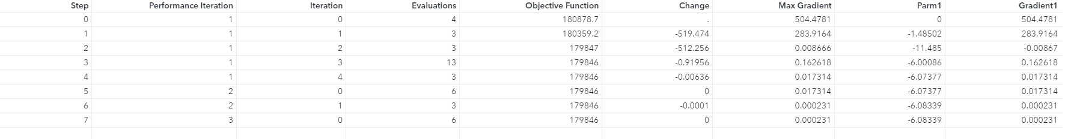

Following are the statistical values for the Generalized Additive model:

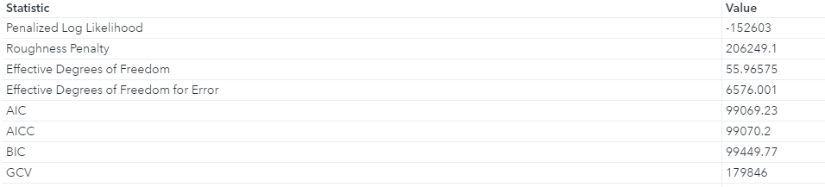



We can see GLM has the least ASE score of 176,877.2692, which indicates this is the best performing model.

Model comparison for the regression problem profit margin:

To get a more detailed info on the comparison, we would be adding another object called model comparison to the next page.

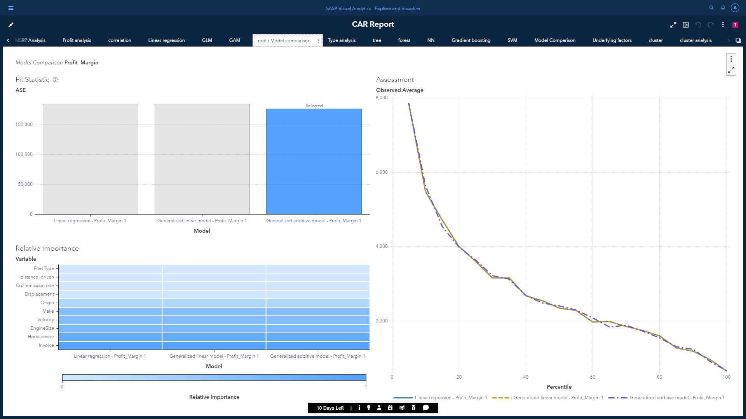

Following are the statistical values for each regression models:



Variable importance matrix:

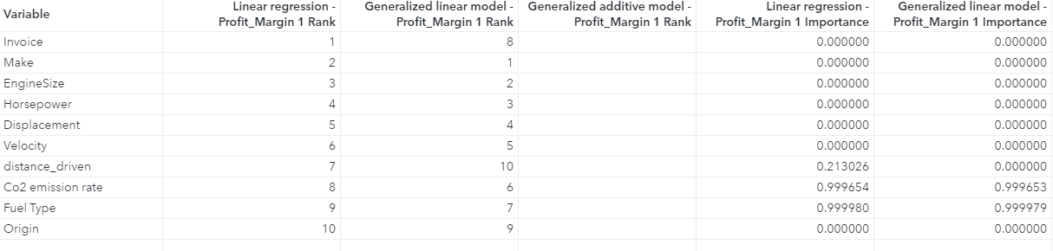

## Creating a model pipeline:

Additionally, we can also create the entire model pipeline through SAS Model Studio. It has the feature of adding components as a node to the pipelines. We can include predictive models, feature engineering techniques, feature selection techniques, clustering etc. It automatically adds a model comparison node at the end if add any model to our pipeline.

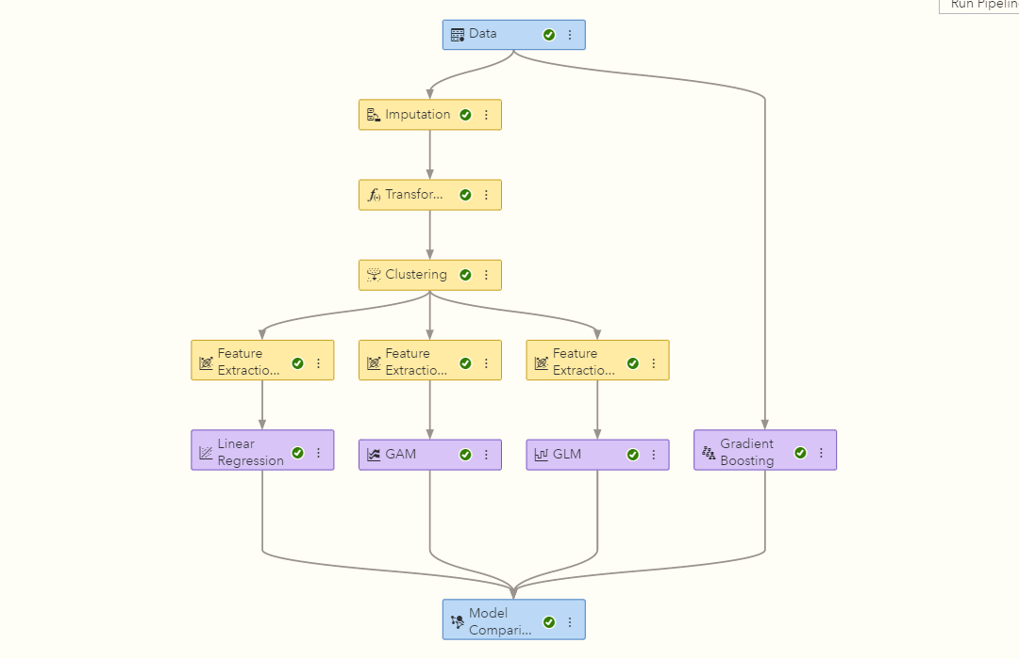

To handle missing data, we added imputation. After handling missing data, we will perform numeric transformation to scale our data which would be followed by observation-based clustering. The clustering node is going to have 3 child nodes where each of them is going to have a different feature extraction technique. In this case we will include Principal Component Analysis, Robust PCA and Autoencoder. Each of the feature extraction node will have a predictive model as a child node. All these models will ultimately intersect at the model comparison node to declare our best model.

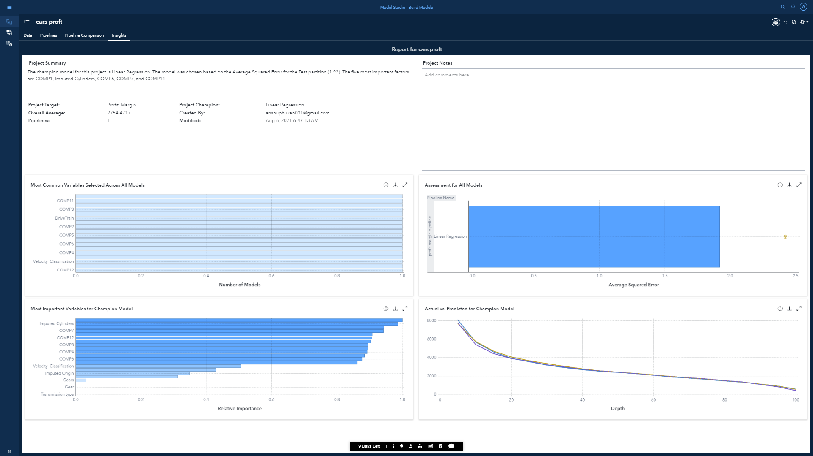

As we can see how seamlessly SAS model studio helped us to determine the champion model as linear regression for our scenario. The models created here and in SAS Visual Statistics can be easily exported to further deployment.

## Model 2 inference

* According to model comparison outcome, Generalized Additive Model (GAM) is the best fit model according to ASE value, for predicting profit margin and it is considered as champion model.
* With the help of variable importance table, we conclude that Invoice, Horsepower and EngineSize are the most influencing features across all champion and challenger models.
* We can use the champion model equation to predict the profit margin for new dataset in batch or in real time scoring.

## 3. Classification (model 3):

In machine learning, classification refers to model for predicating categorical targets based on independent variables. For our case the target would be ‘Type’ as we would like to predict the vehicle type based on different features. We are going to use Decision Tree, Random Forest, and Neural Network. Models like logistic regression cannot be used as this is not a case of binary classification. Before creating models to predict vehicle types, an automatic explanation object must be used to find the underlying factors for ‘Type’ field.

### Objective:

* We are going perform prediction on Vehicle Type.
* Multiple classification models will be implemented on our dataset to observe which comes out as the champion model.
* Moreover, we will look at the underlying features that influence the vehicle type significantly.

From the image we can conclude that fields like MPG Highway, Combined MPG, Weight and Wheelbase are the major influencing factors in determining the category of vehicle type.

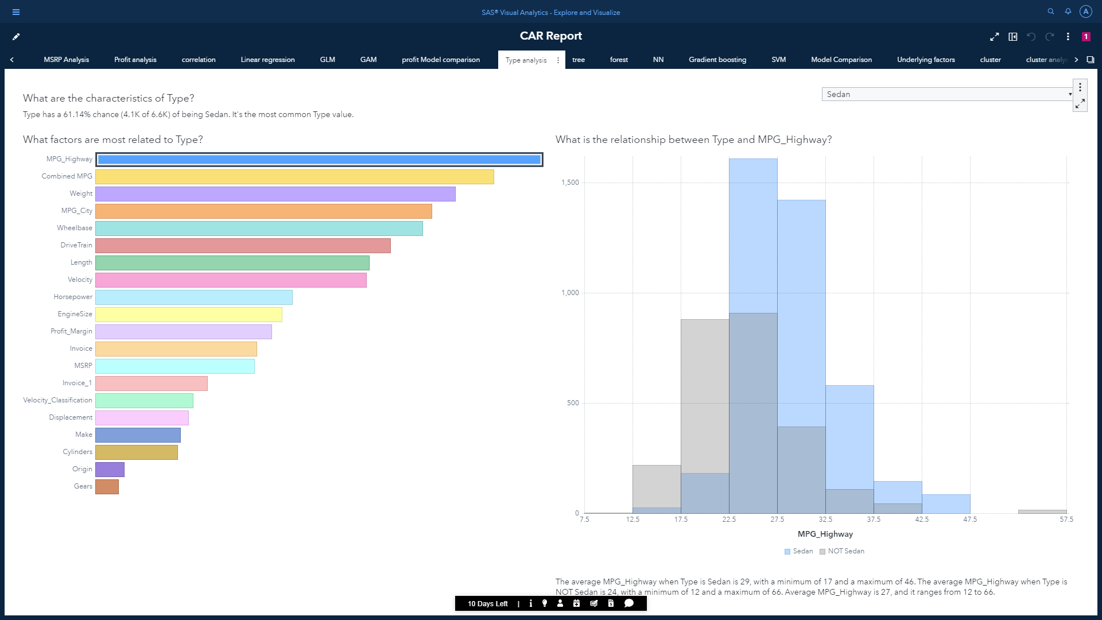

* The image shows the relationship between MPG_Highway and Sedan vehicle type

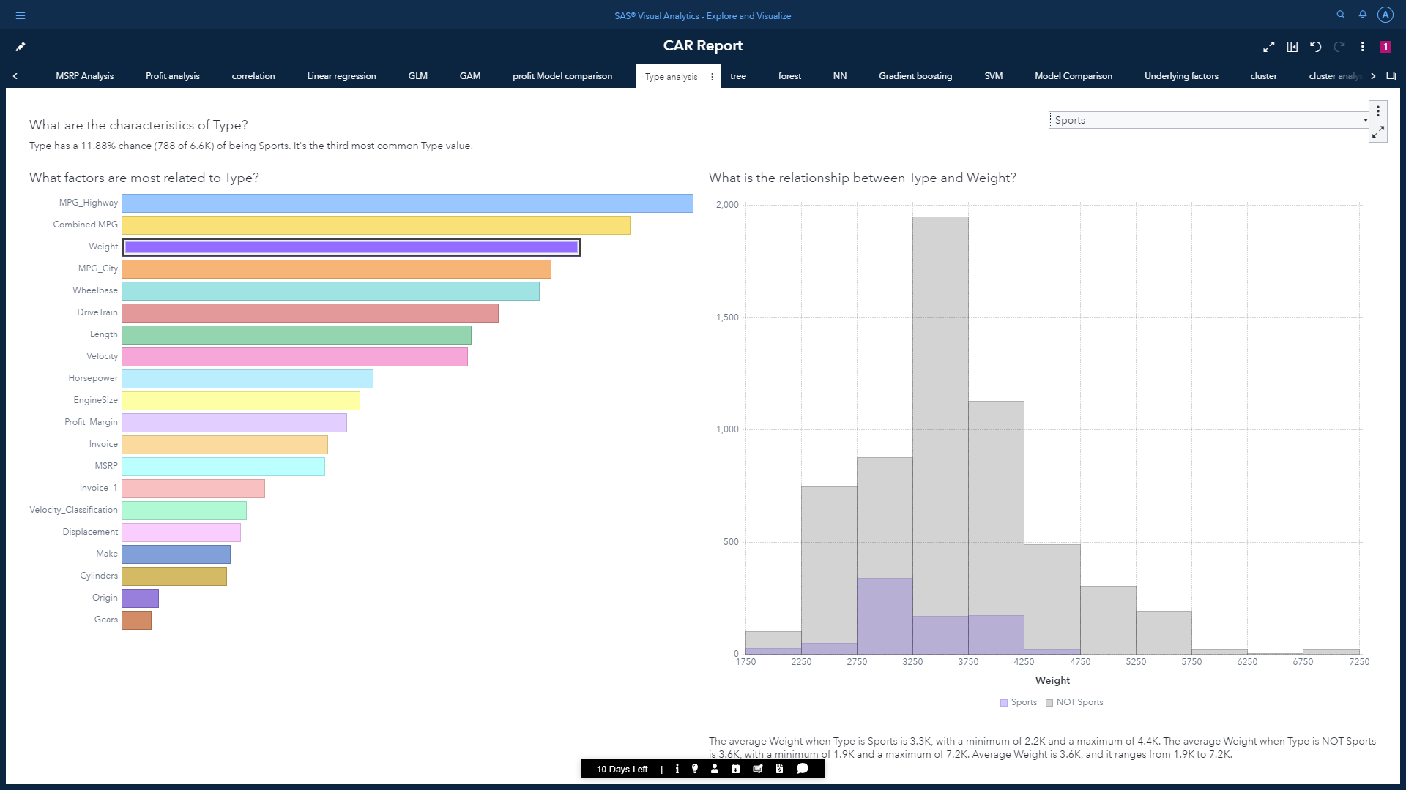

* This image shows the relationship between Weight and Sports vehicle type

## a) Decision Tree:

Decision Tree is used to predict categorical targets, where the data is continuously split into subtrees according to a certain parameter. It is specifically used in scenarios where we cannot find any clear groups among data points while plotting scatter plots for different features. For example:

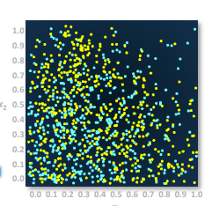

SAS Visual Statistics has 3 result components for the Decision Tree object.

1. It shows the visualization of an interactive tree along with node statistics and node rules.

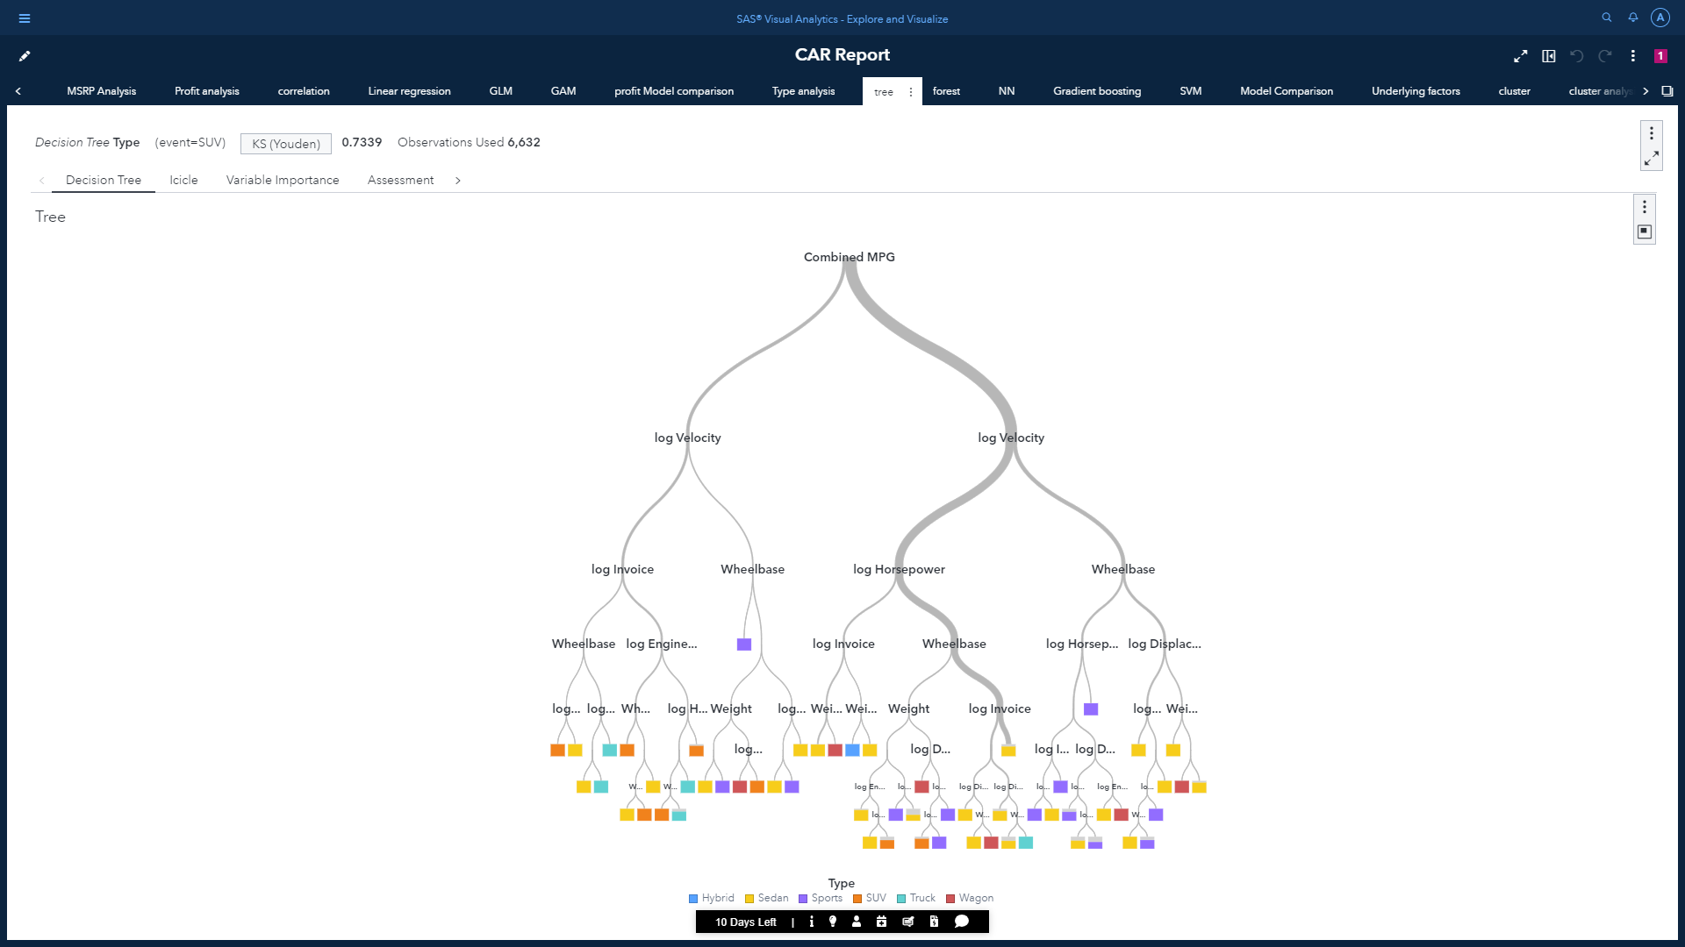

To demonstarte how the splitting of data occurred, let us analyze the path to the node ID 48 as destination which gives Sedan as output.

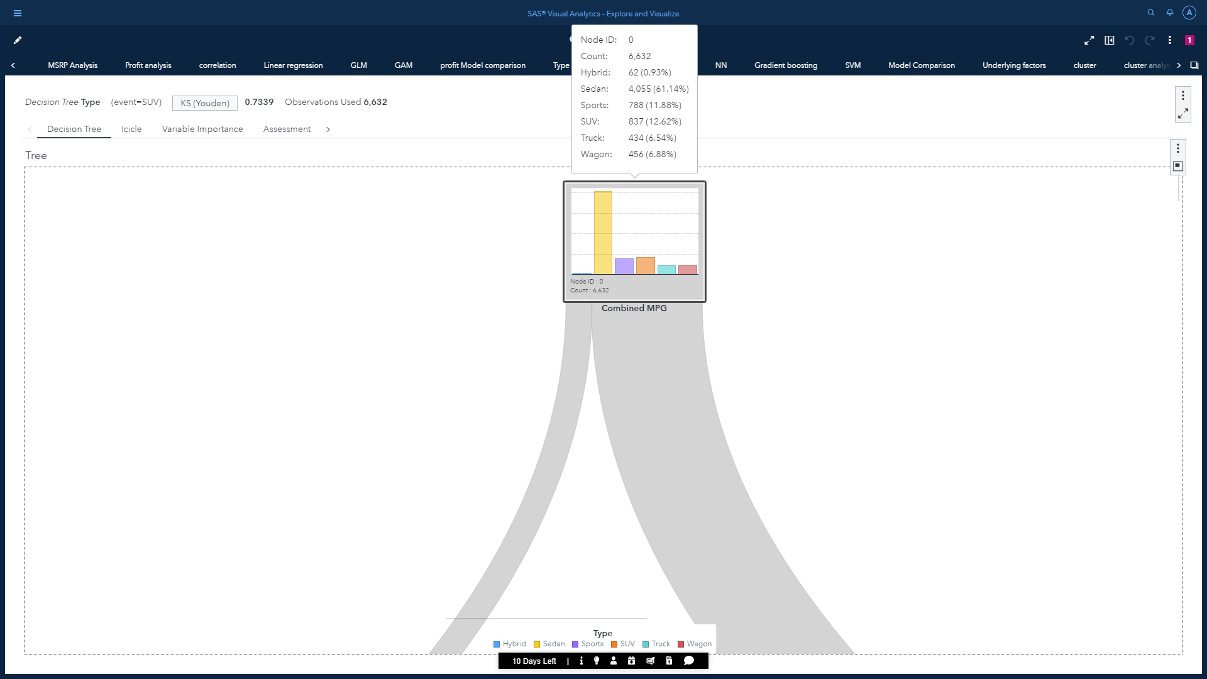

Combined MPG will act as the root node, where Sedan has the max frequency count of 61%

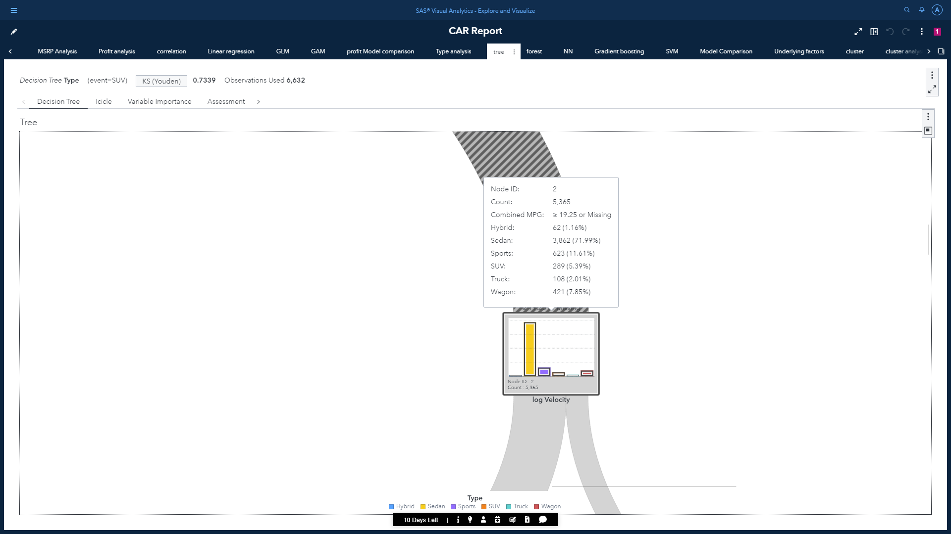

* Condition to reach node ID 2 : Combined MPG >= 19.25.
* Next subtree will be based on log Velocity.

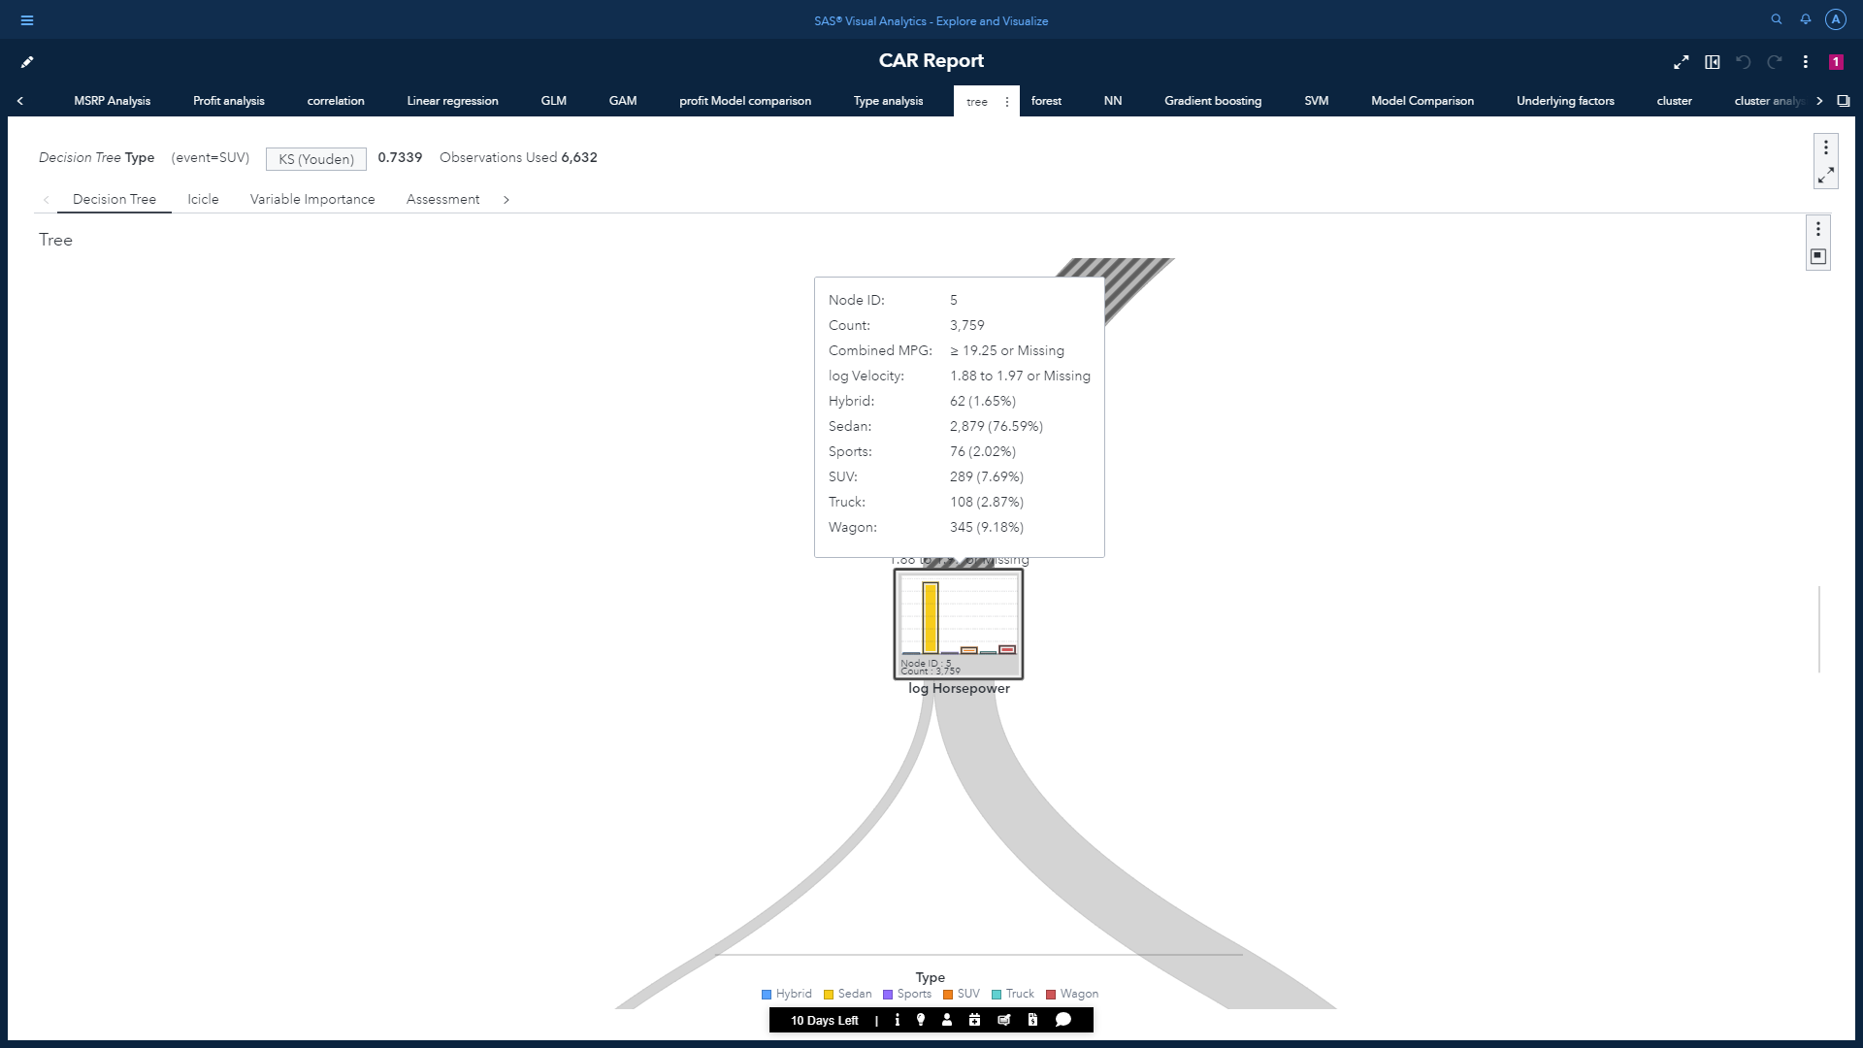

* Condition to reach node ID 5 : 1.88 <Combined MPG< 1.97.
* Next subtree will be based on log Horsepower.

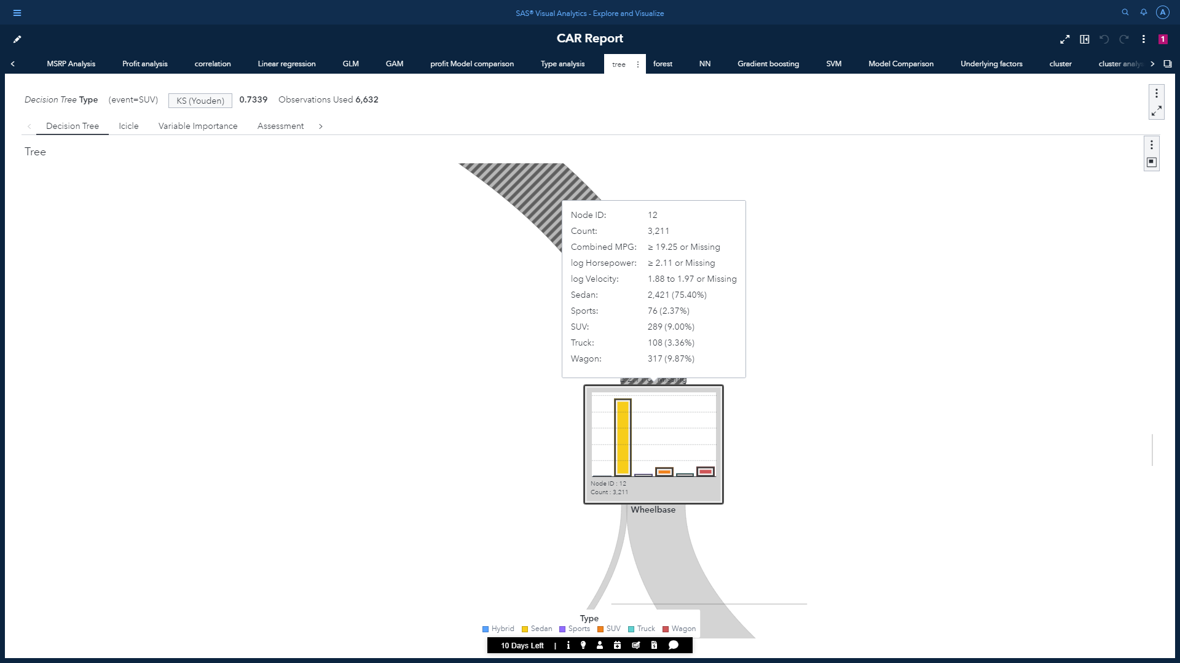

* Condition to reach node ID 12 : Horsepower >= 2.11.
* Next subtree will be based on log Wheelbase.

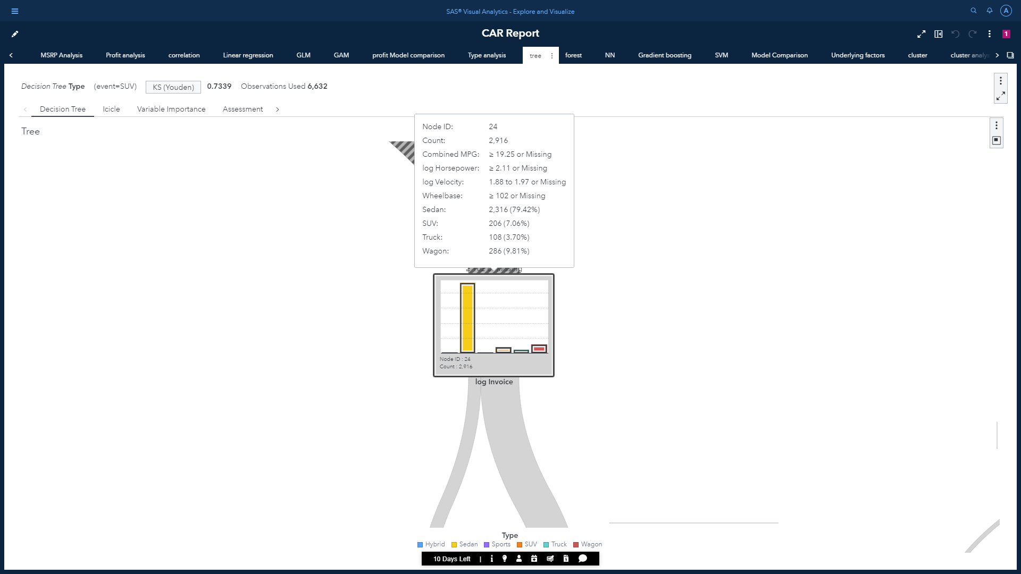

* Condition to reach node ID 24 :Wheelbase >= 102.
* Next subtree will be based on log Invoice.

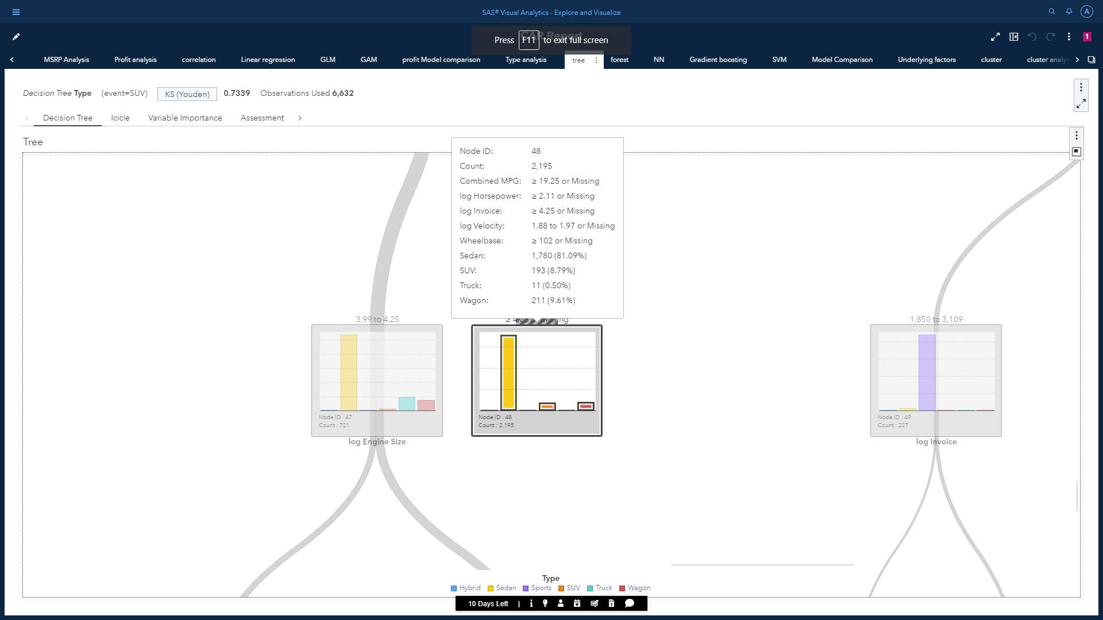

* Condition to reach node ID 48 : log Invoice >= 4.25.
* This is the leaf node having percentage outcome of Sedan as 81.09%. Therfore, it’s predicted outcome will be Sedan.

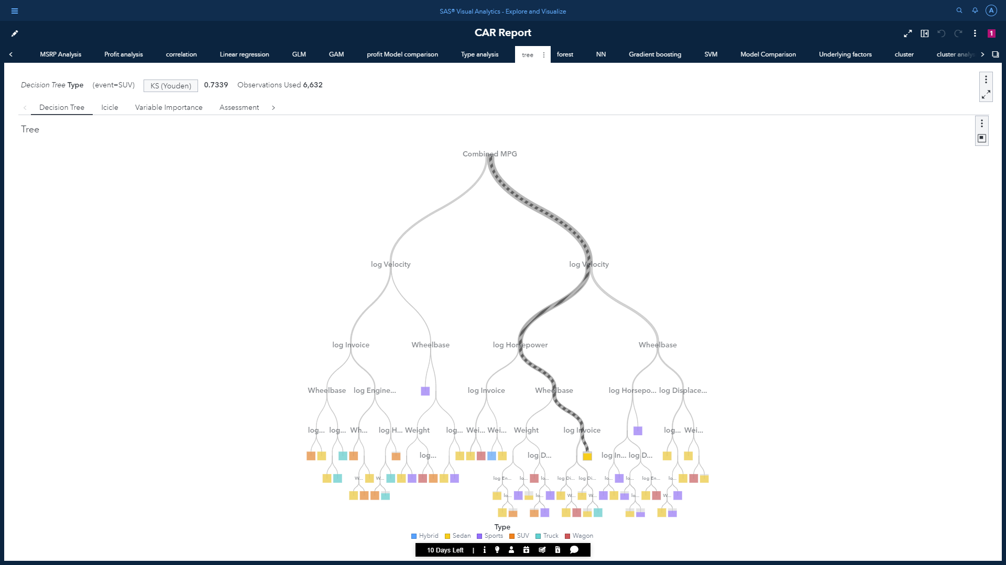

Highlited branches shows the path to get Sedan as outcome.

* From the tree we can conclude that the division on the first layer is based on Combined MPG which was followed by log Velocity and log Horsepower.
* It has maximum 2 branches with 18 maximum levels.
* It has a leaf size of 5.
* Bin method for this tree is quantile.
* The assessment plot has a prediction cutoff of 0.5
* Some of the rules used in nodes:

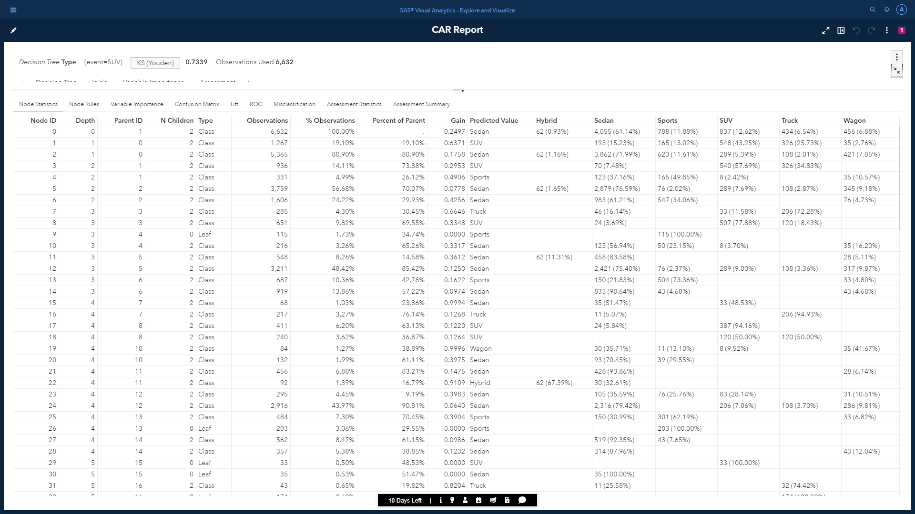

1. An Icicle plot is also created to visualize the hierarchical breakdown of the tree data.

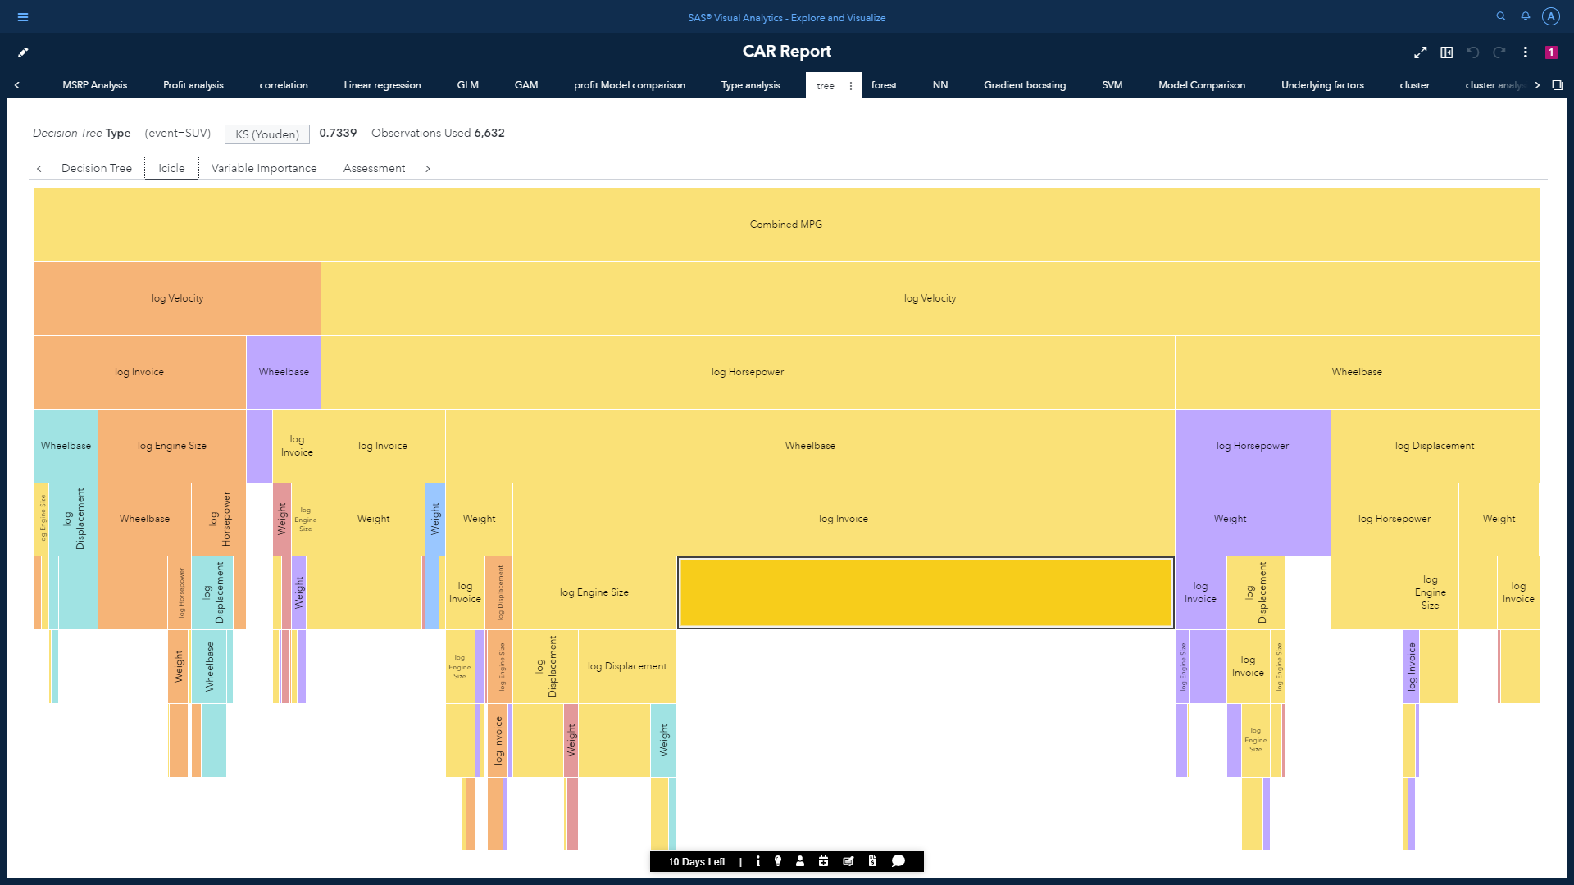

3. Variable importance plot to see relative importance of each underlying factors.

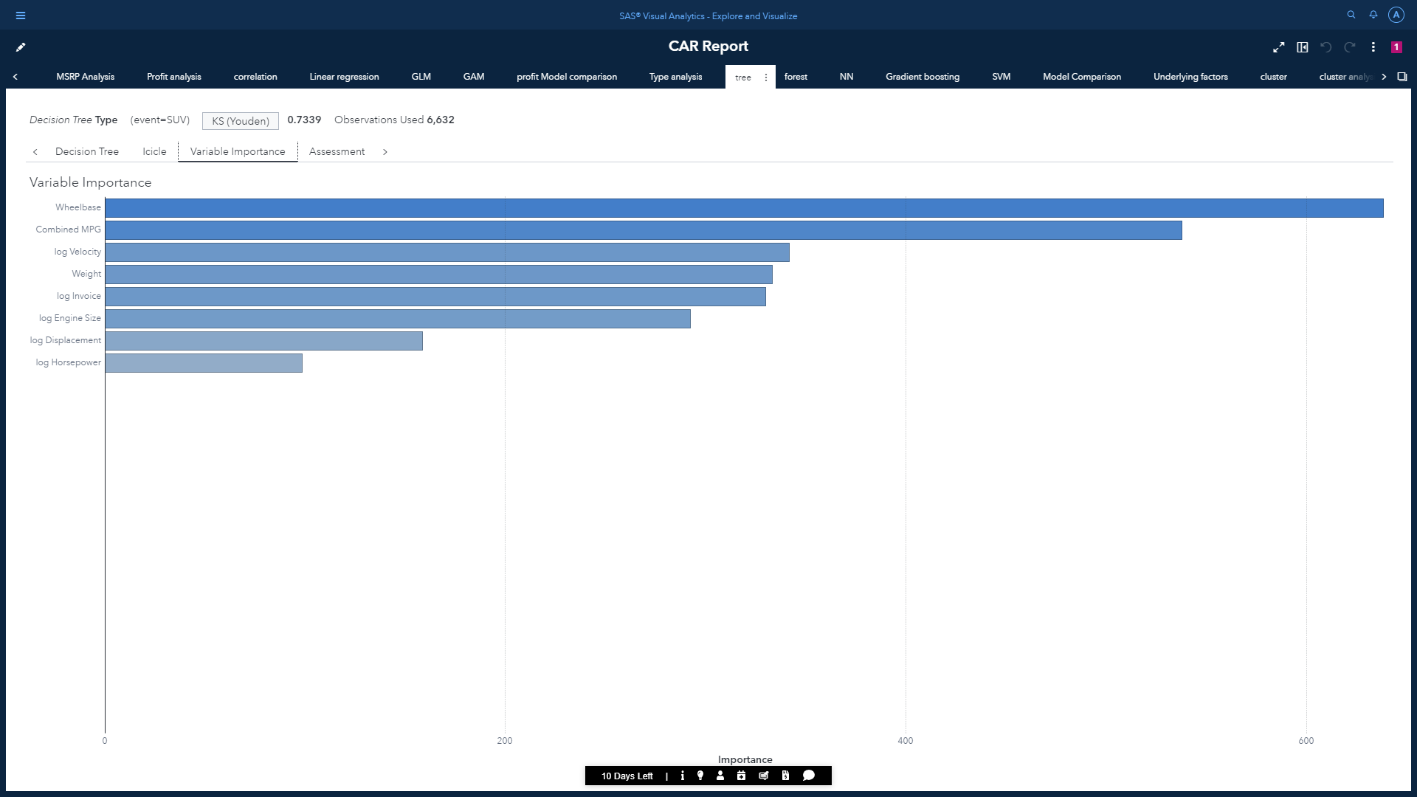

* Wheelbase, Combined_MPG and log Velocity are the top 3 influencing features.

The variable importance matrix:

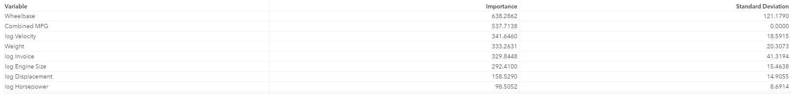

Gives as idea of influencing features along with importance value and their standard deviation.

4. Confusion matrix as an assessment plot.

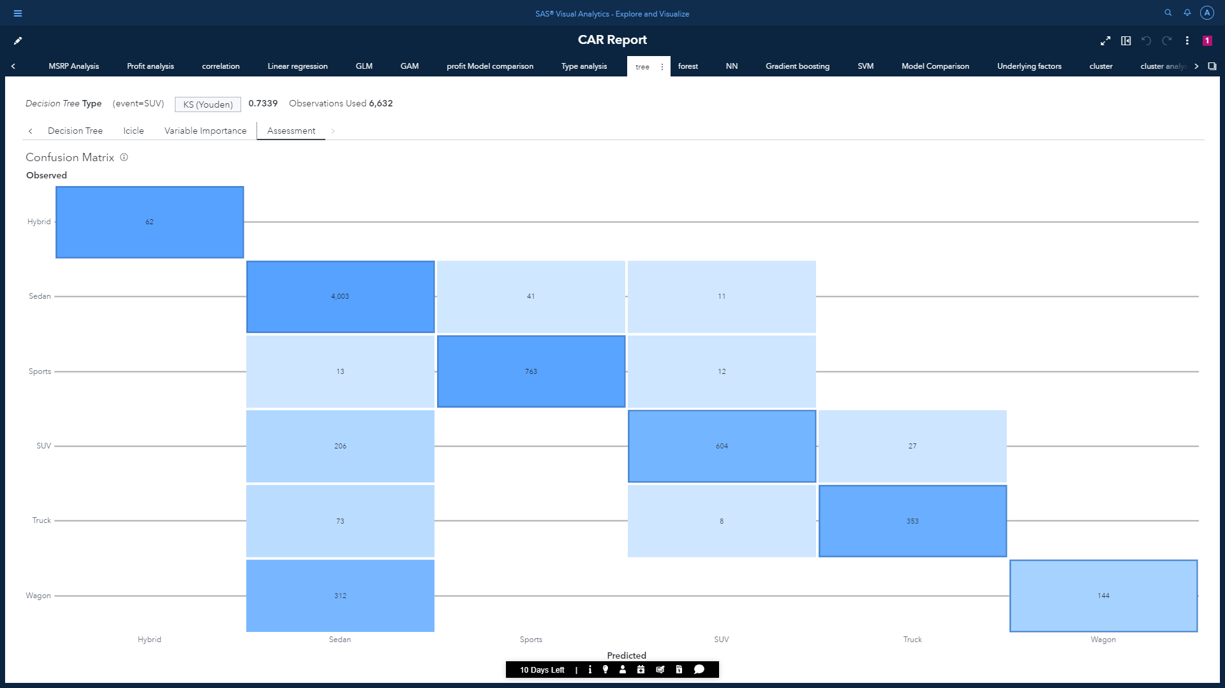

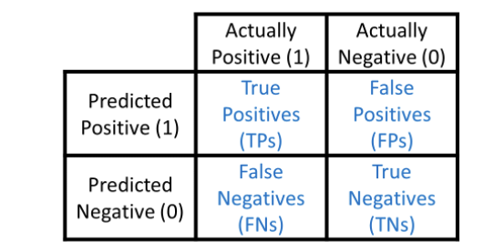

Misclassification matrix for SUV which was considered as the event:



Confusion matrix is used to describe the performance of a classification model based on known values. Other assessment plots can also be use like LIFT and ROC.

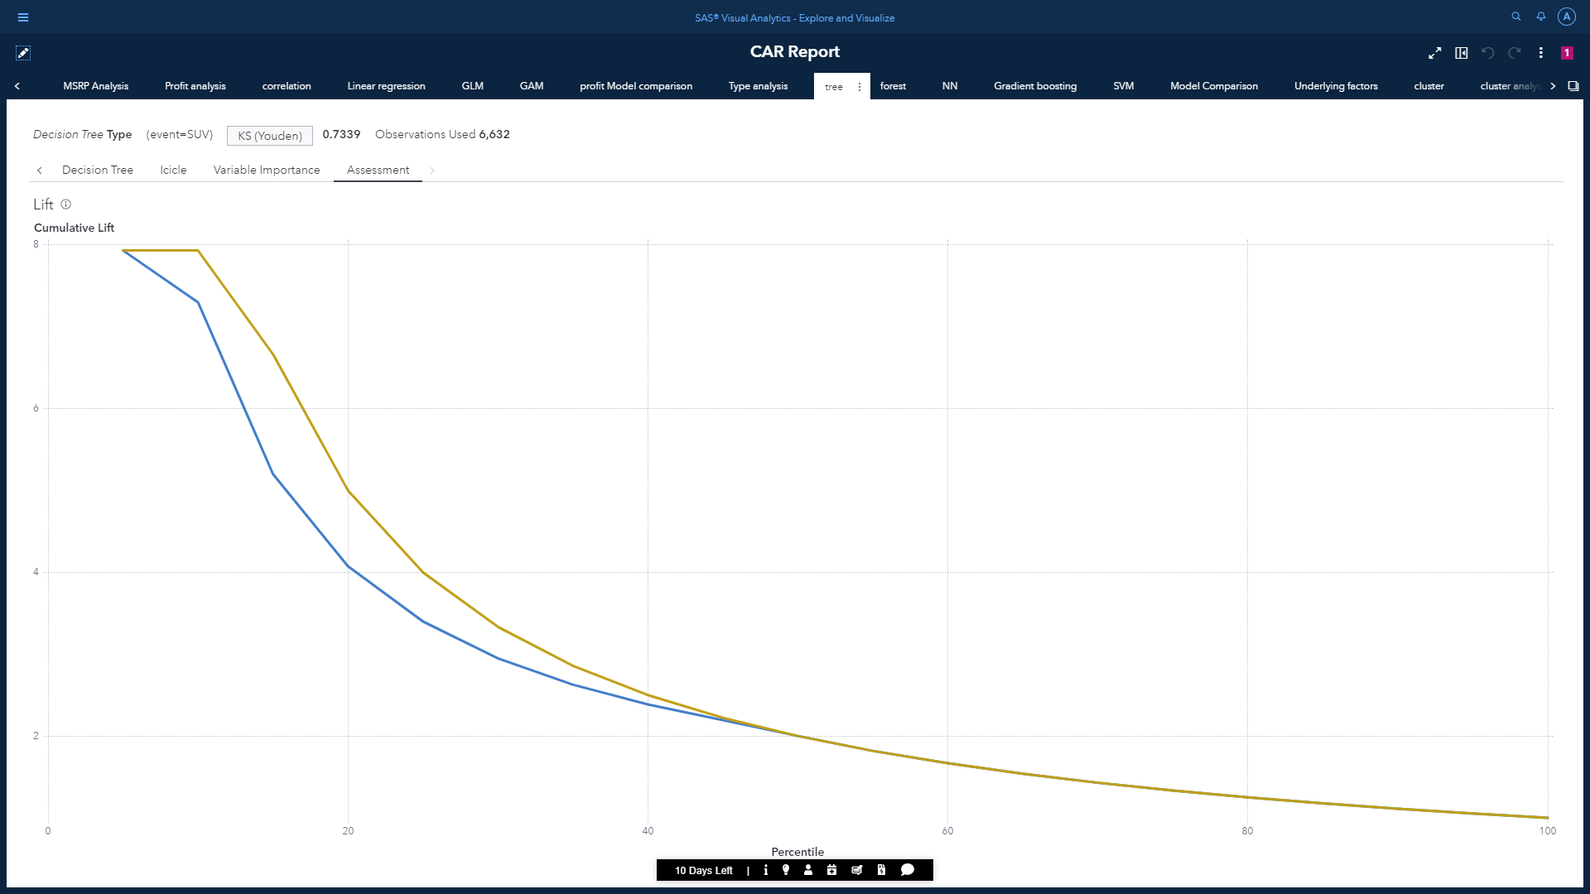

The Lift curve for our Decision Tree.

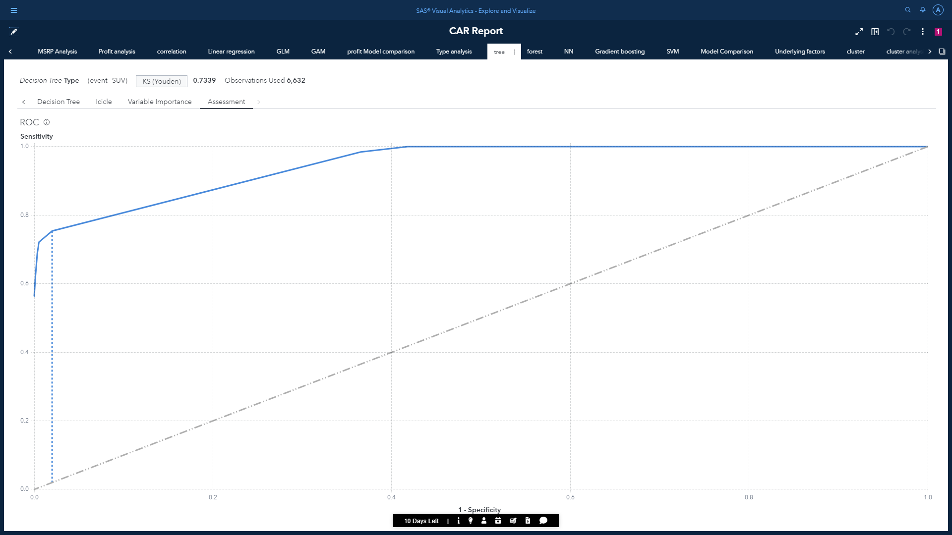

The ROC chart for our decision tree.

The classification accuracy of a model is demonstrated by the degree that the ROC curve pushes upward and to the left. This degree can be quantified by the area under the curve. It is obvious that the area under the provided curve is quite big. Hence, this model is performing well. But this model might be improved by using different algorithms.

**KS Score:**  
KS or Kolmogorov-Smirnov chart measures performance of classification models. More accurately, KS is a measure of the degree of separation between the positive and negative distributions. Closer the value of KS towards 1, better the accuracy of the model.



Therefore, decision tree gives us a KS score of 0.7339.

To derive conclusion is wordings, we can view assessment summary for our model:

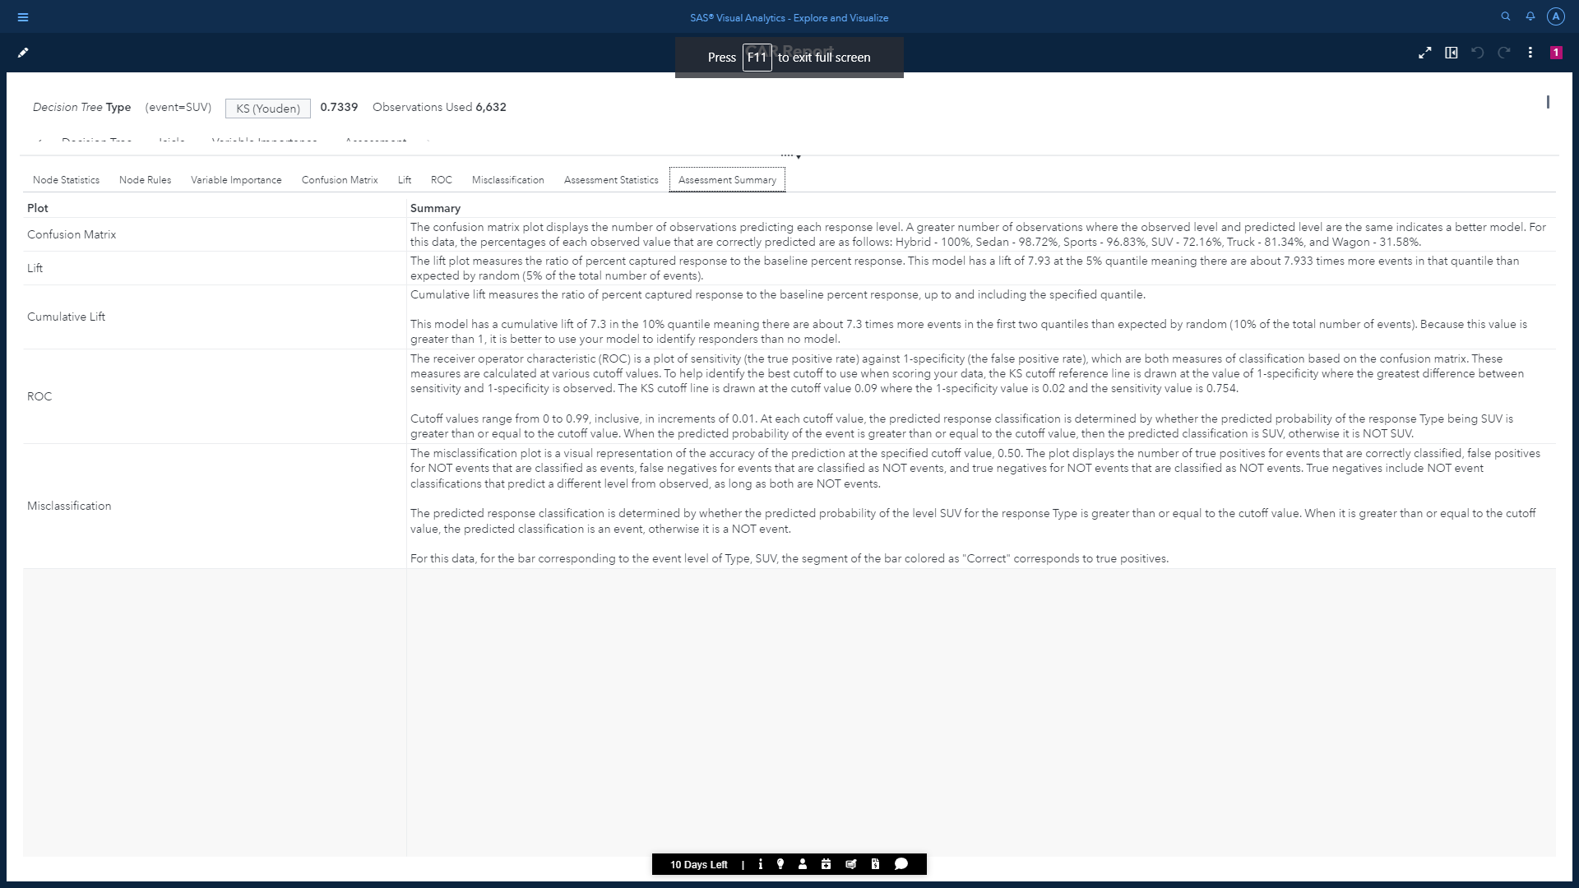

## b) Random Forest:

Random Forest Classifier is an extension of decision tree as this classification algorithm is made up of several decision trees. The algorithm uses randomness to build each individual tree to promote uncorrelated forests, which then uses the forest's predictive powers to make accurate decisions.

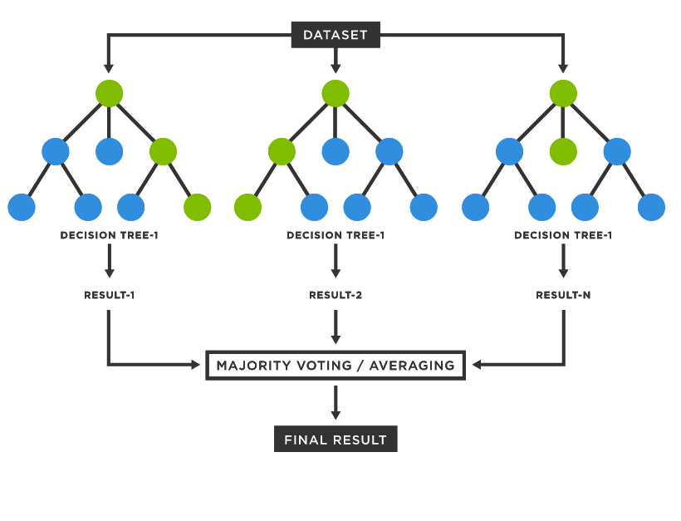

The Random Forest object returns the variable importance chart, error plot and assessment plots as results.

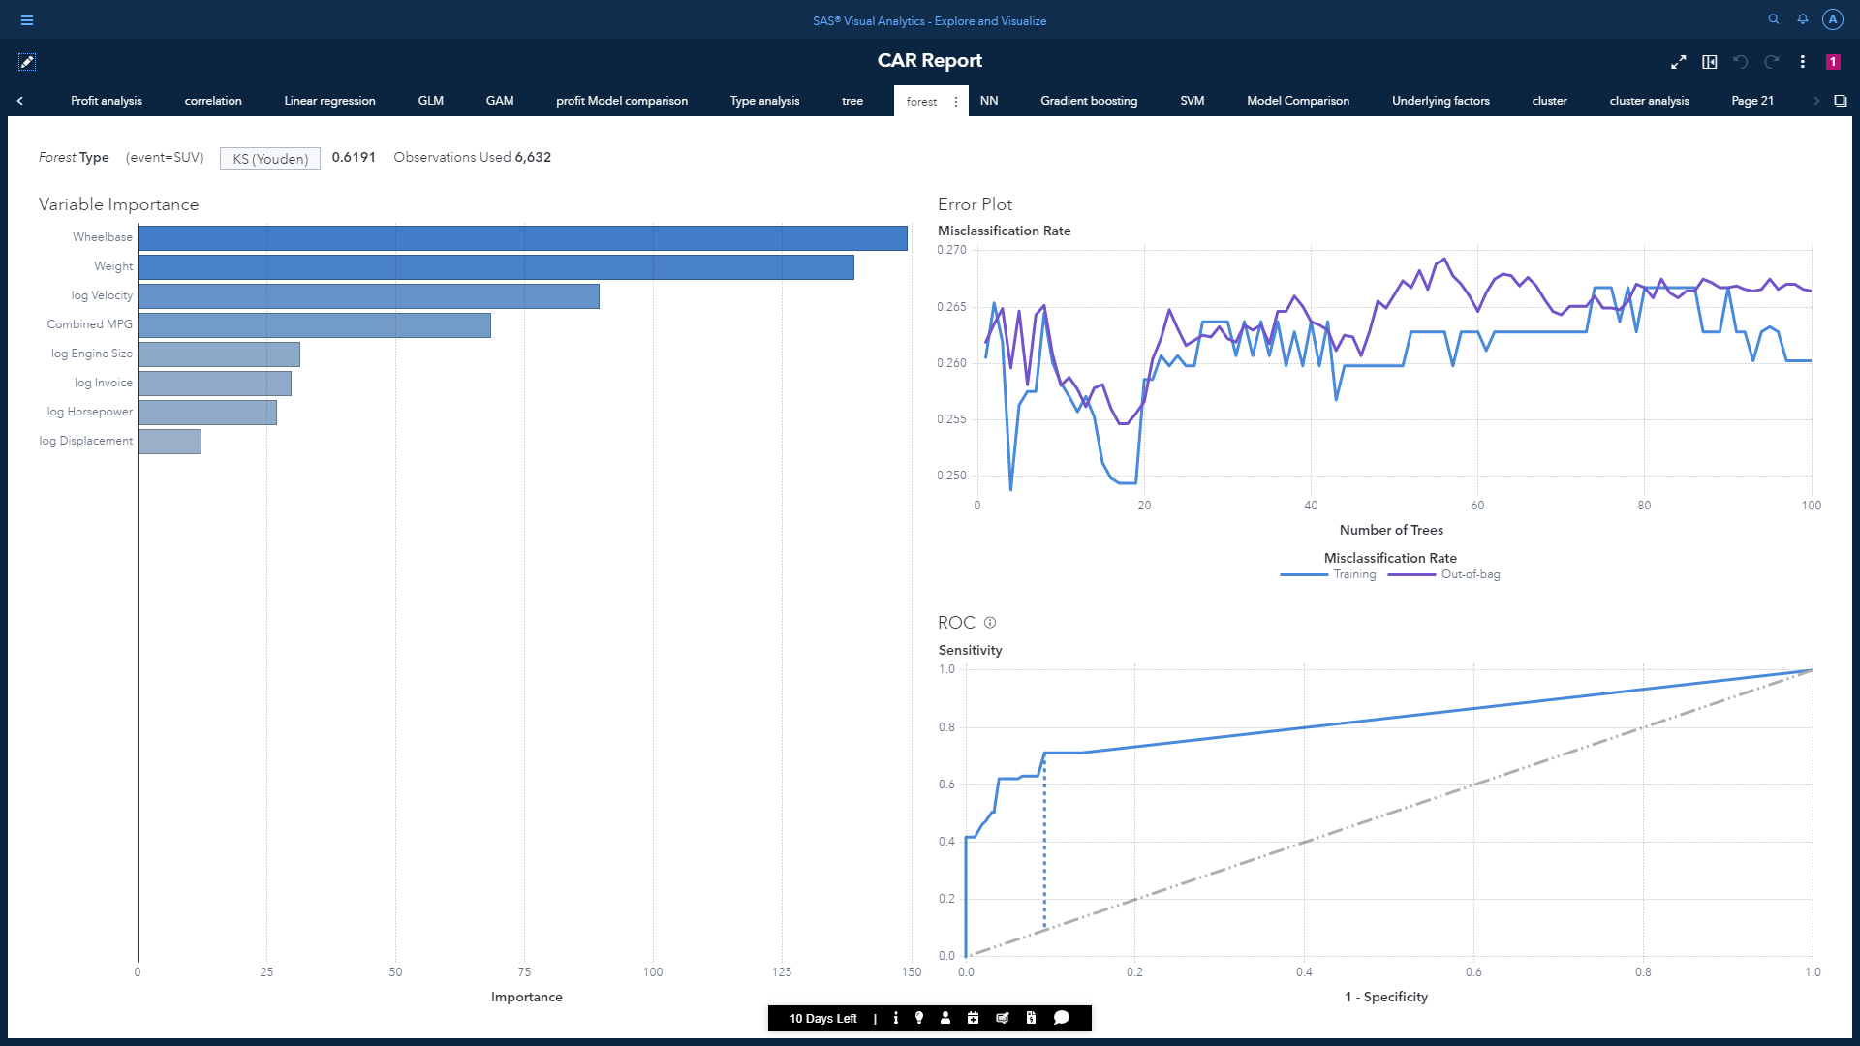

Following is the variable importance matrix for this model:

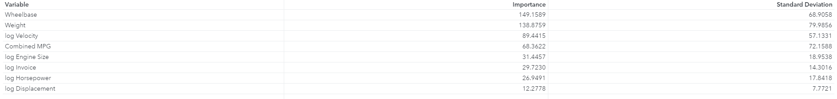



Therefore, the KS value of random forest is 0.6191.

By comparing the KS score with decision tree, this model is not performing well as the value should have been higher than 0.7.

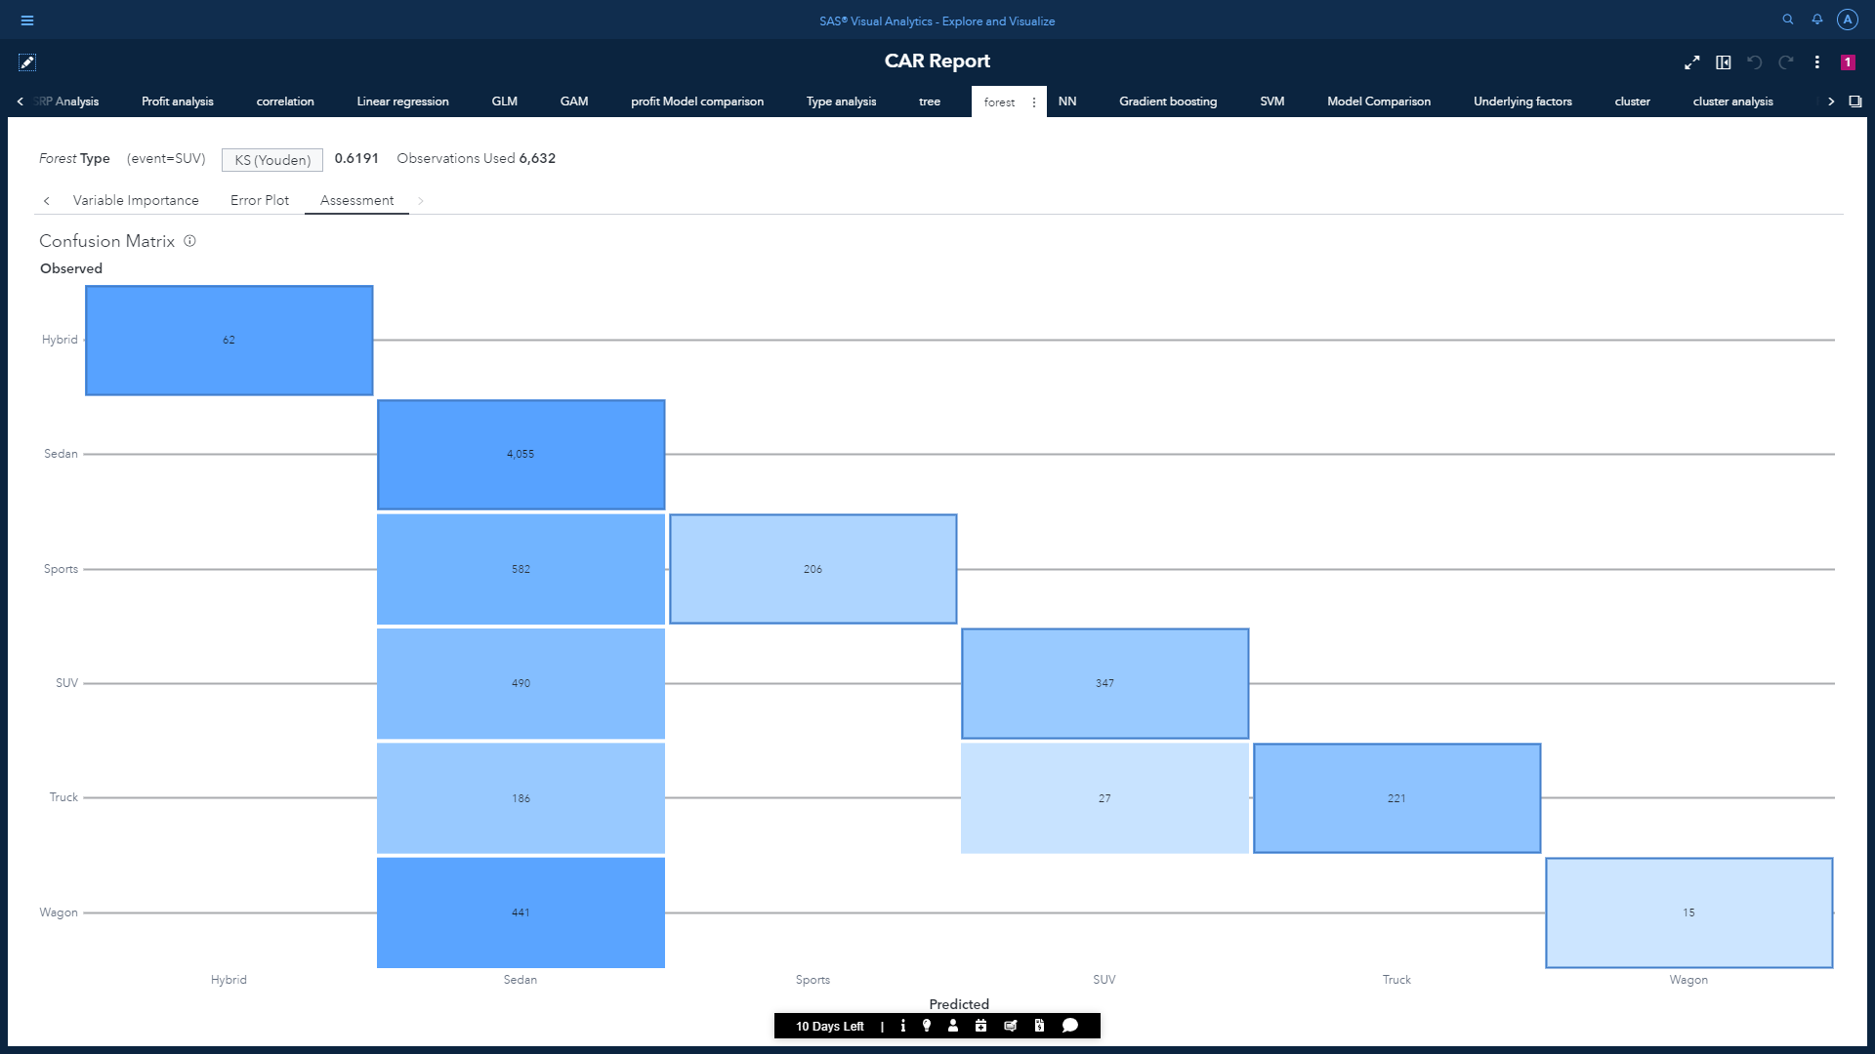

Even in the confusion matrix, there are many recorded observations outside the diagonal, which is a clear indication of false predictions for the vehicle type. Especially we can notice this model is not able to predict properly for the Wagon type. We shall change the assessment plot to ROC to get a clear idea.

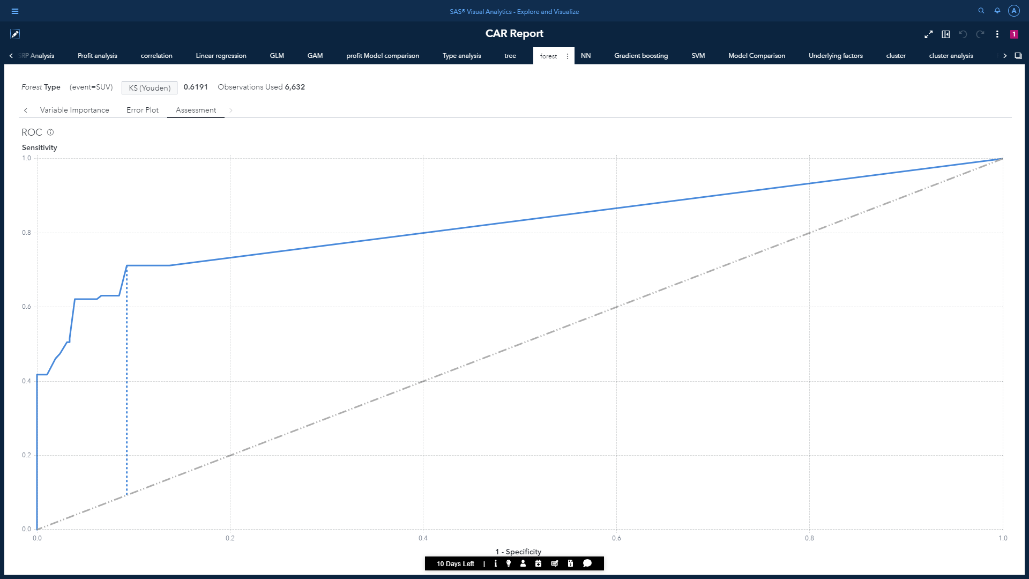

Assessment statistics:

* Misclassification rate: 0.2603
* C Statistics: 0.822
* F1 Score: 0.586
* Lift: 7.933
* Cumulative % events: 100.00
* Gini: 0.645
* Gamma: 0.860

As is demonstrated earlier, the degree of accuracy can be quantified by the area under the ROC curve. It is obvious that the area under the provided curve is decent, but lower than decision tree. Hence, this model is not performing well. But this model can be improved by adjusting the number of branches and max levels.

Assessment summary for the random forest:

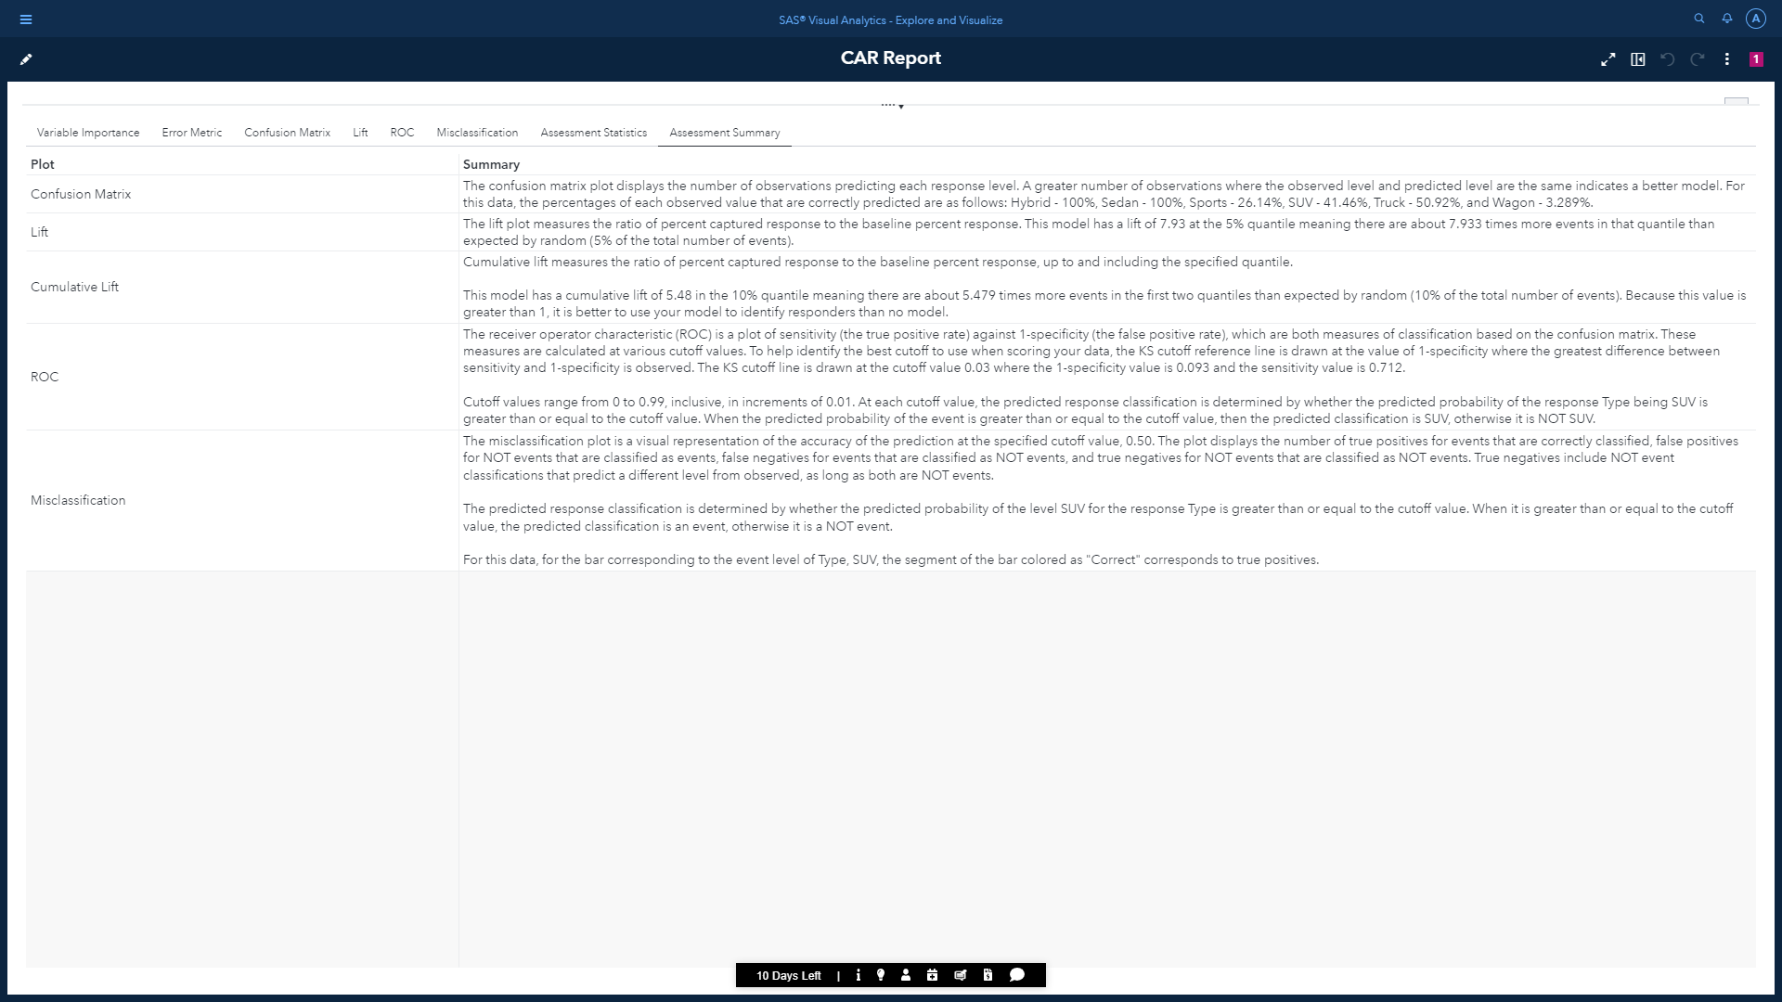

## c) Neural Network:

A neural network consists of many different layers of neurons, with each layer receiving inputs from previous layers, and passing outputs to further layers. Activation functions are responsible for the outputs on each neuron. This model was created to mimic the way a human brain develops classification rules.

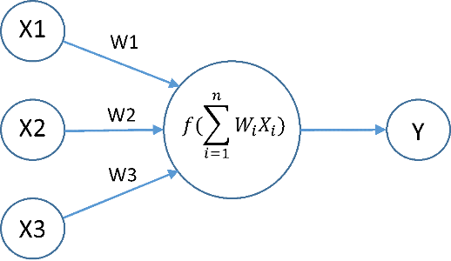

The neural network object under SAS Visual Statistics returns the network diagram, iteration plot and assessment plot.



We can observe the KS value is 0.9195, which is greater than Decision tree. Therefore, it is performing quiet well as the value is close to 1.

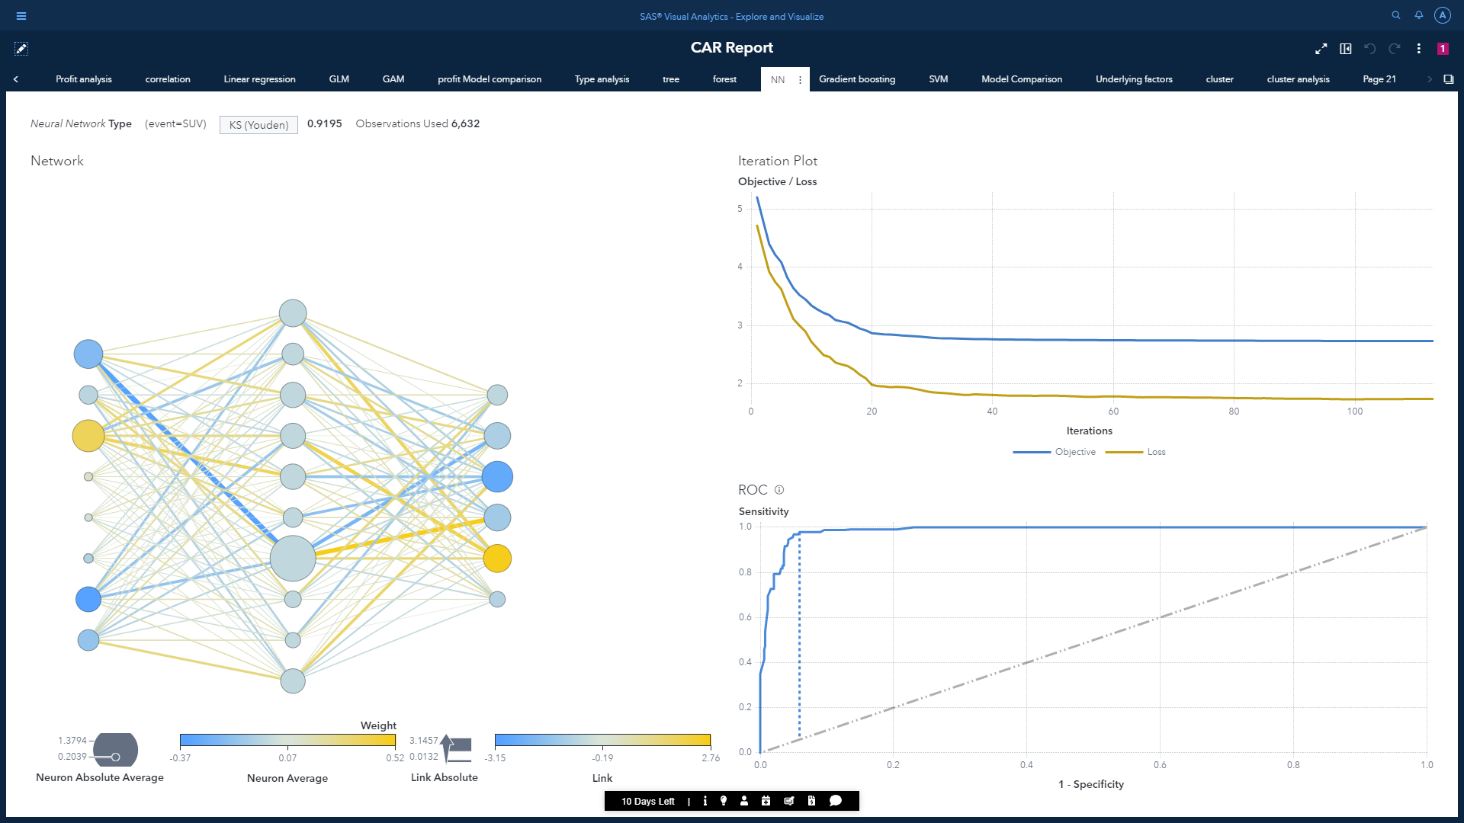

* This neural network has 1 hidden layer with 10 neurons.
* Hyperbolic tangent will be the activation function for the neurons.
* Optimization method will be LBFGS.
* Method for standardization used is Midrange.

The ROC curve for the neural network:

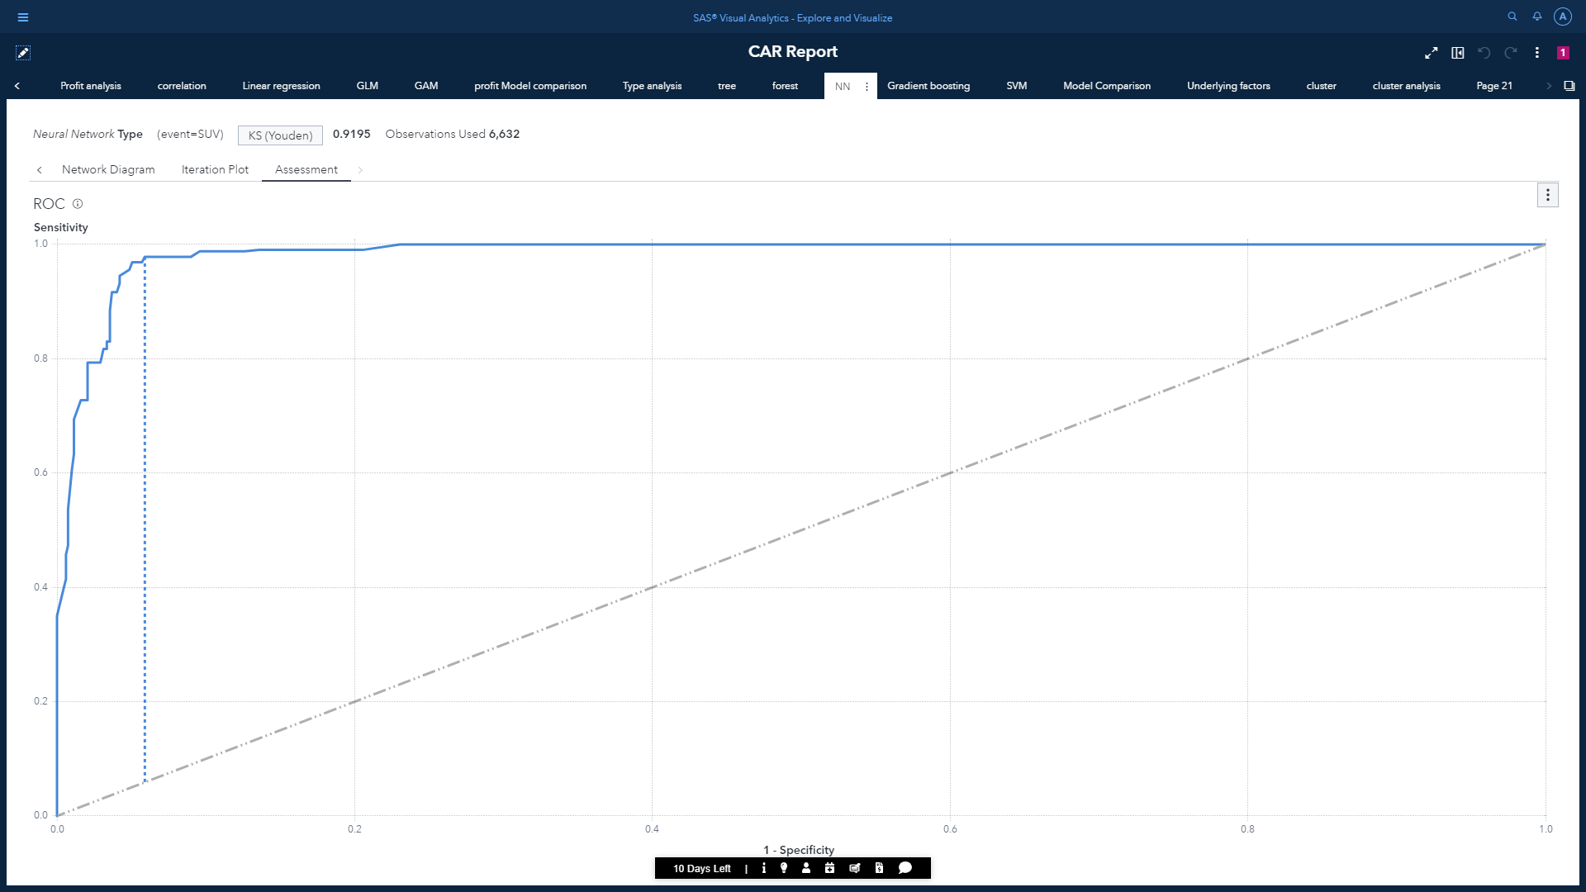

The ROC chart also shows that the area under the curve is quite big. This indicates that the classification accuracy of our model is high. We will again perform a model comparison for classification as we did for regression.

For clarification we can also check the confusion matrix

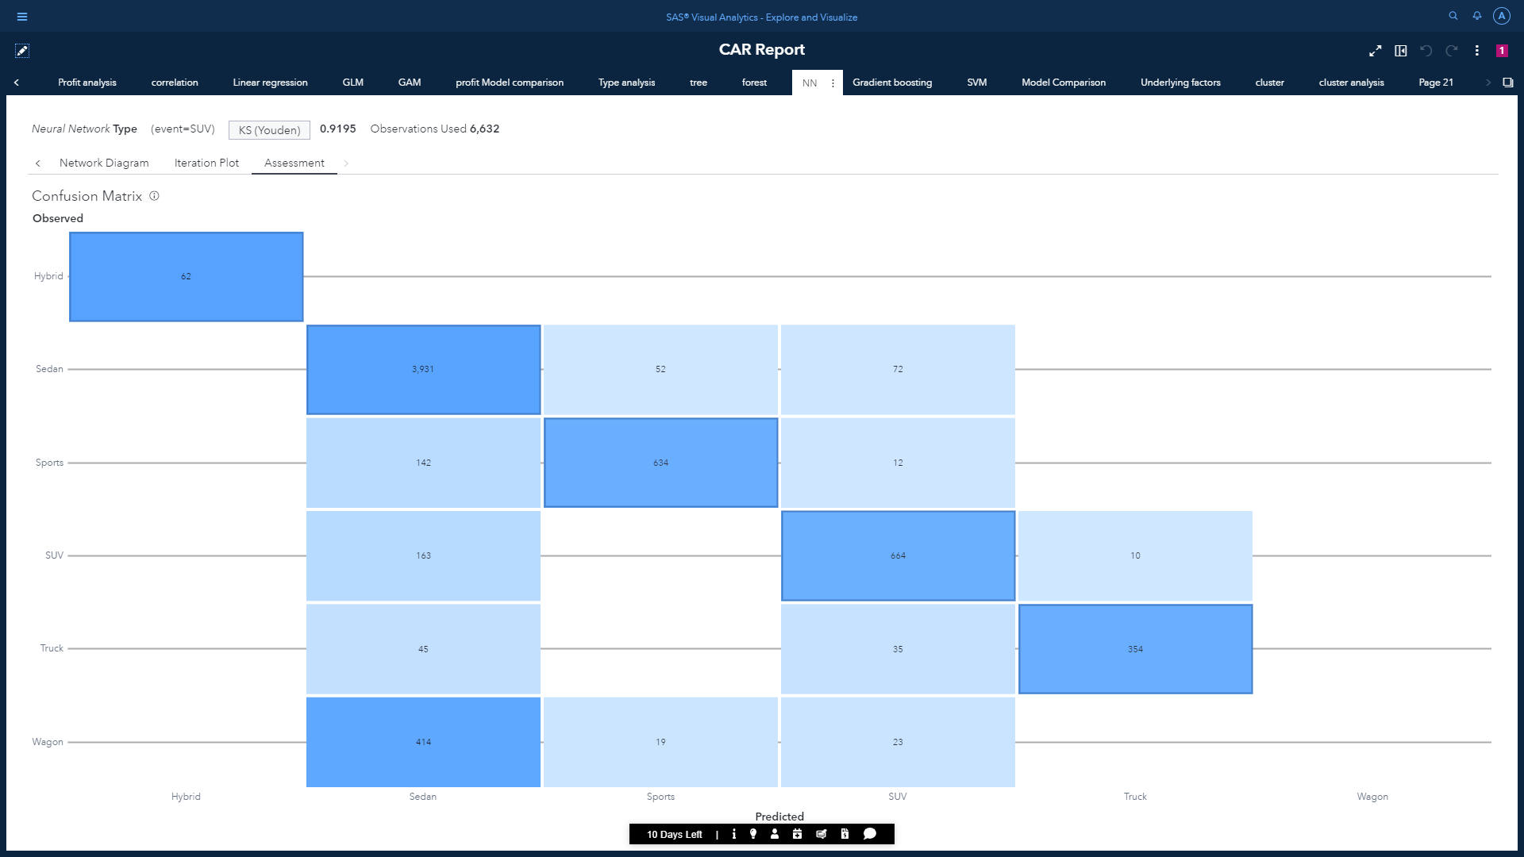

Most of the values lie in diagonal but our model still is not able to perform predictions for the Wagon Type

Assessment statistics:

* Misclassification rate: 0.0688
* C Statistics: 0.1488
* F1 Score: 0.778
* Lift: 7.933
* Cumulative % events: 100.00
* Gini: 0.970
* Gamma: 0.971

Assessment for the Neural Network:

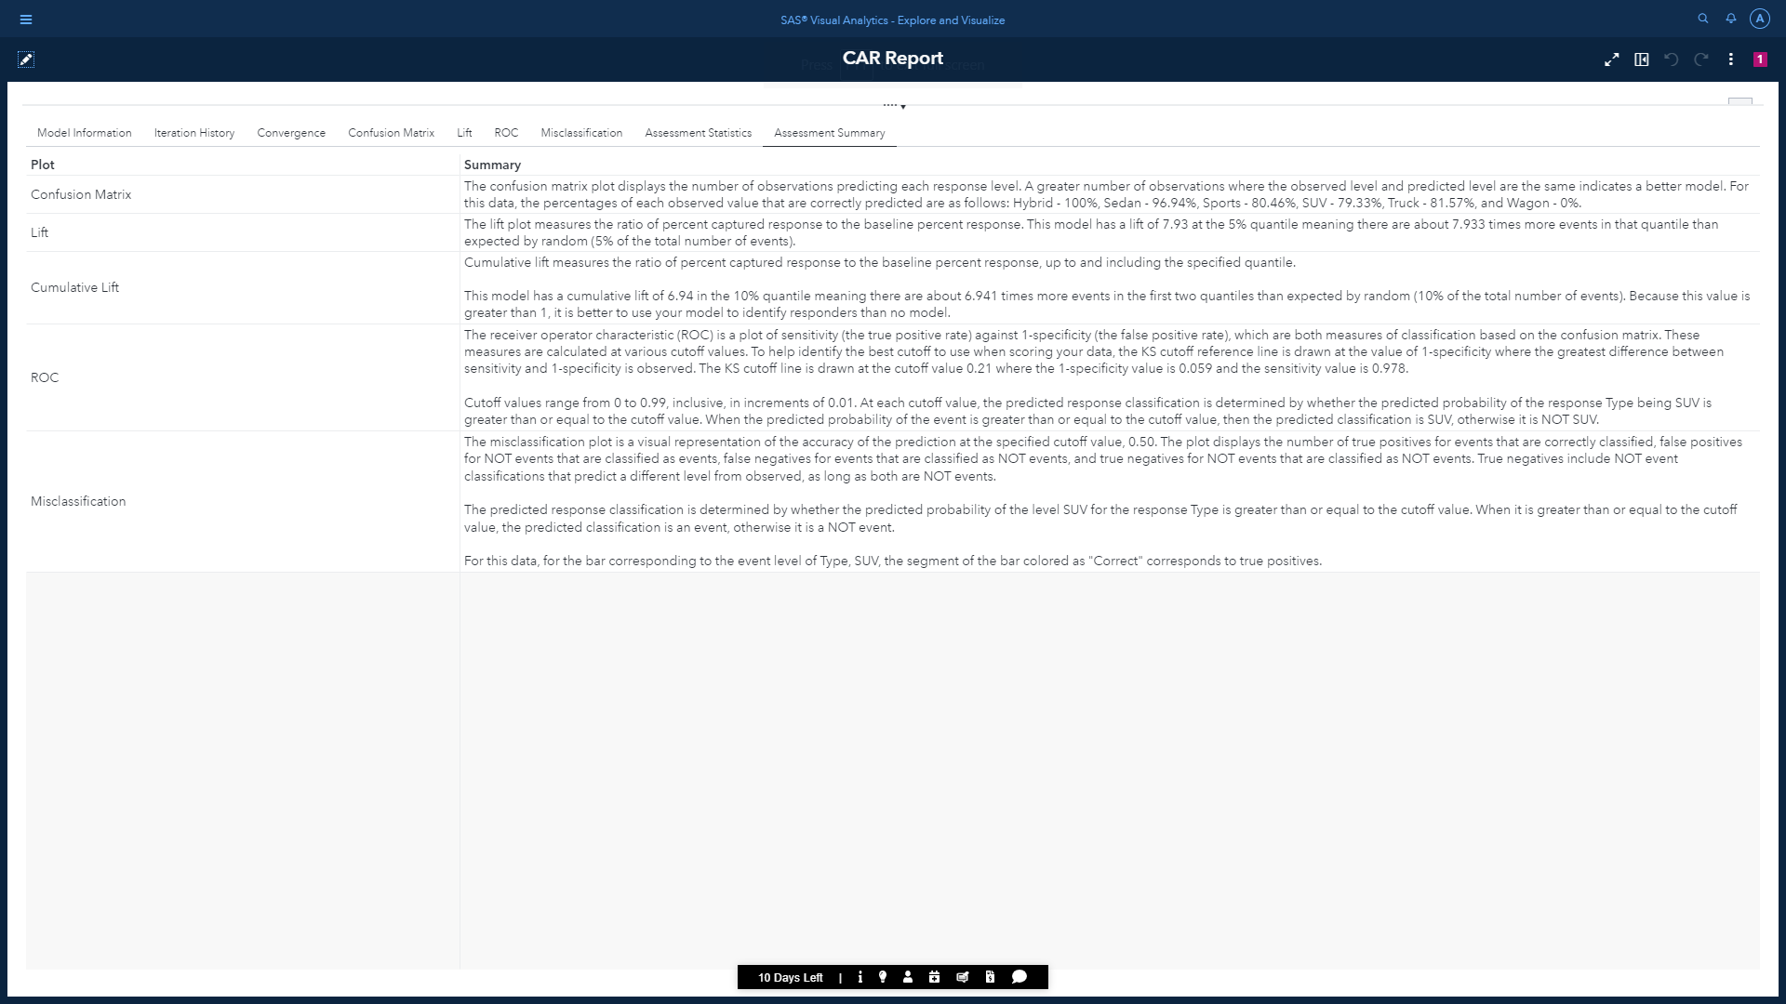

## d) Gradient Boosting

## Gradient boosting is a type of machine learning boosting. It relies on the intuition that the best possible next model, when combined with previous models, minimizes the overall prediction error. The key idea is to set the target outcomes for this next model to minimize the error. It produces a prediction model in the form of an ensemble of weak prediction models.

## 

## The Gradient Boosting object under the SAS Visual Statistics gives us Variable Importance, Iteration Plot and Assessment plot as results

## 

## 

## As we can see the KS value is approximately 1. This indicates this our best performing model. However, we will be performing model comparison to confirm our assumption.

## The confusion matrix of the Gradient Boosting method:

## 

## We can observe almost all the values lie in the diagonal indicating our model is performing almost flawlessly.

Assessment statistics:

* Misclassification rate: 0.0014
* C Statistics: 1.000
* F1 Score: 1.000
* Lift: 7.933
* Cumulative % events: 100.00
* Gini: 1.000
* Gamma: 1.000

## Model comparison for vehicle type classification:

## Model comparison based on KS value:

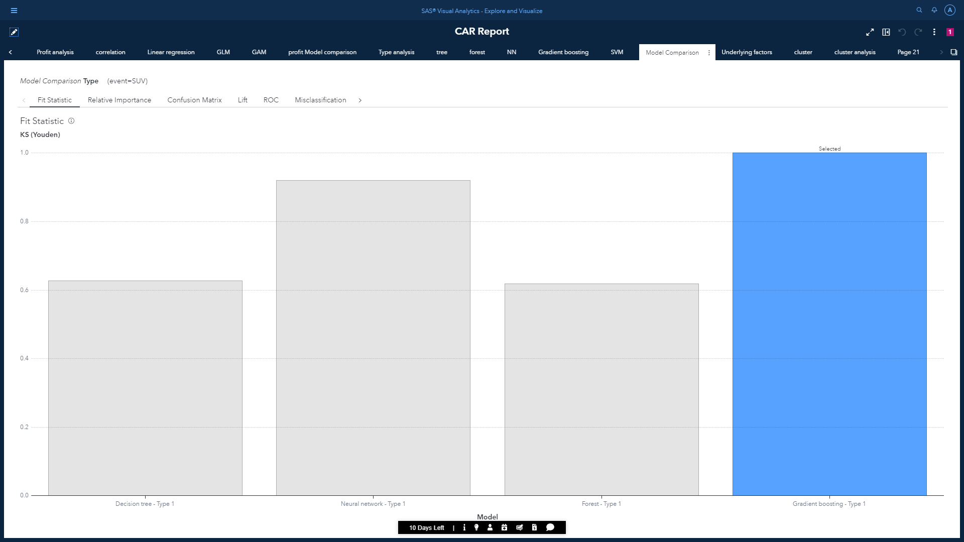

Following are the statistical values of each classification model:



Variable importance matrix:

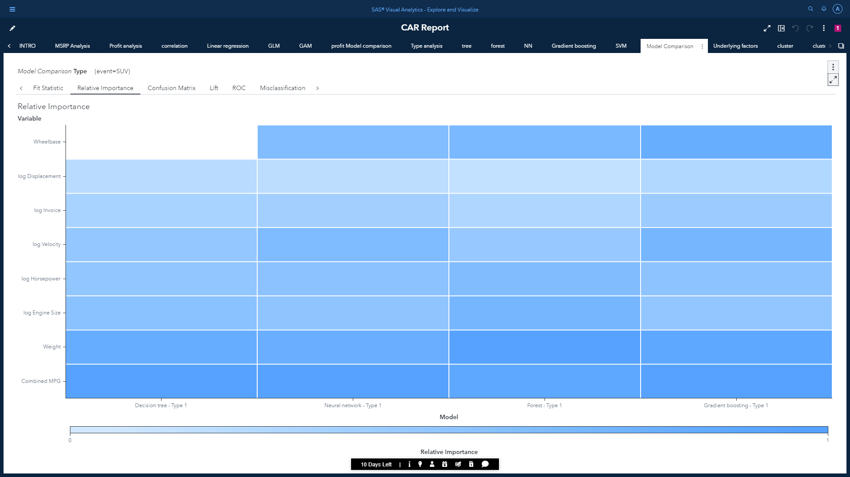

Values for the variable importance matrix of all models:  
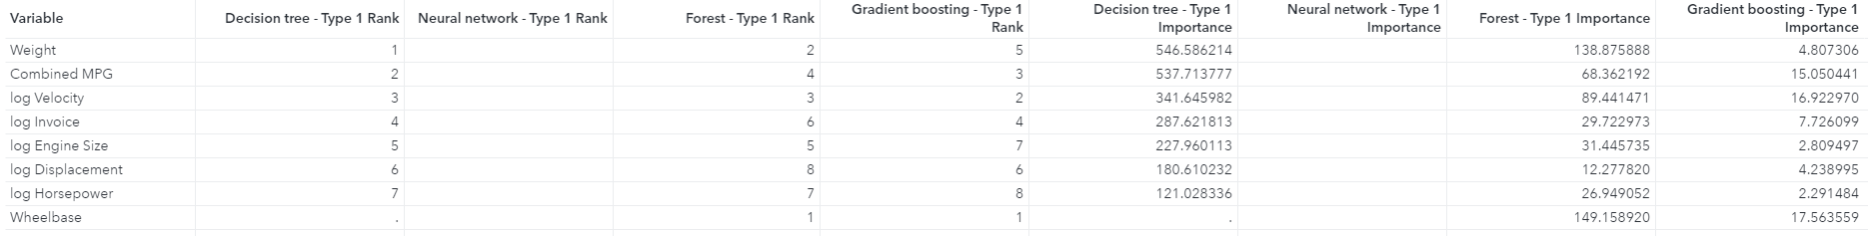

Cumulative lift curve for the model comparison:

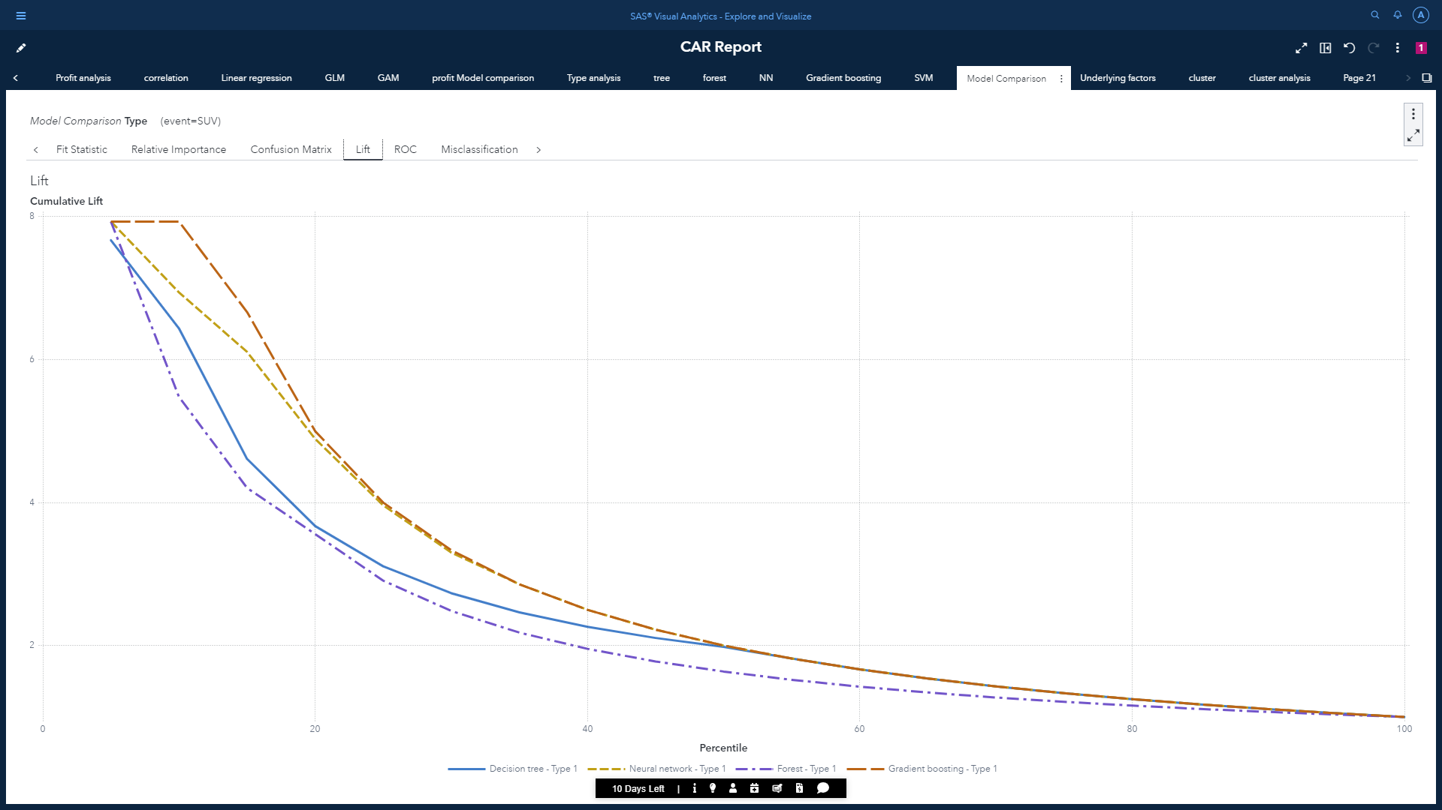

Misclassification plot for all models on SUV vehicle type:

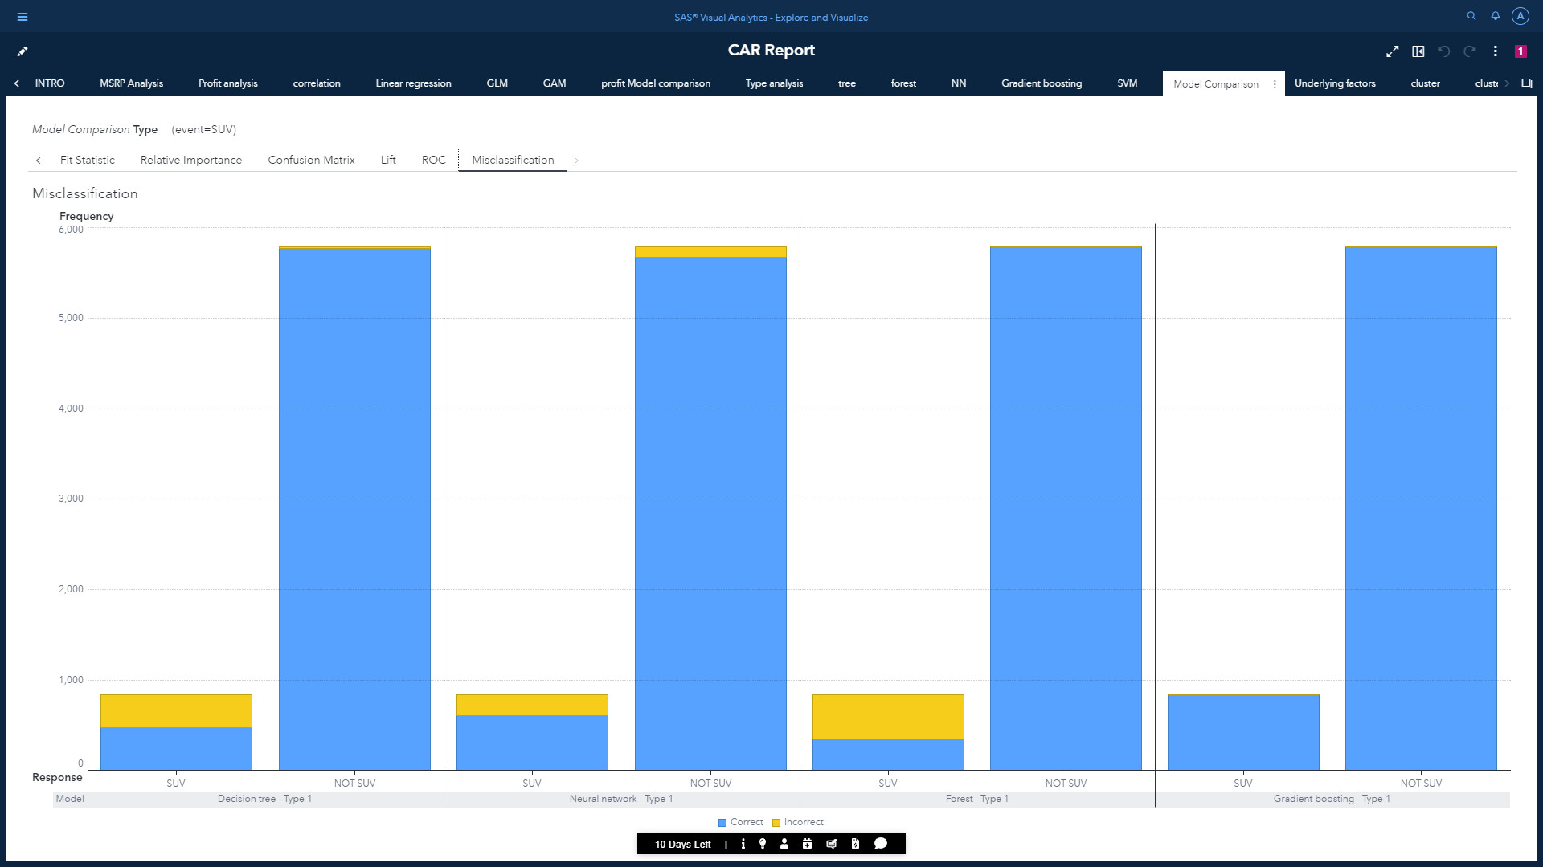

## Model 3 inference:

* We can conclude that the best performing model according to is the Gradient Boosting. This model was selected based on KS value with 0.5 as the cutoff percentage.
* 99.86% of the data was correctly classified using Gradient Boosting.
* The most influencing factors for predicting the vehicle type across all champion and challenger models are Combined MPG, Weight, and log Velocity.
* We can use the champion model to predict the vehicle type for new dataset in batch or in real time scoring.

To see how the underlying factors changes according to the target class, we can use the derived predicted class as prompts in a different page having histograms for underlying factors.

Change in values of underlying factors Sedan is selected:

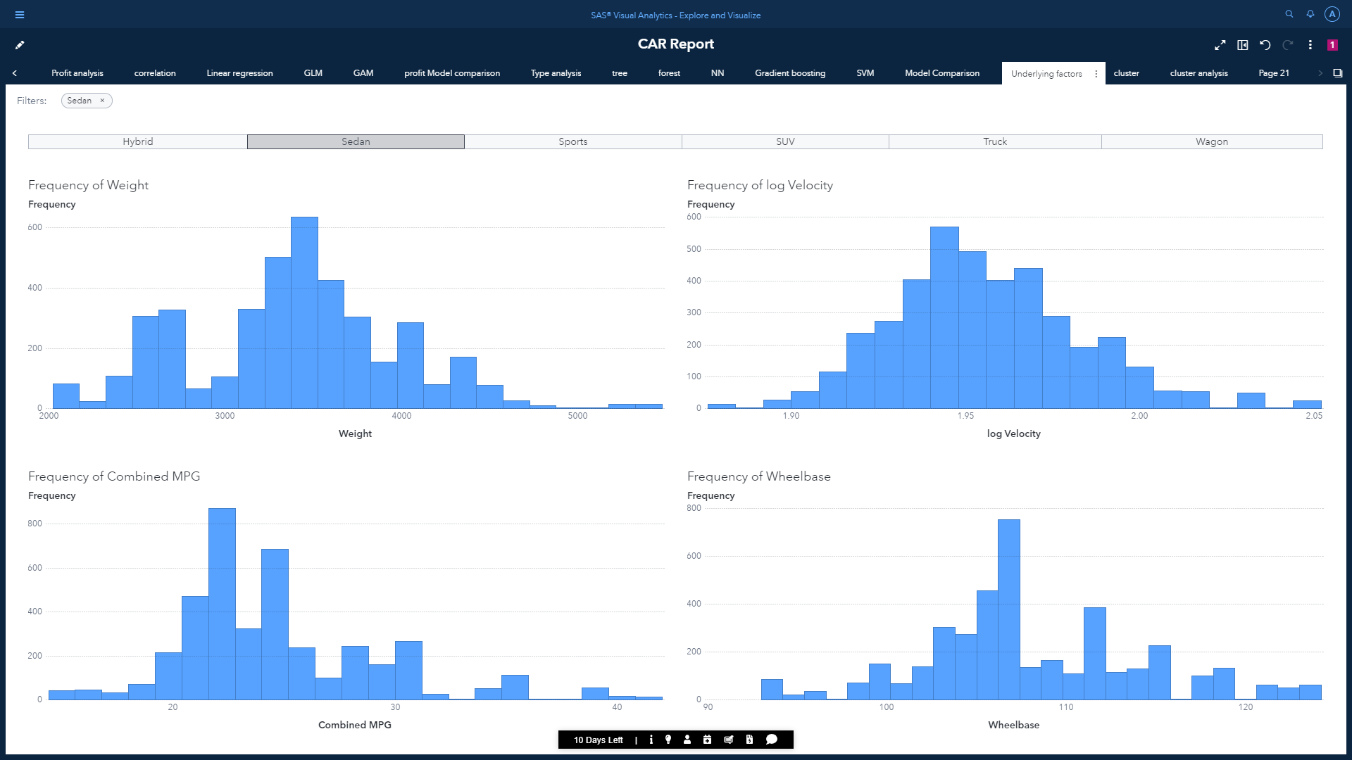

Change in values of underlying factors SUV is selected:

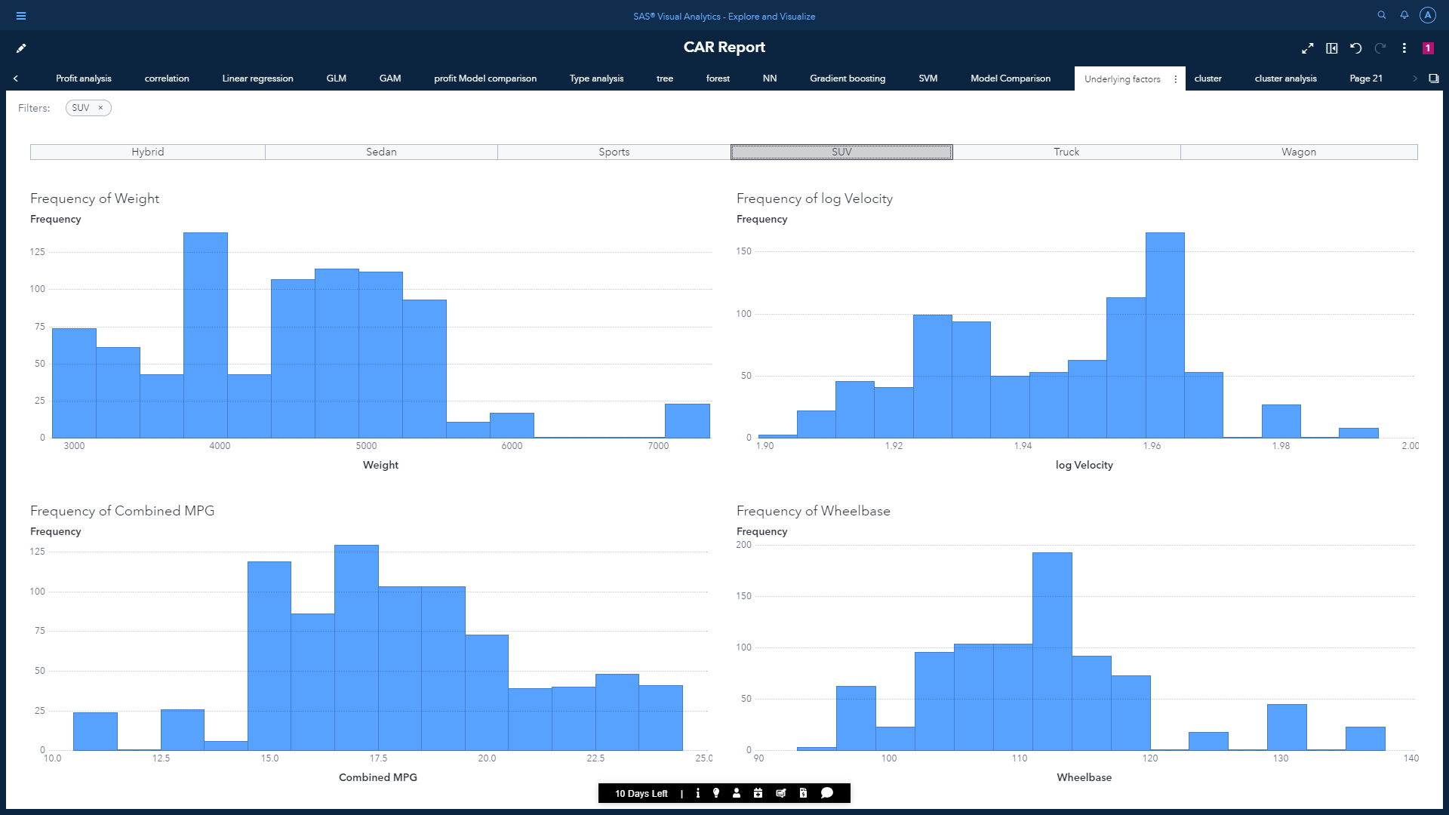

Conclusion:

### General:

* CO2 emission, Distance Driven and displacement are one of the most independent features among others.
* The most profitable company is Porsche with the 911 GT2 2dr the most profitable model. The least profitable company is Suzuki with Forenza S 4dr being the least profitable model.

### Model 1:

* here we can see the cluster ID 1 under US has the maximum profit margin. And the cluster ID 4 under US has the least profit margin.
* Conditions determining for the datapoint to come under cluster 1:

Length > 181

6.2 < Engine Size > 3.4

1.99 < log Velocity > 1.90

Weight > 3452

MSRP < 64,936

### Model 2:

* According to model comparison outcome, Generalized Additive Model (GAM) is the best fit model according to ASE value, for predicting profit margin and it is considered as champion model.
* With the help of variable importance table, we conclude that Invoice, Horsepower and EngineSize are the most influencing features across all champion and challenger models.

### Model 3:

* We can conclude that the best performing model according to is the Gradient Boosting. This model was selected based on KS value with 0.5 as the cutoff percentage.
* The most influencing factors for predicting the vehicle type across all champion and challenger models are Combined MPG, Weight, and log Velocity.